**AMITY UNIVERSITY GWALIOR**

**(MADHYA PRADESH)**



**PYTHON PRACTICAL FILE**

**CSE - 322**

SESSION - 2020-24

SUBMITTED BY:- SUBMITTED TO:-

MR. RAJAT GUPTA Dr. Ashok Kumar Shrivastava

Btech (CSE) ASS. PROFESSOR (CSE)

ENROLLMENT NO:-

A60205220088

**ASSIGNMENT :- 1**

**Q1. Write python program to perform arithmetic operations on two numbers:**

Ans :-

a=8

b=2

#for addition

c=a+b

print("sum :",c)

#for subtraction

d=a-b

print("sub :",d)

#for division

e=a/b

print("div :",e)

#for multiplicaton

f=a*b

print("mul :",f)

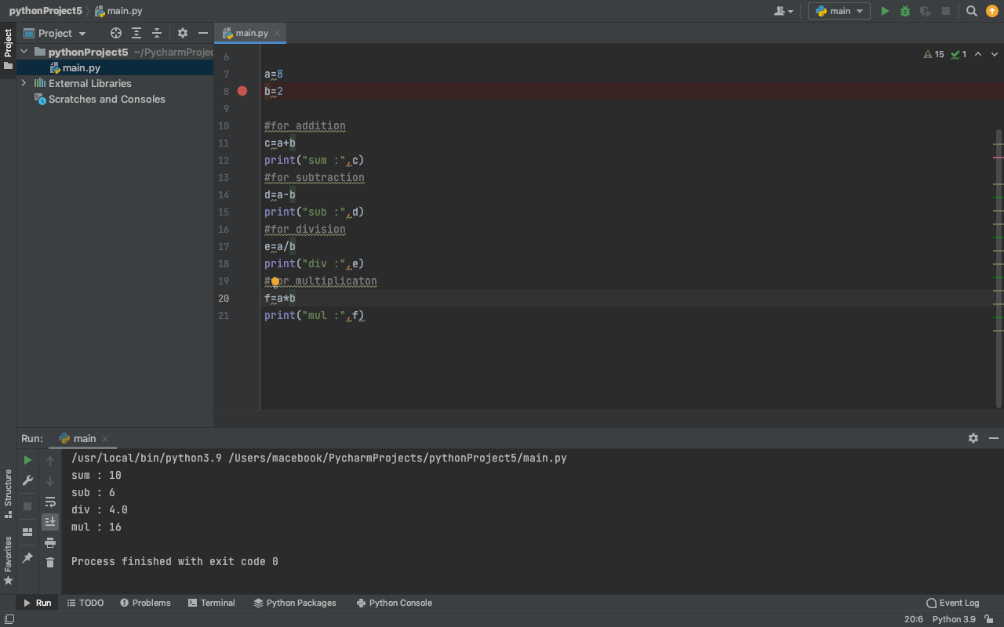

**Q2. Implement following Algebraic formulas:**

* **(a+b)2 = a2 + b2 + 2ab**
* **(a+b) (a-b) = a2– b2**

ANS:-

#1st part

a=8

b=2

c=(a*a)+(b*b)+2*a*b

print("the vaue of c :",c)

#2nd part

a=8

b=2

c=(a+b)*(a-b)

d=a*a-b*b

print("the vaue of c :",c)

print("the vaue of d :",d).

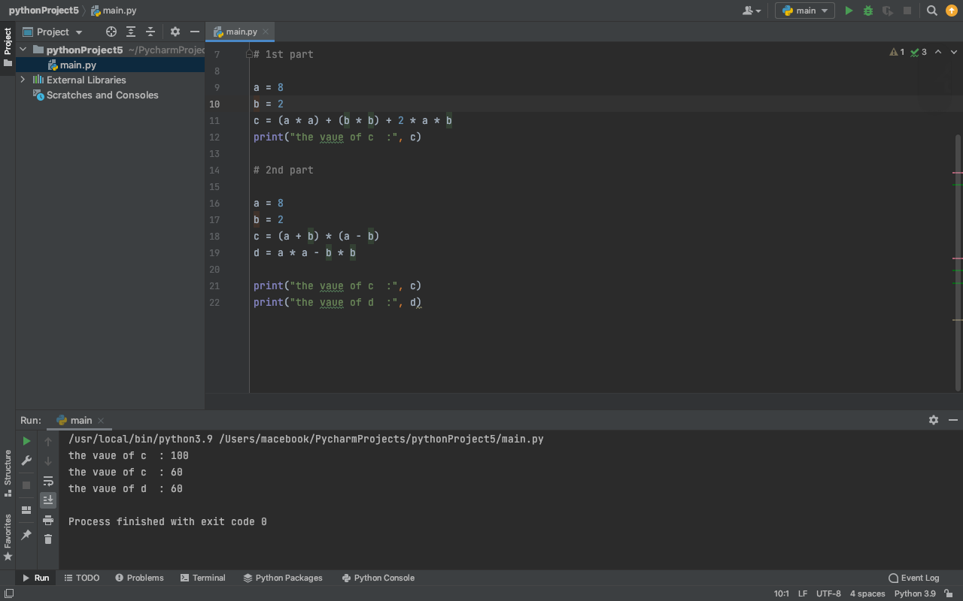

**Q3. Implement following Sphere Formulas:**

* **Diameter of sphere**
* **Circumference of Sphere**
* **Surface area of sphere**
* **Volume of sphere**

ANS:-

#1st part

diameter=8

radius=diameter/2

print("the vaue of sphere radius is :",radius).

#2nd part

radius=4

circumference=2*3.14*radius

print("the value of sphere circumference is :",circumference)

#3rd part

radius=4

surface_area =4*3.14*radius*radius

print("the value of sphere surface area is :",surface_area)

#4th part

radius=4

v =4/3*3.14*radius*radius

print("the value of Volume of sphere is :",v).

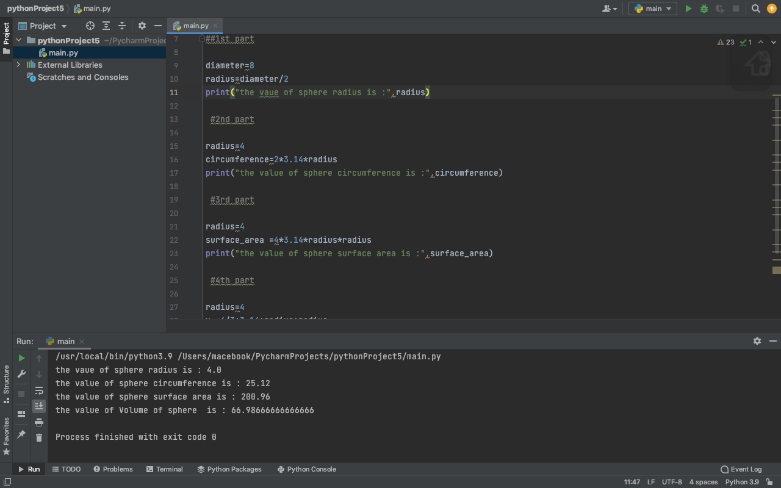

**Q4. Implement following Cylinder Formulas:**

* **Circumference of Cylinder**
* **Curved surface area of Cylinder**
* **Total surface area of Cylinder**
* **Volume of Cylinder**

ANS:-

#1st part

radius=4

Circumference =2*3.14*radius

print("the value of Circumference of Cylinder is :",Circumference)

#2nd part

radius=4

height=2

Csa =2*3.14*radius*height

print("the value of Csa of Cylinder is :",Csa)

#3rd part

radius=4

height=2

tsa =2*3.14*radius*(height+radius)

print("the value of tsa of Cylinder is :",tsa)

#4th part

radius=4

height=2

v =3.14*radius*radius*height

print("the value of Volume of Cylinder is :",v).

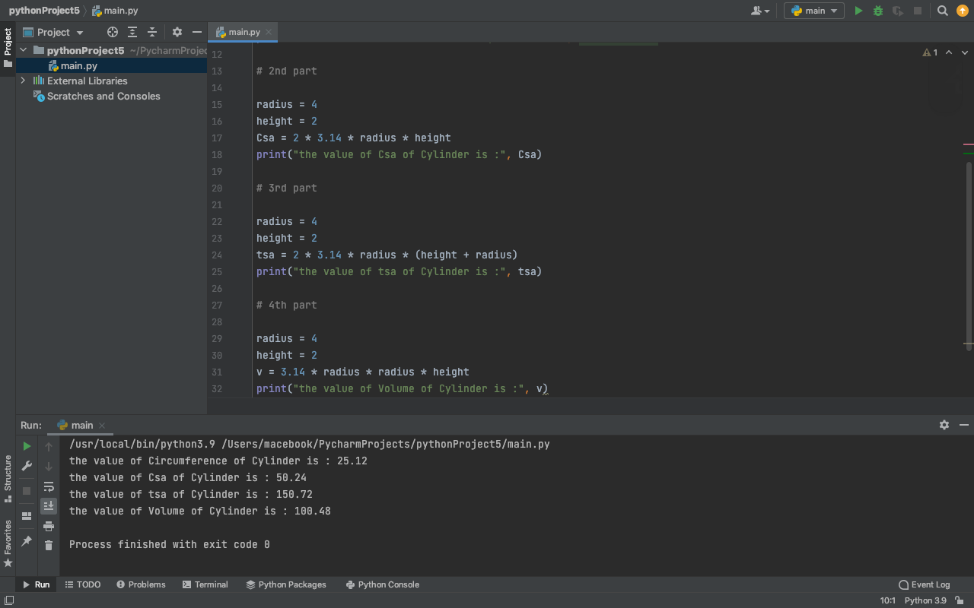

**Q5. Implement following Cone Formulas:**

* **Curved surface area of cone**
* **Total surface area of cone**
* **Volume of cone**

ANS:-

r=4

l=2

h=8

#1st part

csa=3.14*r*l

#2nd part

tsa=3.14*r*l+3.14*r*r

#3rd part

v=3.14*r*r*h/3

print("Curved surface area of cone :", csa)

print("Total surface area of cone :",tsa)

print("Volume of cone : ",v).

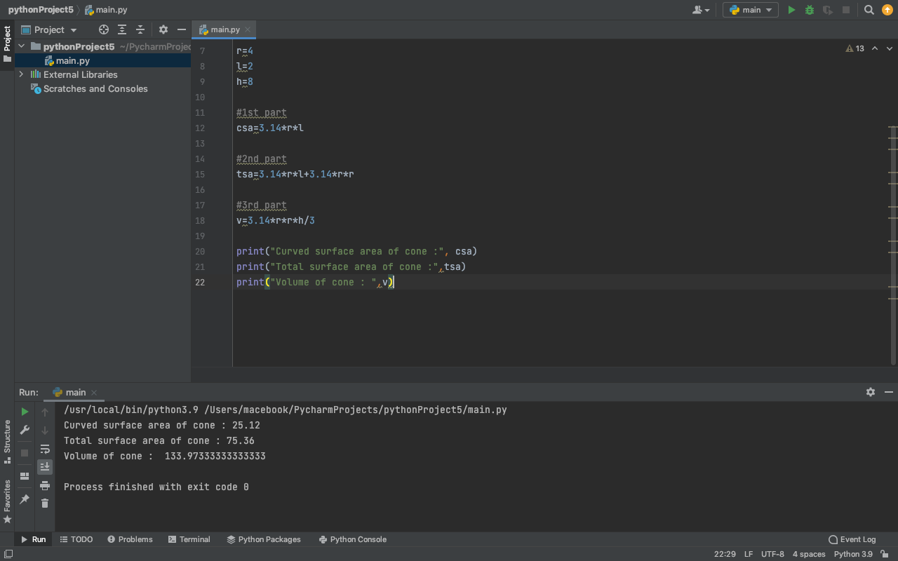

**Q6. Implement following Cuboid Formulas:**

* **Perimeter of cuboid**
* **Total surface area of cuboid**
* **Volume of Cuboid**

ANS:-

b=4

l=2

h=8

#1st part

Perimeter=4*(l+b+h)

#2nd part

tsa=2*(l*b+b*h+l*h)

#3rd part

v=l*b*h

print("Perimeter of cuboid :", Perimeter)

print("Total surface area of cuboid :",tsa)

print("Volume of cubid : ",v).

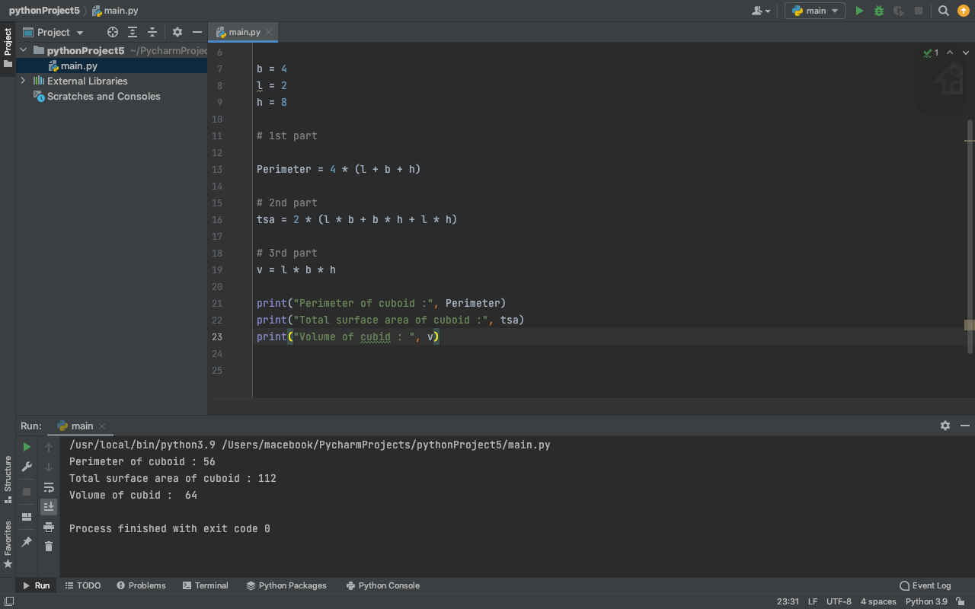

**Q7. Implement compound interest.**

ANS:-

def compound_interest(principle, rate, time):

# Calculates compound interest

Amount = principle * (pow((1 + rate / 100), time))

CI = Amount - principle

print("Compound interest is", CI)

compound_interest(10000, 10.25, 5).

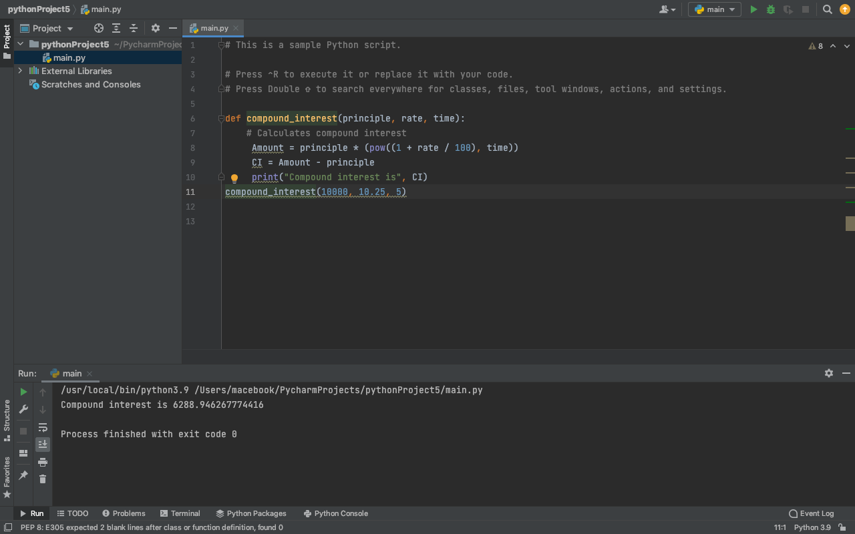

**Q8. Implement conversion from Fahrenheit to Celsius.**

ANS:-

tf=60

tc=(tf-32)*5/9

print("the value of temperature in celsius is :",tc).

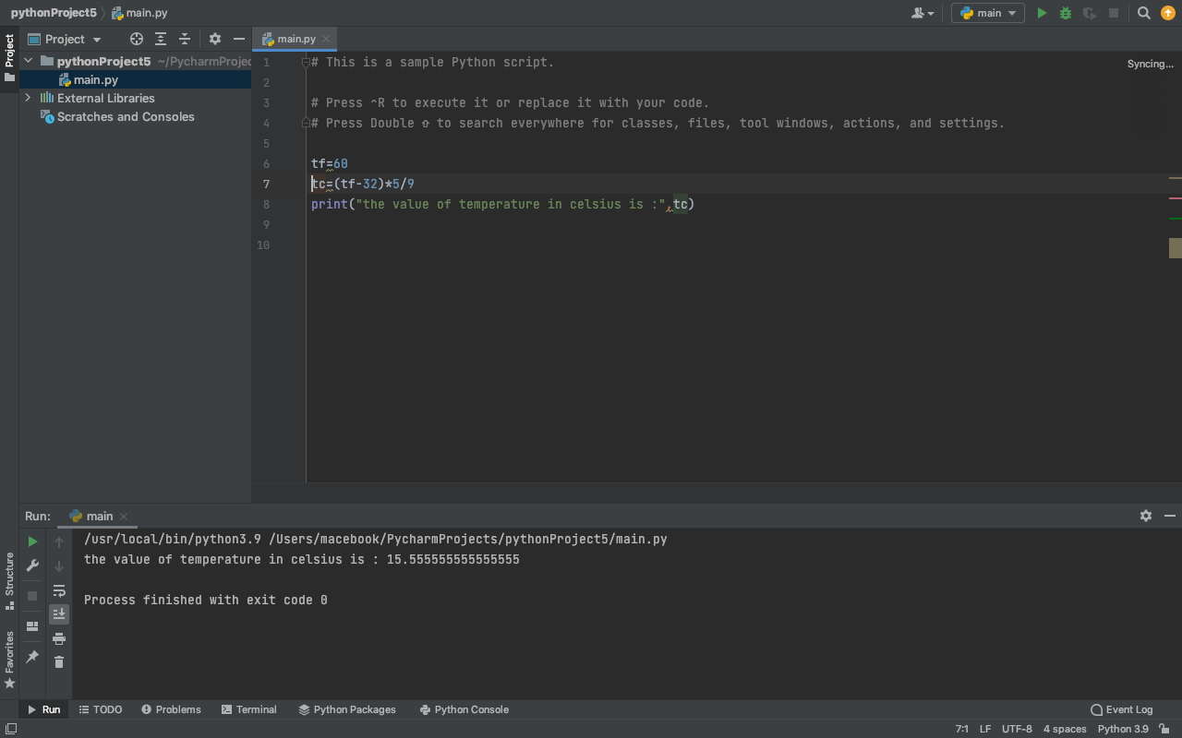

**ASSIGNMENT :- 2**

**Q1. Write a Python program to print the following string in a specific format (see the output).**

**Sample String: "Twinkle, twinkle, little star, How I wonder what you are! Up above the world so high, Like a diamond in the sky. Twinkle, twinkle, little star, How I wonder what you are!"**

**Output:**

**Twinkle, twinkle, little star,**

**How I wonder what you are!**

**Up above the world so high,**

**Like a diamond in the sky.**

**Twinkle, twinkle, little star,**

**How I wonder what you are!**

ANS:-

print("Twinkle, twinkle, little star, \n\tHow I wonder what you are! \n\t\tUp above the world so high, \n\t\tLike a diamond in the sky. \nTwinkle, twinkle, little star, \n\tHow I wonder what you are!").

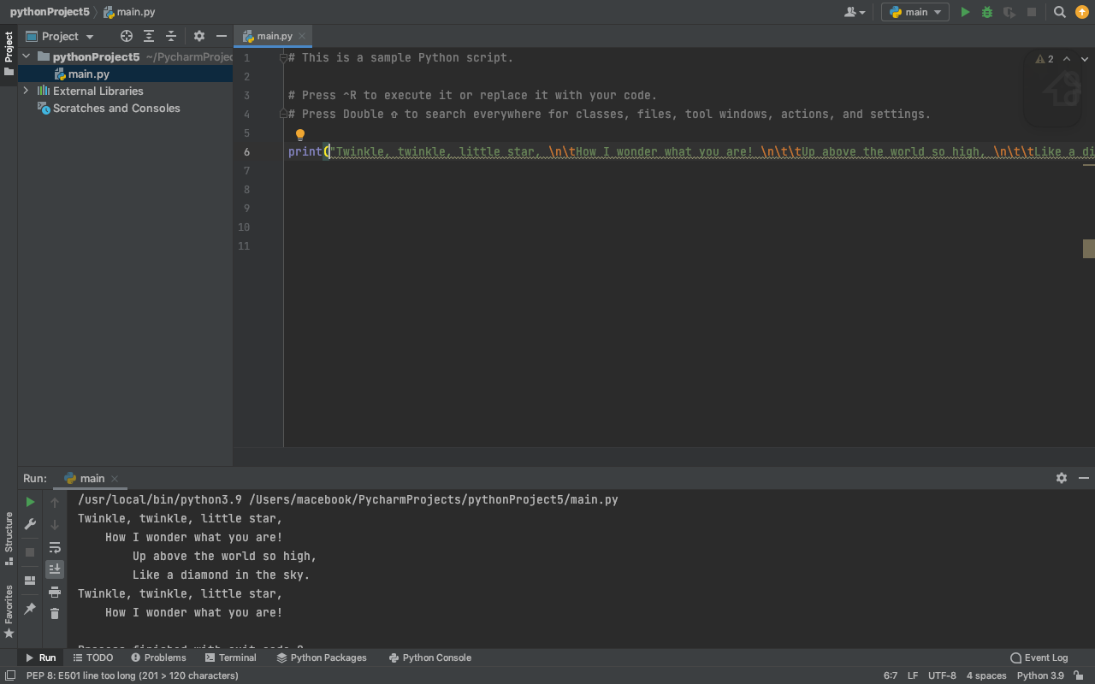

**Q2. Write a Python program which accepts the user's first and last name and print them in reverse order with the help of format function.**

ANS:-

first_name=input(“enter your first name”)

last_name= input(“enter your last name”)

Print((f ‘{last_name} { first_name}’))

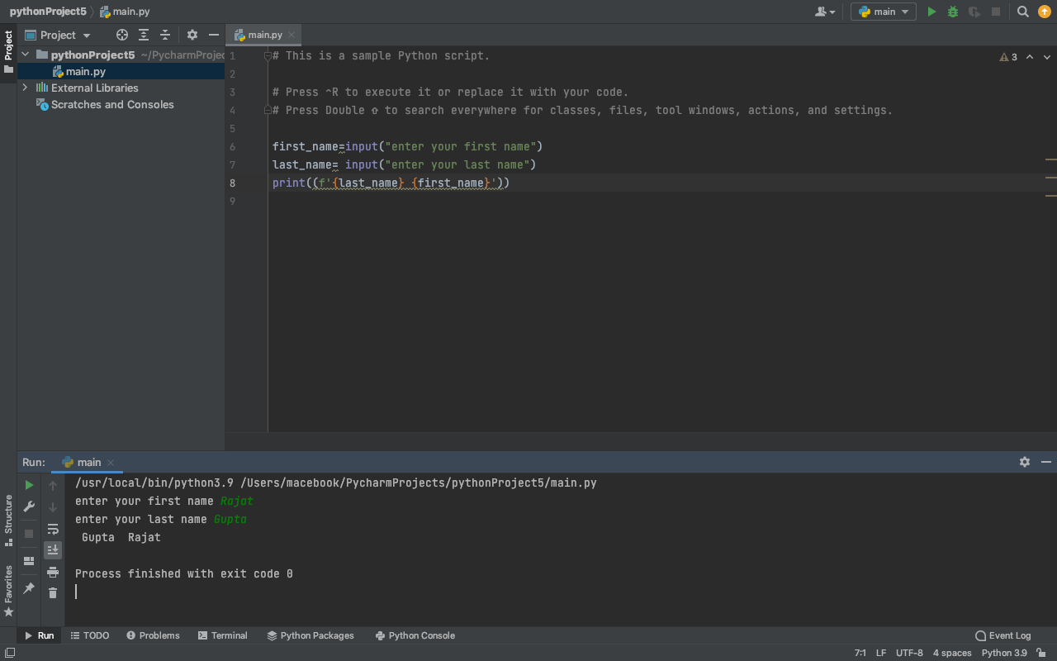

**Q3. Write a Python program that accepts an integer (n) and computes the value of n+nn+nnn. (Hint: nn does not shows multiplication of n and n)**

ANS:-

a=int(input("enter any num" ))  
print('{}+{}{}+{}{}{}'.format(a,a,a,a,a,a))

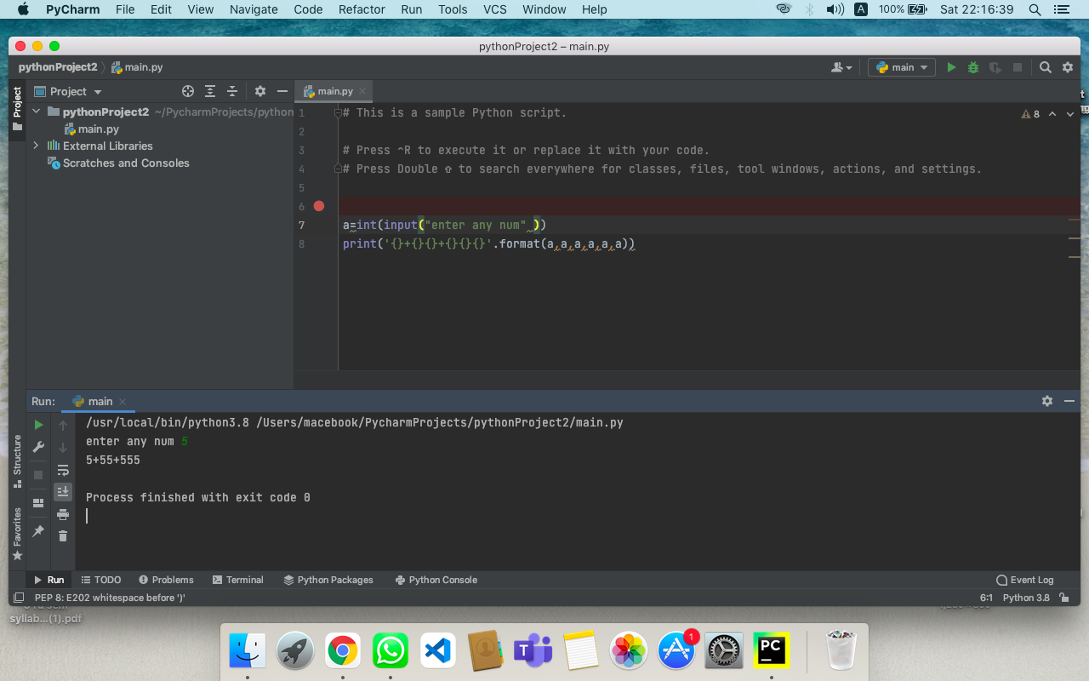

**Q4. Write a program to perform addition of two numbers without using + operator.**

ANS:-

A=5

B= 4

C=A-(-B)

Print(C)

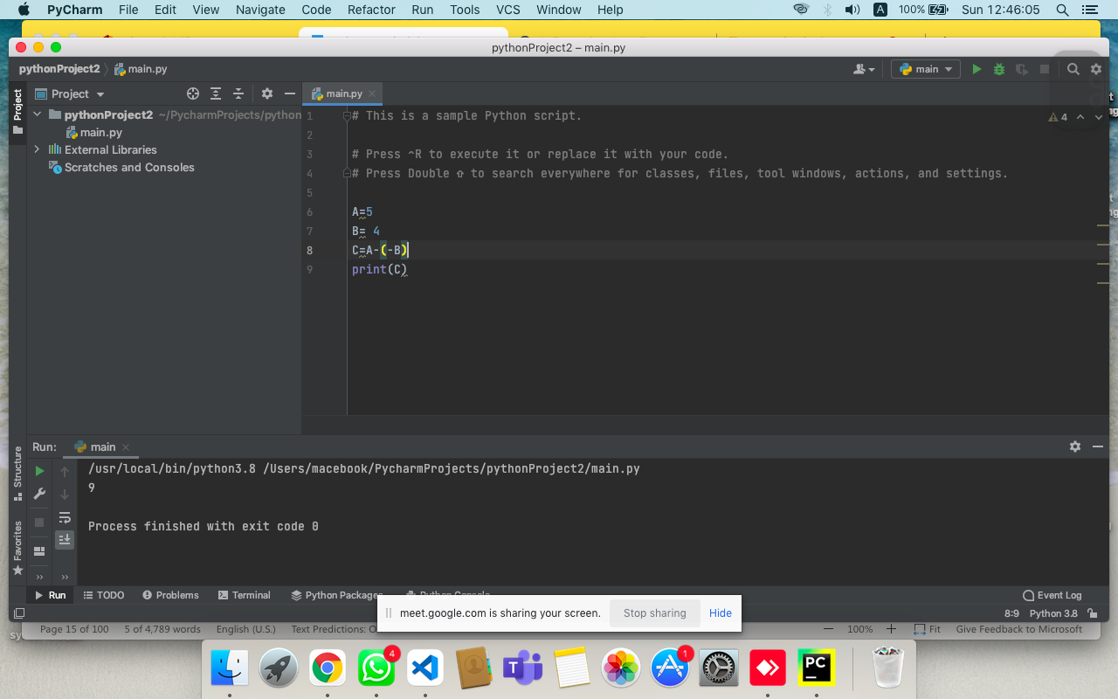

**Q5. Program to enter basic salary and calculate the gross salary of an employee. (Hint: calculate hra and da as per your choice)**

ANS:-

basic_sal = int(input("Enter the basic salary= "))  
da = (float) (15 *basic_sal) / 100.0  
hr = (float) (10 *basic_sal) / 100.0  
da_on_ta = (float) (3 * basic_sal) / 100.0  
gross_sal = basic_sal+ da + hr +da_on_ta  
print("Gross salary from the given basic salary =" ,gross_sal)

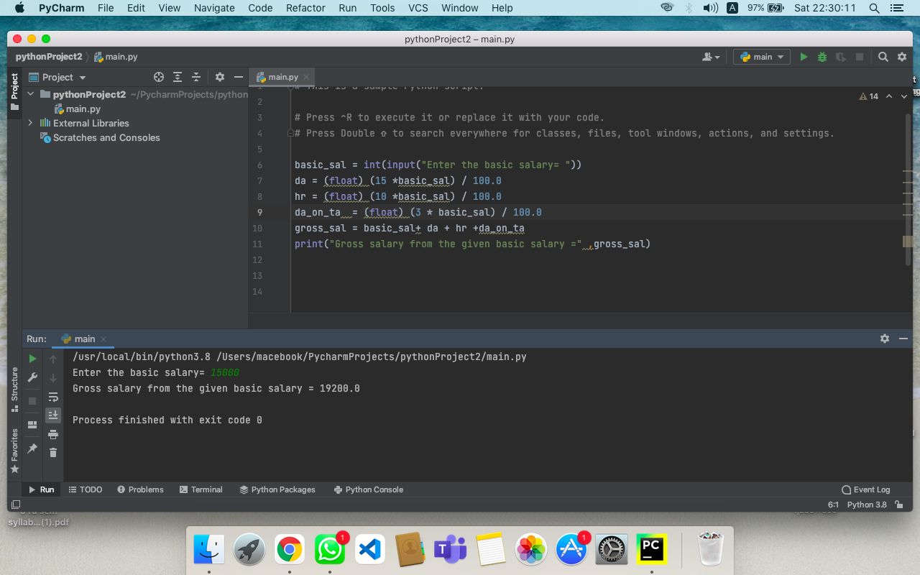

**Q6. Swap two numbers without using any other third variable in Python.**

* **Use product and division to swap two numbers.**
* **Use addition and subtraction swap two numbers.**

ANS:-

#a

a=5;

b=6;

b=a*b;

a=int(b/a);

b=int(b/a);

print(a,b)

#b

a=5;

b=6;

b=a+b;

a= b-a;

b= b - a

print(a,b)

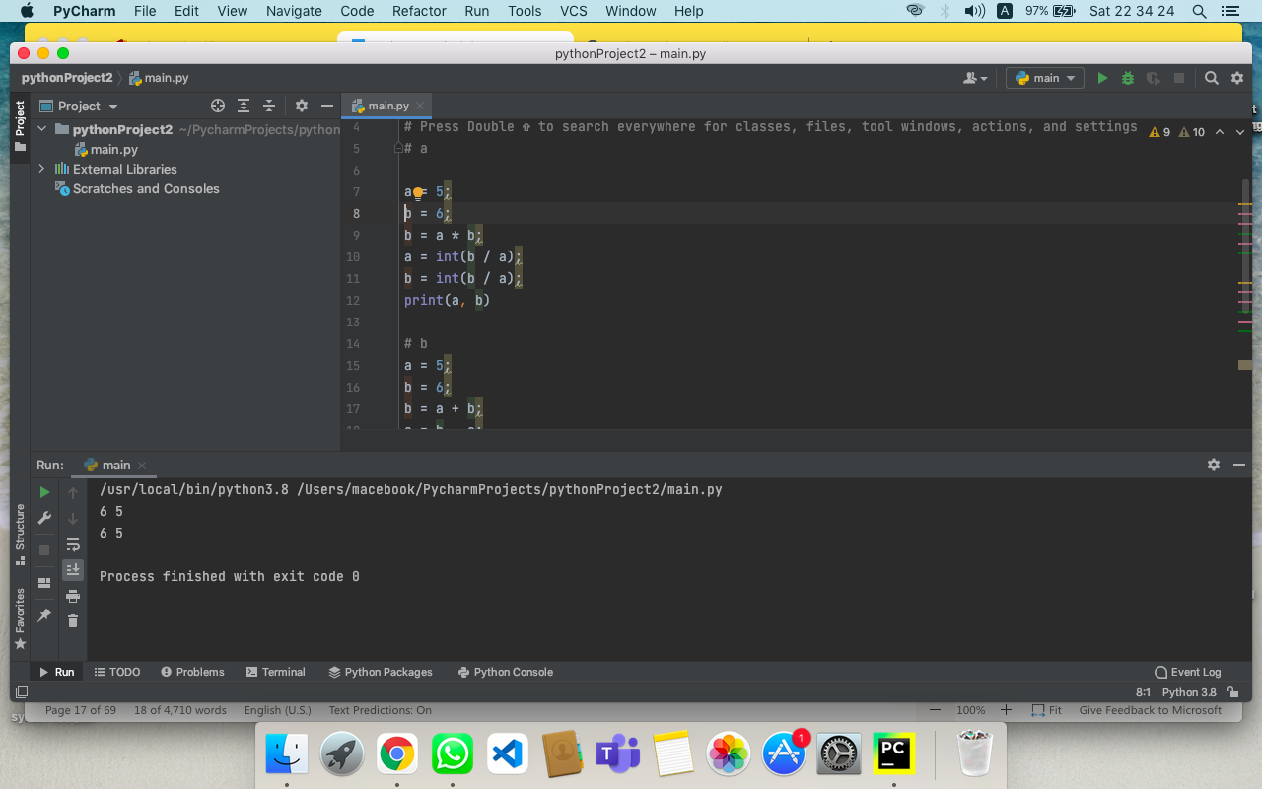

**Q7. Write a python program to create list of strings and check whether their identities are unique or not.**

ANS:-

first_list = [1,2,3,'a']

second_list = ['a','b', 'c',10]

#loop around the list

for i in first_list:

if i in second_list:

print(i,"is present in both lists")

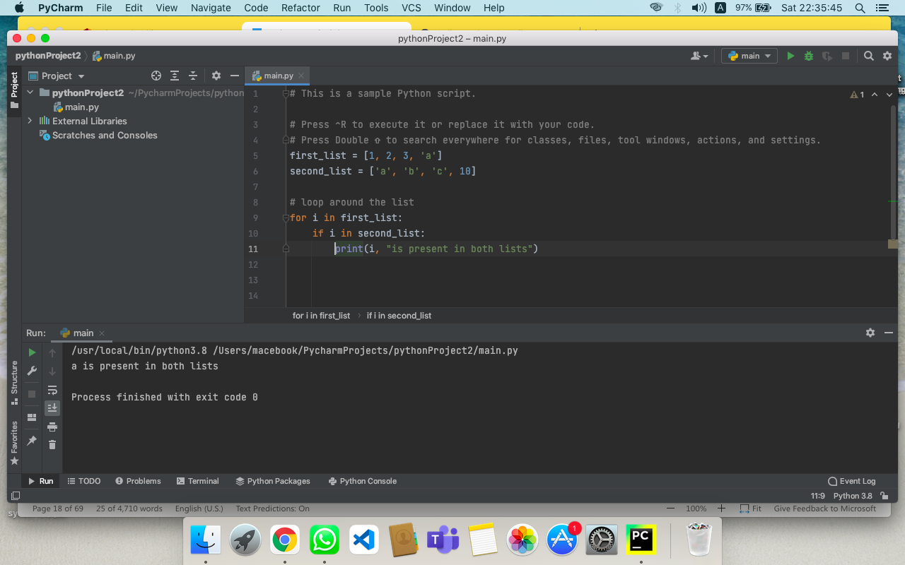

**Q8. Write a program to increase the value of three global variables and use modify values to create list and then display each value using slicing.**

ANS:-

def modify():

global a,b,c;

a=a+5;

b=b+1;

c=c+4;

a,b,c=(input("enter the values")).split()

a=int(a);

b=int(b);

c=int(c);

modify()

new_list=[a,b,c]

new_list[:]

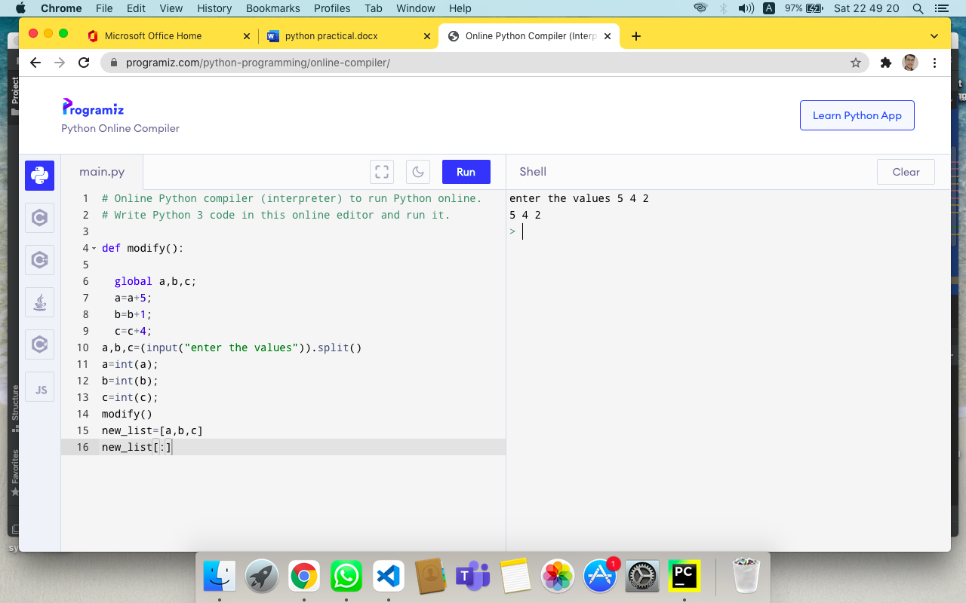

**Q9. Write functions to perform swap values of two number.**

ANS:-

def swap(a,b):

b=a+b

a=b-a

b=b-a

print (a,b)

Swap(4,3)

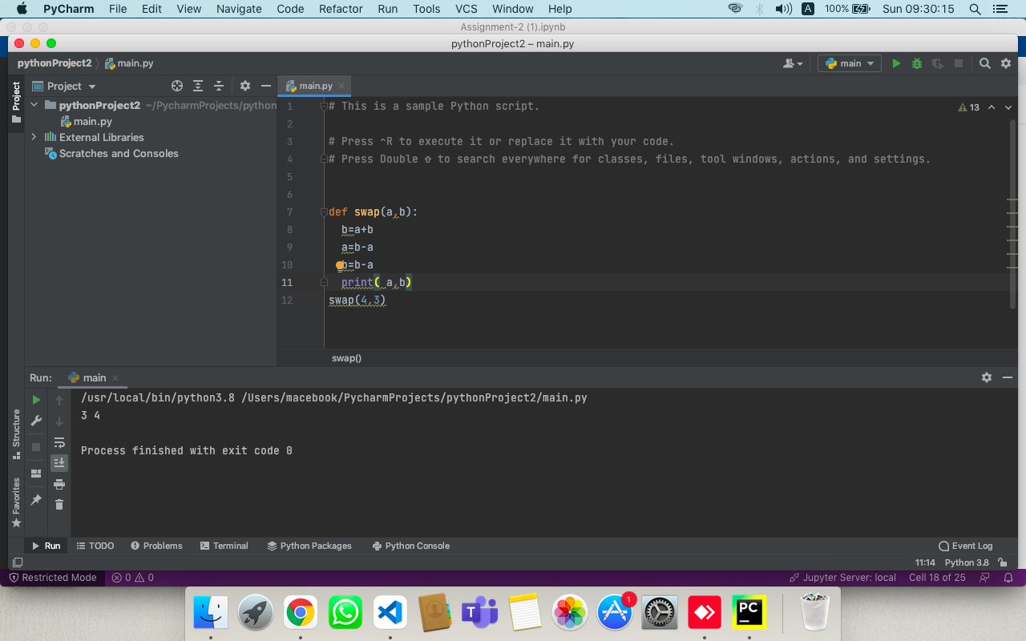

**Q10. Write function to perform arithmetic operations using integers and float numbers.**

ANS:-

calc(a,b):

print("choose 1 for + 2 for - 3 for / 4 for *")

c=int(input())

if c==1:

print(a+b)

if c==2:

print(a-b)

if c==3:

print(a-b)

if c==4:

print(a*b)

a=int(input("enter value of a "))

b=float5(input("enter a float value"))

calc(a,b)

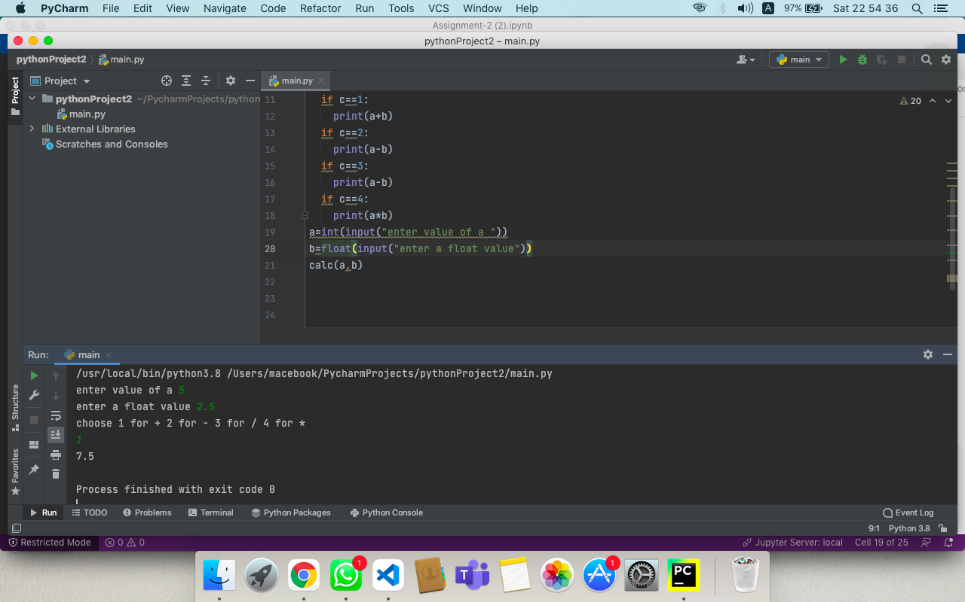

**Q11. Subtract two integer without using minus operator.**

ANS:-

num1=20

num2=5

sub=num1+(~num2+1)

print('The subtraction of {0} and {1} is: {2}'.format(num1, num2, sub))

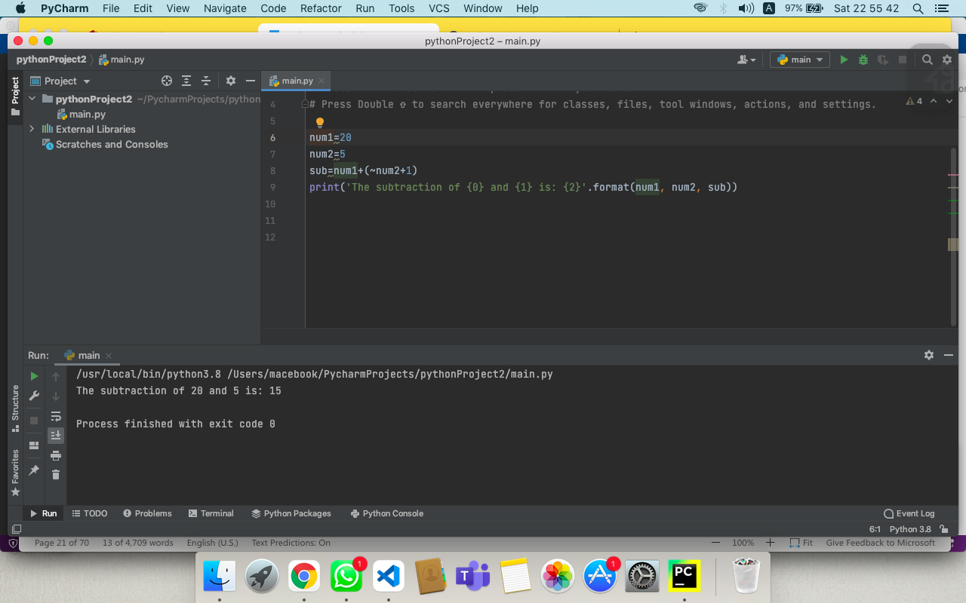

**Q. 12 Take a list of int and float valued and find sum and avg. of them.**

ANS:-

a=[1,2,3,5.0,9.0]

sum=0;

for i in range(len(a)):

sum+=a[i]

print(sum)

print(sum/(i+1))

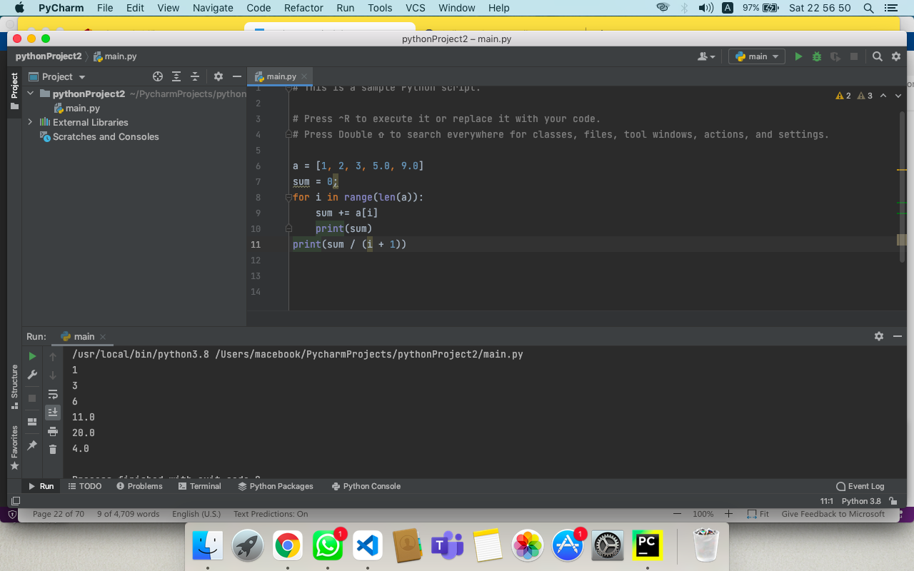

**Q.13 Take multiple input by user in one line and find avg. of them.**

ANS:-

a,b,c=(input("enter a b and c")).split()

a=int(a);

b=int(b);

c=int (c);

print((a+b+c)/3)

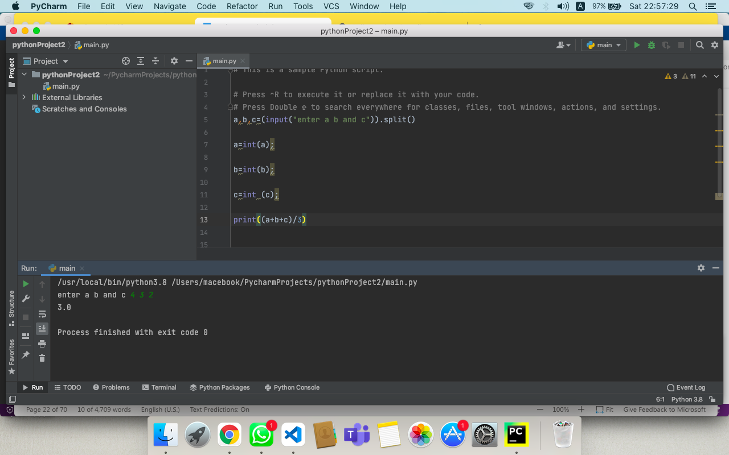

**Q.14 Take two strings like “hello” and “world” with two different variable, write program to print output without a newline. You have to use two print statement to print in same line**

ANS:-

a="hello"

b="world"

print(a,end=" ")

print(b)

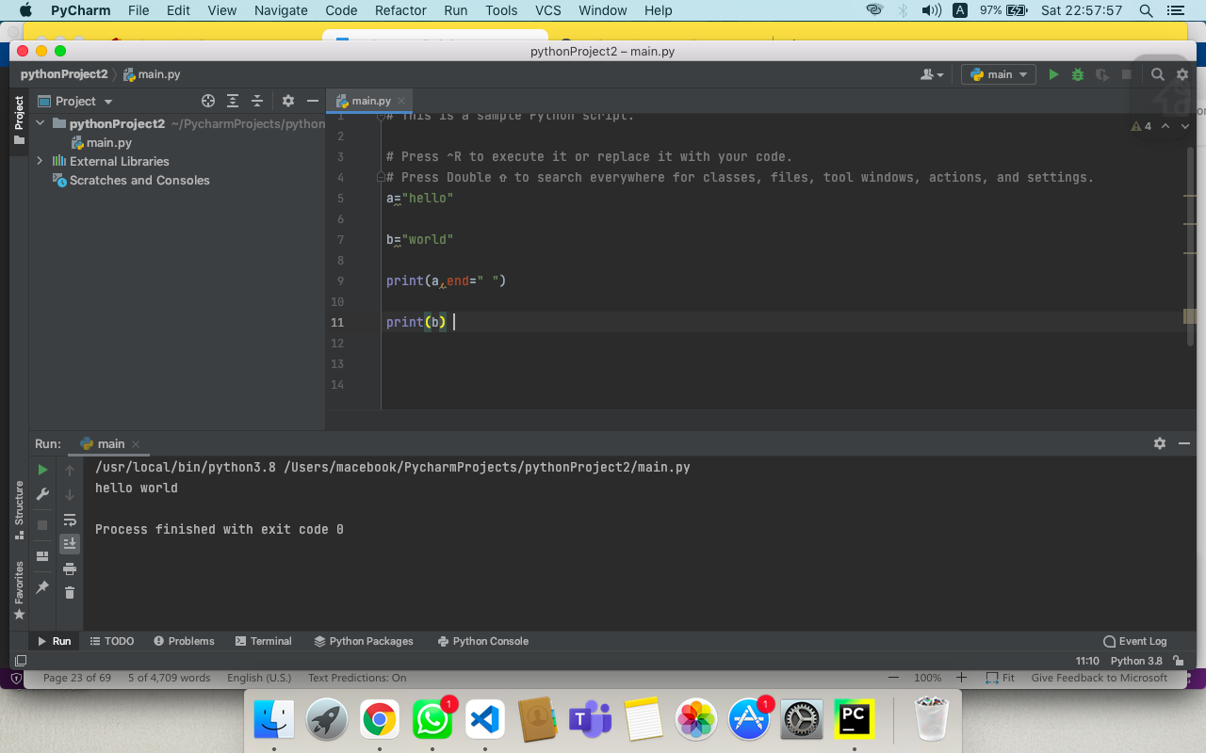

**ASSIGNMENT :- 3**

**Q1. Take a list of int and float valued and find sum and avg. of them.**

ANS:-

L = [1,2.0,6.0,4,8]

sum = 0

for i in L:

sum += i

avg = sum/len(L)

print("sum = ", sum)

print("average = ", avg)

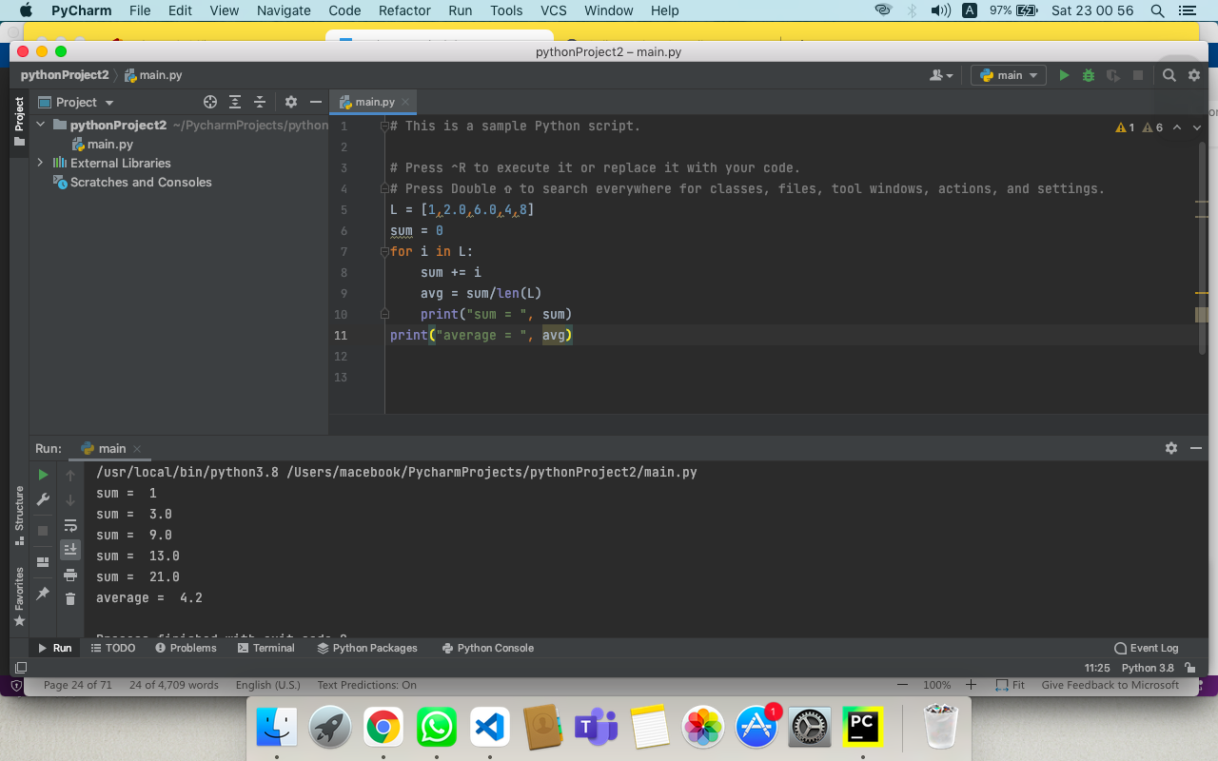

**Q2. Take multiple input by user in one line and find avg. of them.**

ANS:-

num = [int(x) for x in input('enter the numbers: ').split()]

print(sum(num))

average=sum(num)/len(num)

print(average).

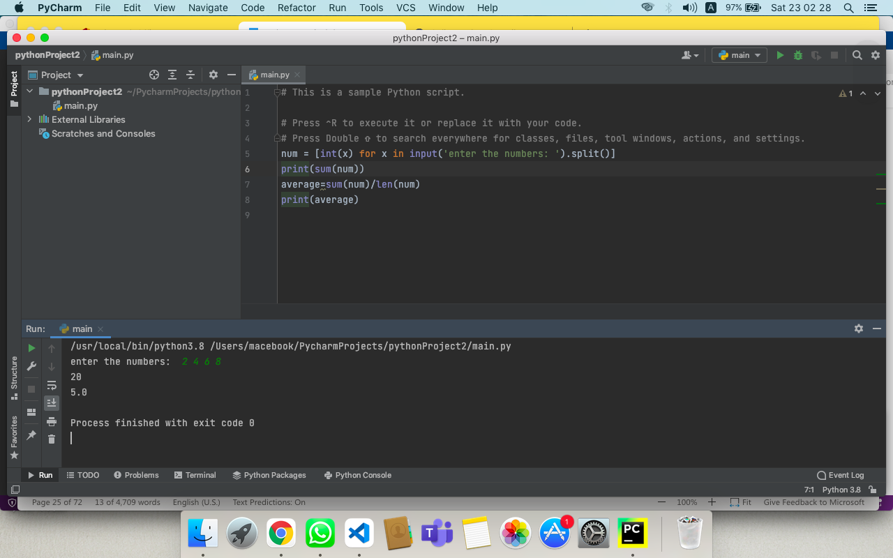

**Q3. Take two strings like “hello” and “world” with two different variable, write program to print output without a newline. You have to use two print statement to print in same line.**

ANS:-

r="hiii"

g="manas"

print(r,end=' ')

print(g)

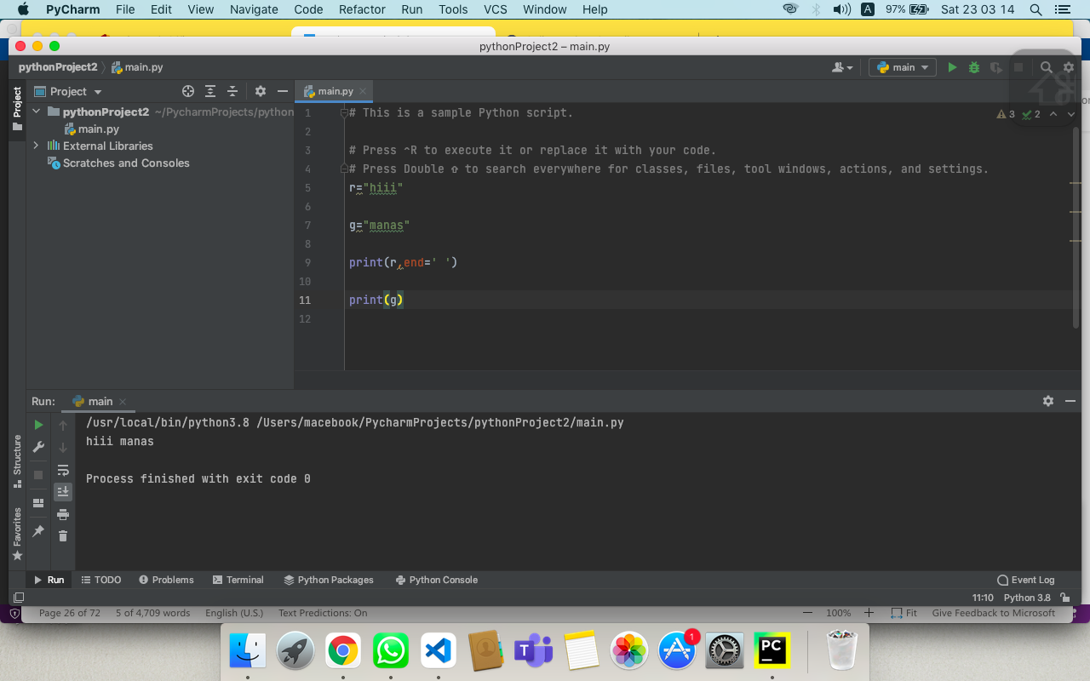

**Q4. Write a python program to perform following operation on list.**

* **Create a list of strings and add an element at the end of list.**
* **Inserts an elements at specified position (position taken by user and it should be within the range of List.)**
* **Adds contents to List2 to the end of List1**
* **Calculates total occurrence of given element of List**
* **Calculates total length of List.**
* **Returns the index of first occurrence.**
* **Perform min() and max() functions of List.**
* **Take a list of numbers and display in ascending and descending order.**
* **Perform deletion by using string and index on list.**
* **Display list items using negative indexing.**
* **Create a list of mix data and convert it into tuple.**

ANS:-

#1st part

mylist=['rajat','makes learning with fun']

mylist.append("shashankj")

print(mylist)

#2nd part

mylist.insert(2,'palak')

print(mylist)

#3d part

yourlist=[1,2,3,'frnd','relation']

#for concatenate

print(mylist+yourlist)

#length function

print(len(mylist))

#for min function

print(min([1,2,3,4]))

#for max function

print(max([1,2,3,4]))

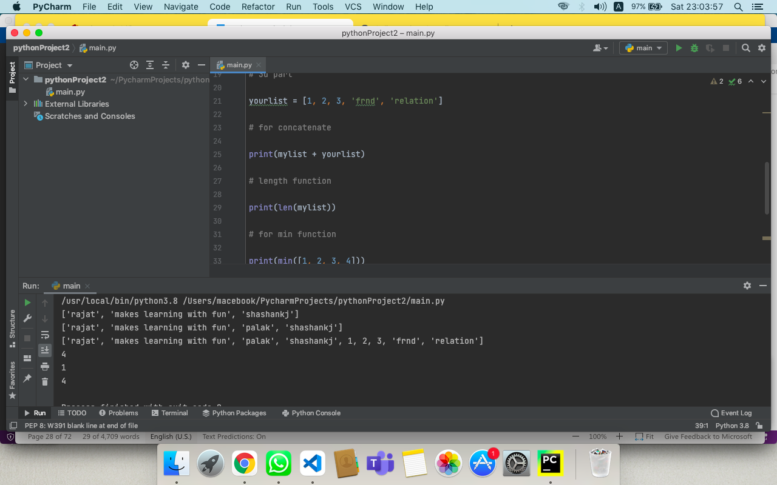

**Q5. Write a python program to perform following operation on tuple.**

* **Perform packing and unpacking on tuple items**
* **Sorting on tuple items but keep sorted items in the form of tuple only**
* **Create a tuple of single element only and display it type.**
* **Access tuple elements using indexing**
* **Create a nested tuple which contains string, list and tuple as its elements.**
* **Perform negative indexing for accessing tuple elements**

ANS:-

tup_1=(1,2,3,4)

tup=(1,2,3,4,5,6,7,8,9,10)

(time,time_1,time_2,time_3)=tup_1

print(time)

print(time_1)

tup_2=tuple(sorted(tup_1))

tup_2

tup_3=(50,)

type(tup_3)

tup[1]

tuple_mix=([1,2,3],'string',(4,5,6))

tup[-1]

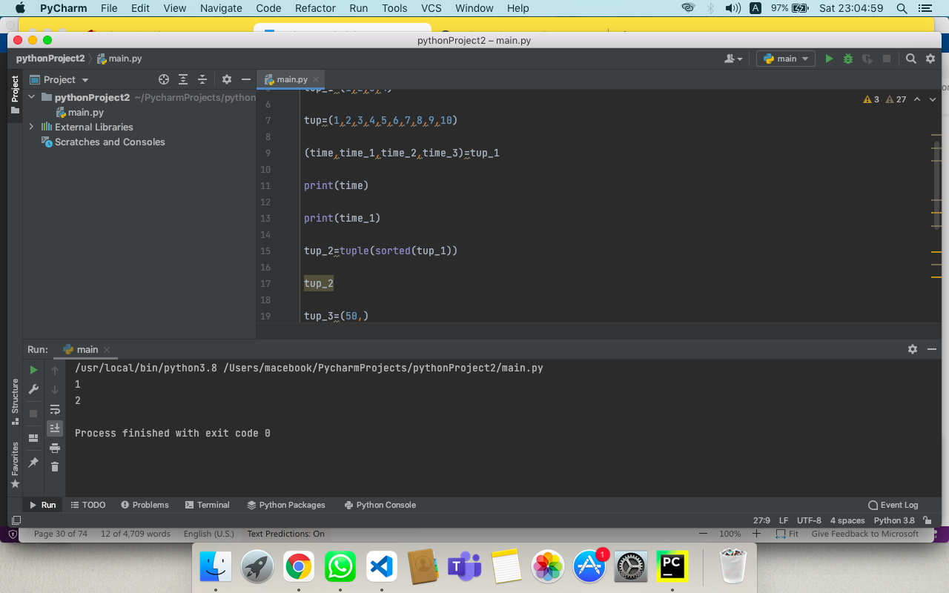

**Q6. Accessing tuple elements using slicing:**

* **elements 2nd to 4th**
* **elements beginning to 2nd**
* **elements 8th to end**
* **elements beginning to end**

ANS:-

tup=(1,2,3,4,5,6,7,8,9,10)

print(tup[2:5])

print(tup[:3])

print(tup[8:])

print(tup[:])

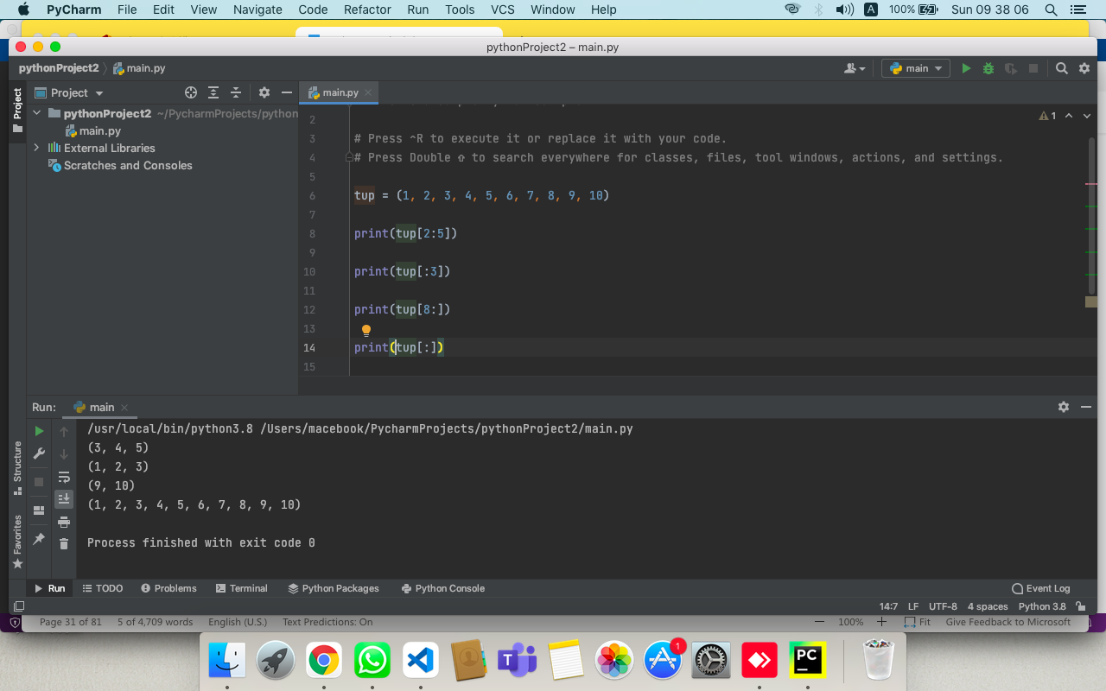

**Q7. Write a python program to combine two tuples and perform repeat operation.**

ANS:-

from itertools import repeat

a=(1,2,3,4)

b=(2,3,4)

c=a+b

res = tuple(repeat(c, 4))

print(res)

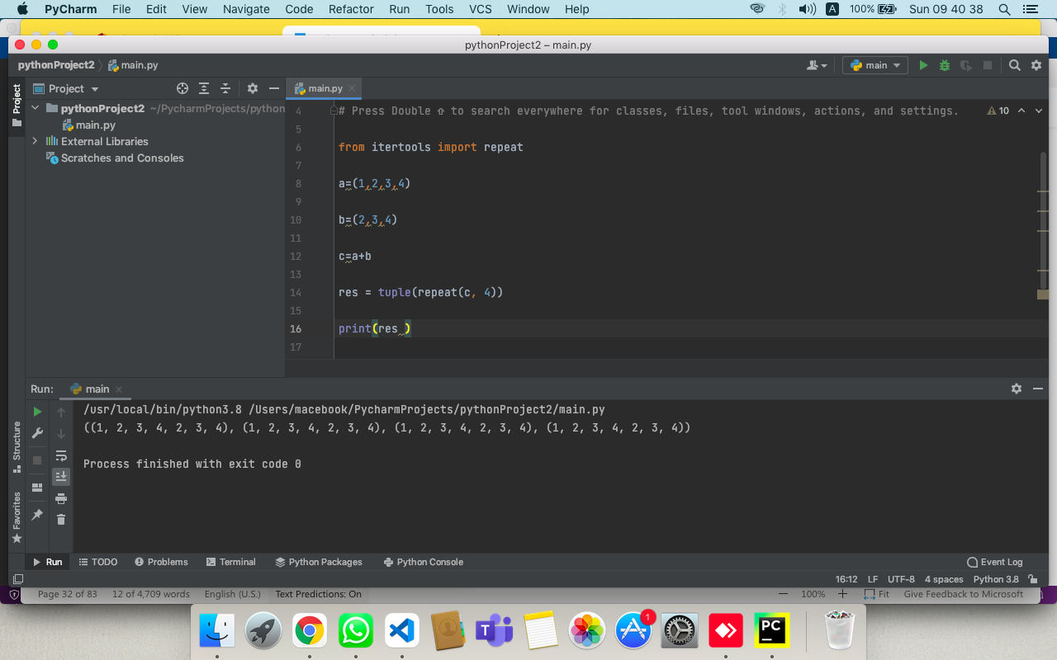

**Q8. Write a python program to perform Membership test in tuple.**

ANS:-

a=(1,2,3,4)

print("3 in number",3in a)

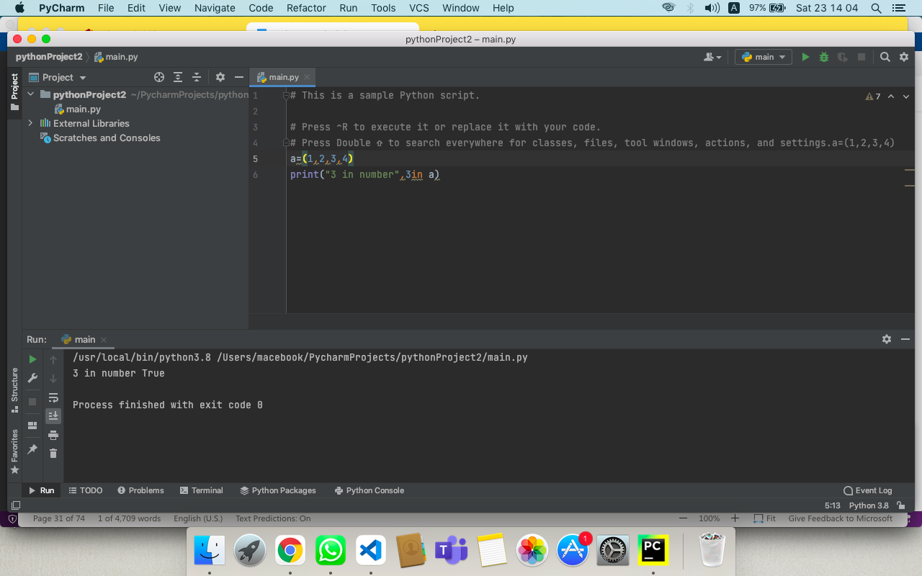

**Q9. Write a python program to perform different type of string formatting.**

ANS:-

Name="sitaRaman"  
print(Name[1:4]) #slicing  
  
print(Name.capitalize() )  
  
print(Name.casefold() )  
  
new_string=Name.center(25)  
  
print(new_string )  
  
print(Name.count('a') )  
  
print(Name.endswith('n') )  
  
print(Name.islower() )

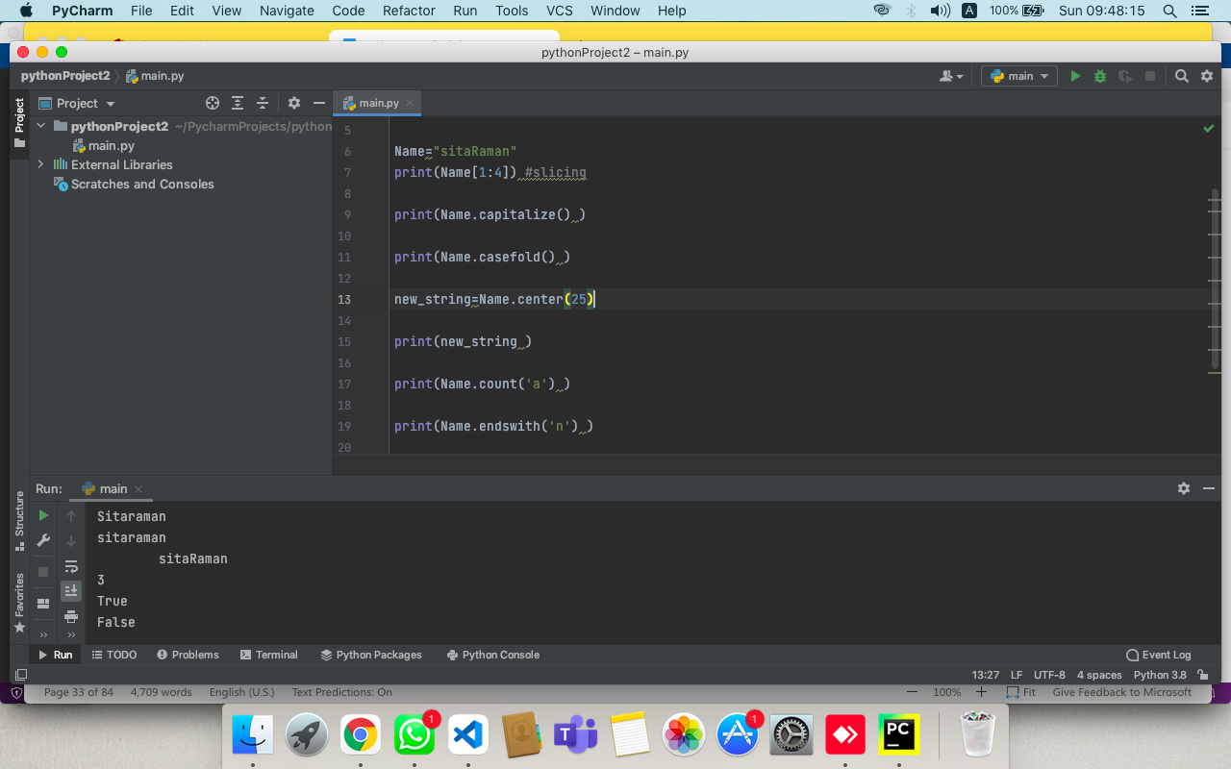

**ASSIGNMENT :- 4**

**Q1. Write a program that takes your full name as input and displays the abbreviations of the first and middle names except the last name which is displayed as it is. For example, if your name is Ram Kumar Sharma, then the output should be R. K. Shrama.**

ANS:-

str=input("Enter a your full name:")

list1=str.split(" ")

print(list1[0][0],list1[1][0],list1[2])

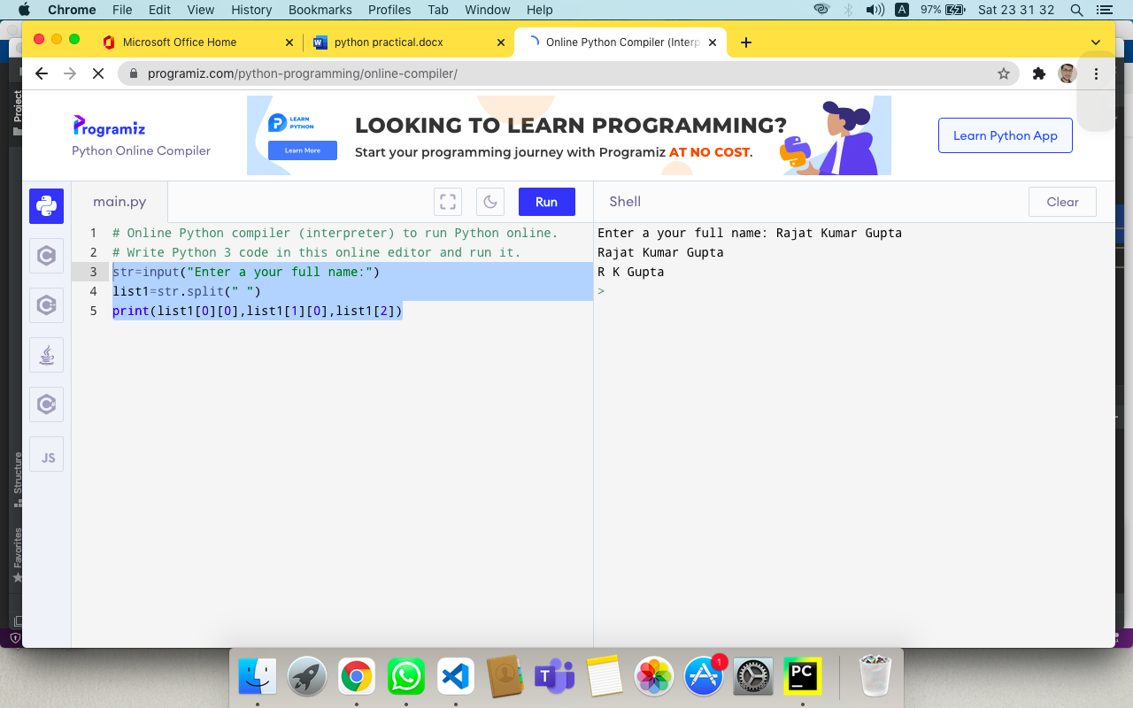

**Q2. Check the occurrence of the letter 'e' and the word 'is' in the sentence "This is umbrella".**

ANS:-

a="This is umbrella"

print(a.count("e"))

print(a.count("is")).

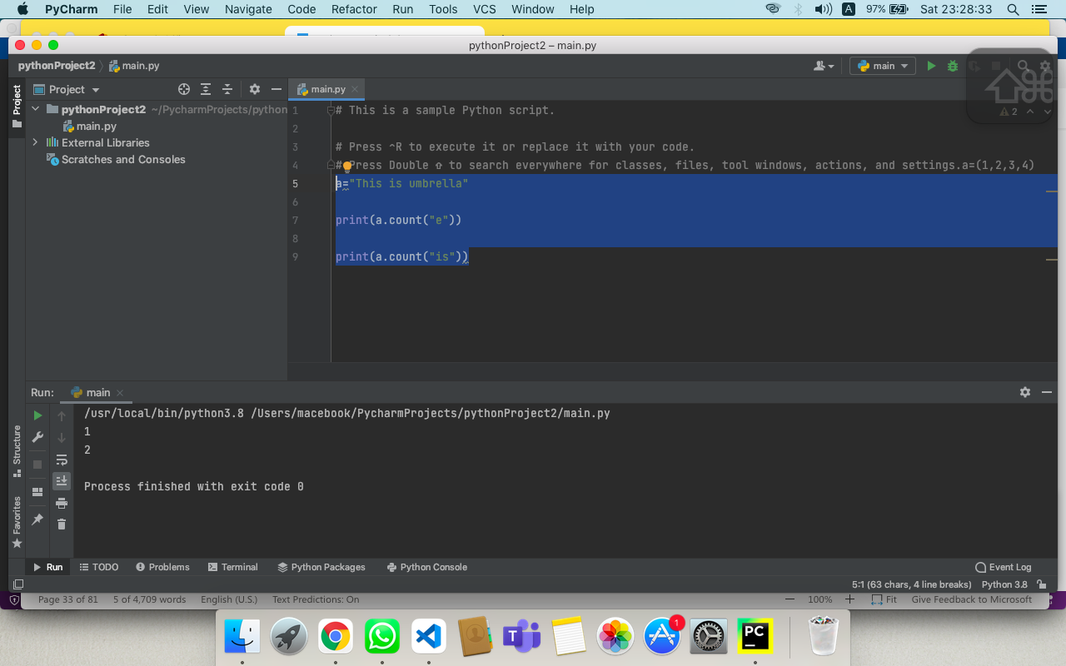

**Q3. Remove items from set1 that are not common to both set1 and set2**

ANS:-

a={1,3,5,7}

b={1,2,3,4,5}

s=(a & b)

print(s)

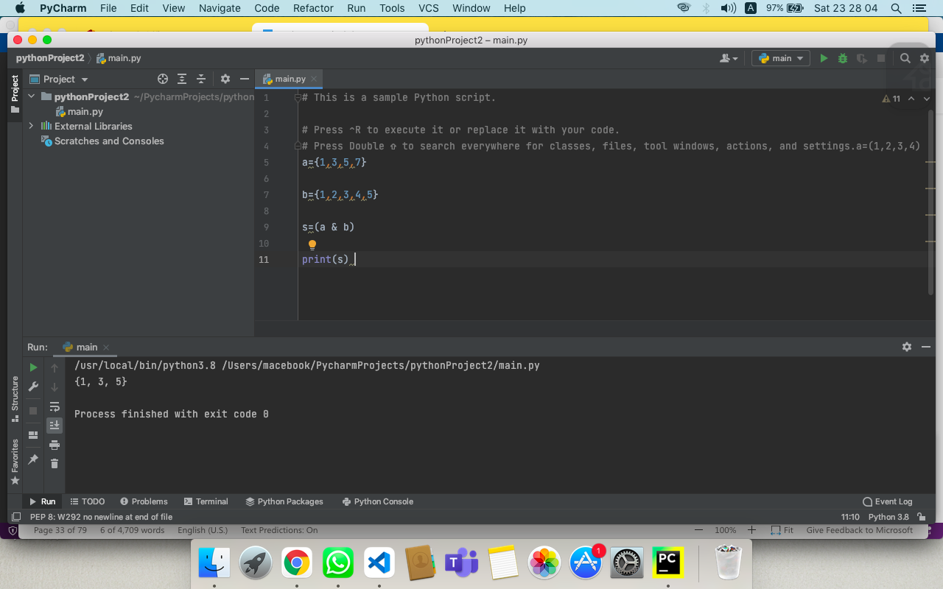

**Q4. Write a program to check if the word 'orange' is present in the "This is orange juice".**

ANS:-

a="This is orange juice"

print("orange" in a)

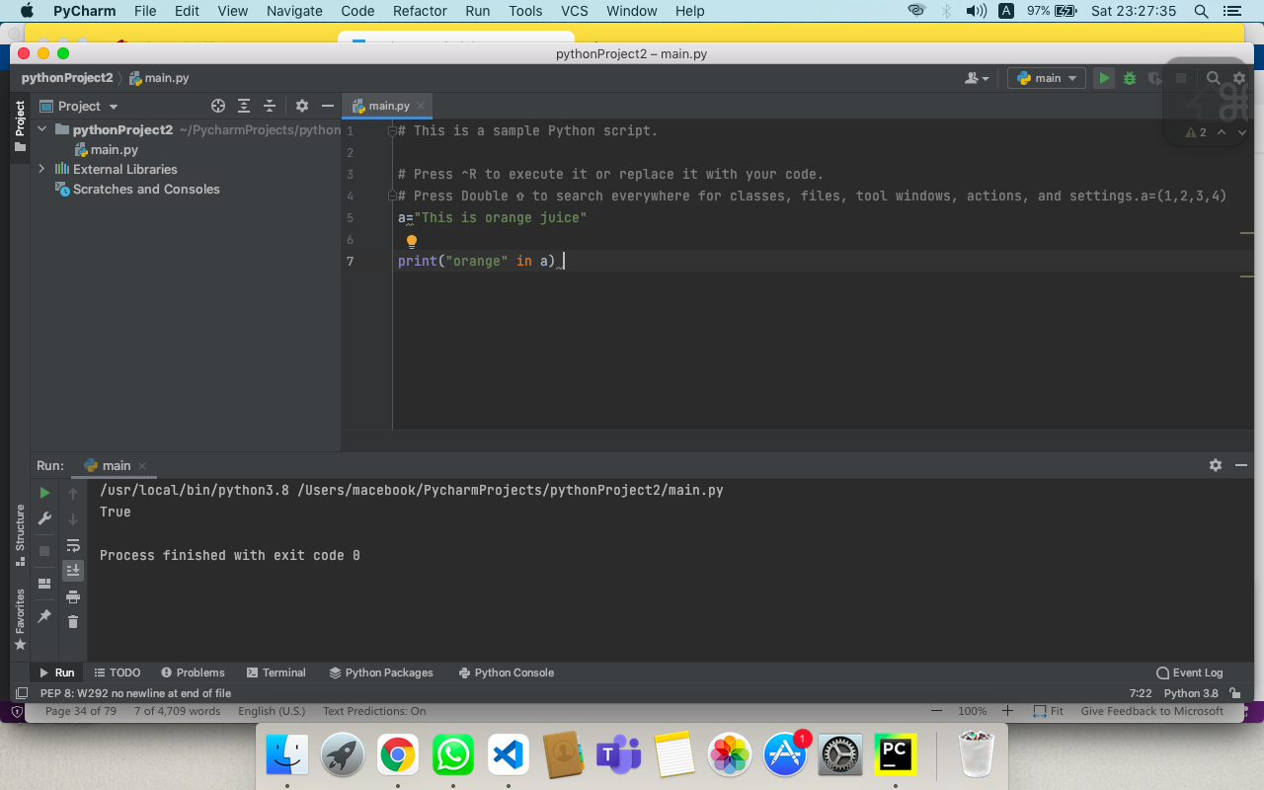

**Q5. Write a program to find the length of the string "refrigerator" without using len function.**

ANS:-

a="refrigerator"

num=0

for i in a:

num=num+1

print(num)

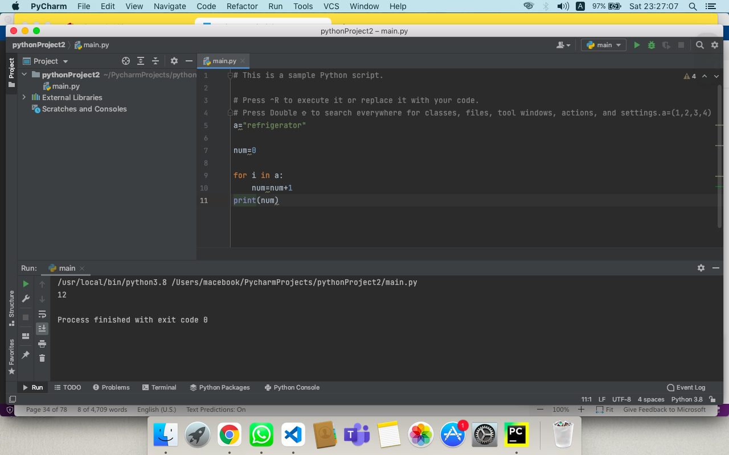

**Q6. Write a program to print every character of a string entered by user in a new line using loop.**

ANS:-

a = input()

for i in a:

print(i)

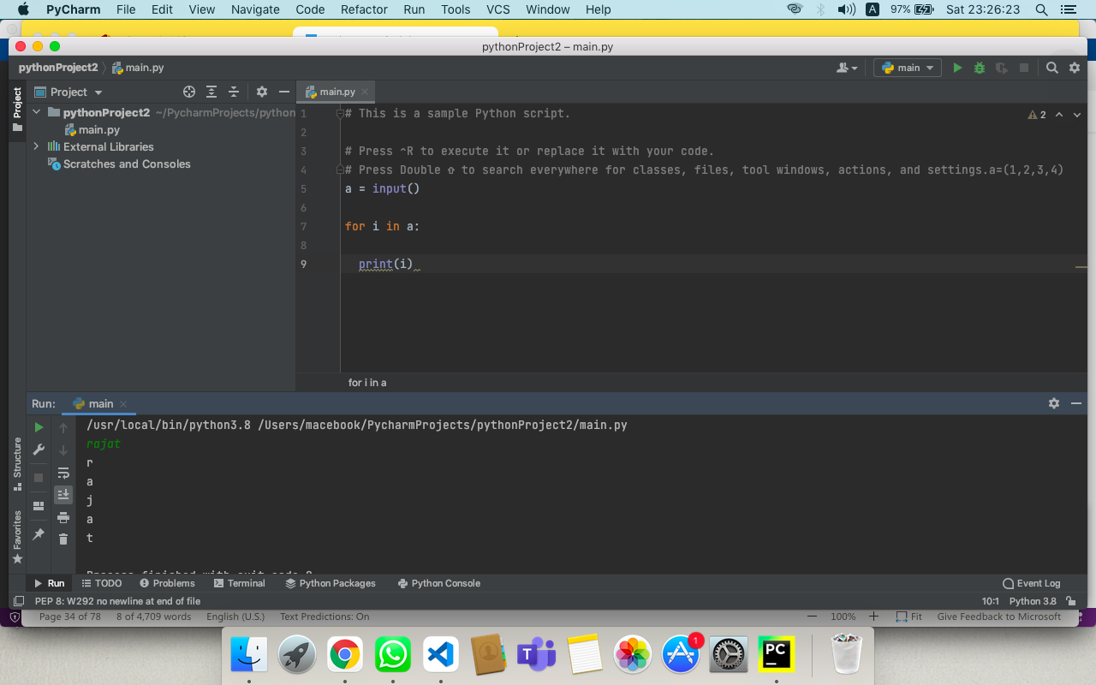

**Q7. Add a list of elements to a given set**

ANS:-

a={1,2,3,4,5}

a.update([6,7,8])

print(a)

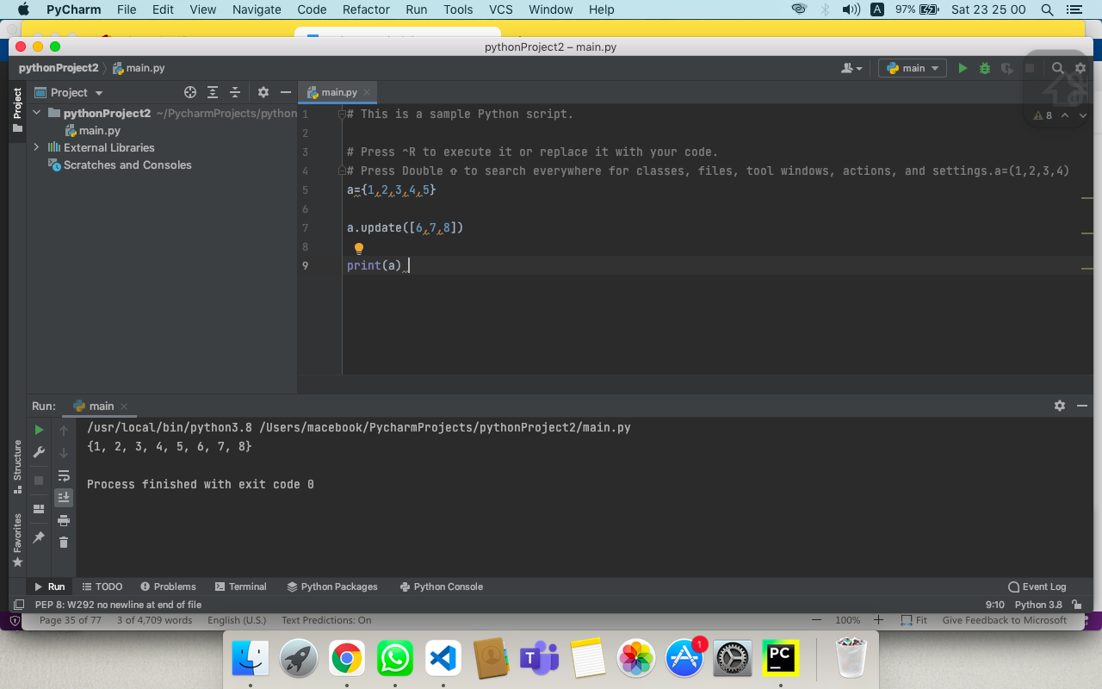

**Q8. Return a new set of identical items from a given two set.**

ANS:-

a= {10, 20, 30, 40, 50}

b= {30, 40, 50, 60, 70}

s=(a & b)

print(s).

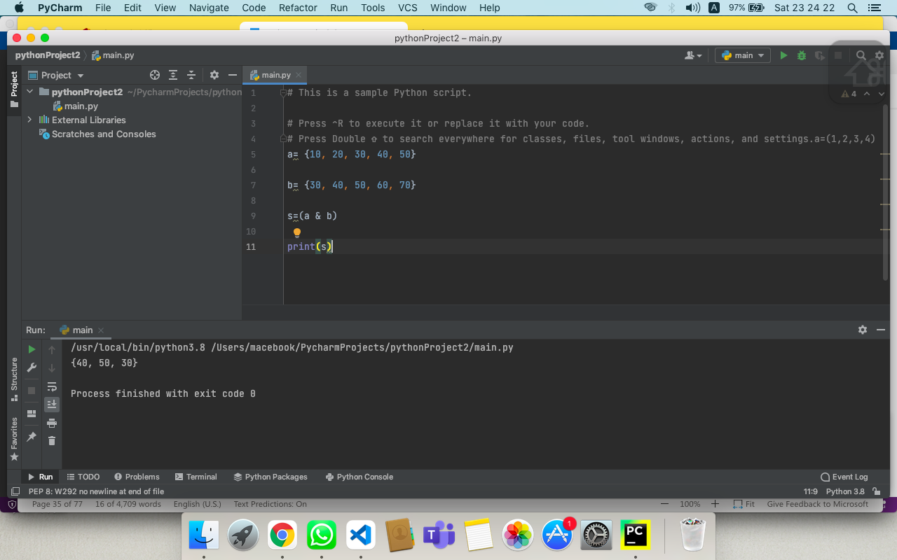

**Q9. Returns a new set with all items from both sets by removing duplicates.**

ANS:-

set1 = {10, 20, 30, 40, 50}

set2 = {30, 40, 50, 60, 70}

**print**(set1.intersection(set2))

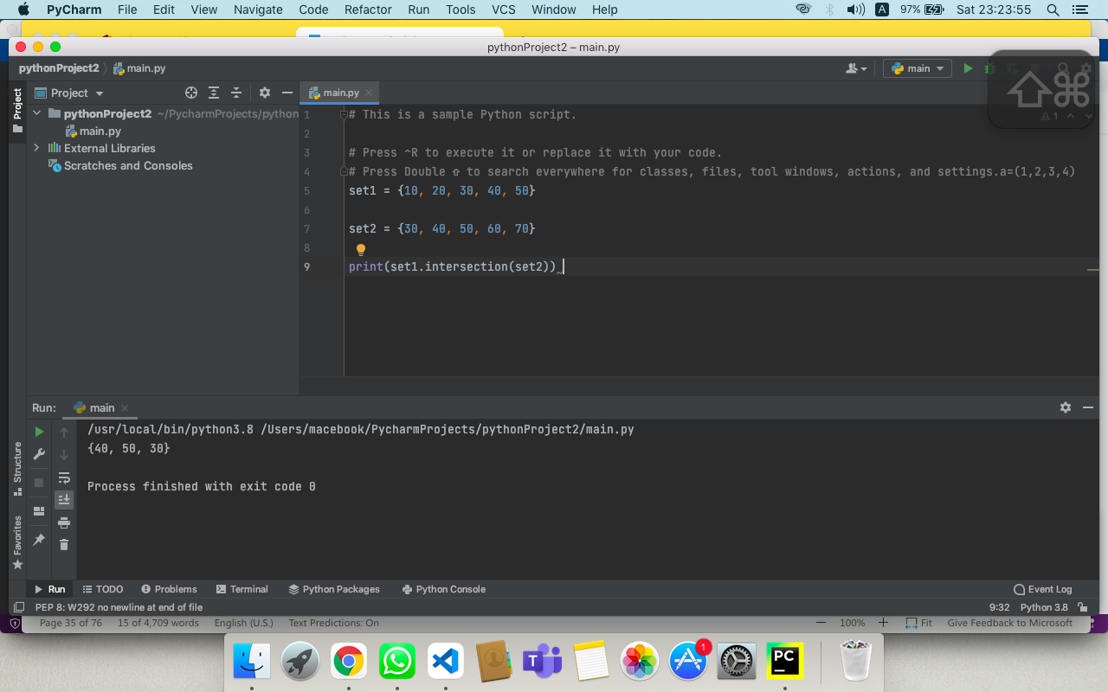

**Q10. Given two Python sets, update the first set with items that exist only in the first set and not in the second set.**

ANS:-

a = {10, 20, 30}

b = {20, 40, 50}

a.difference_update(b)

print(a).

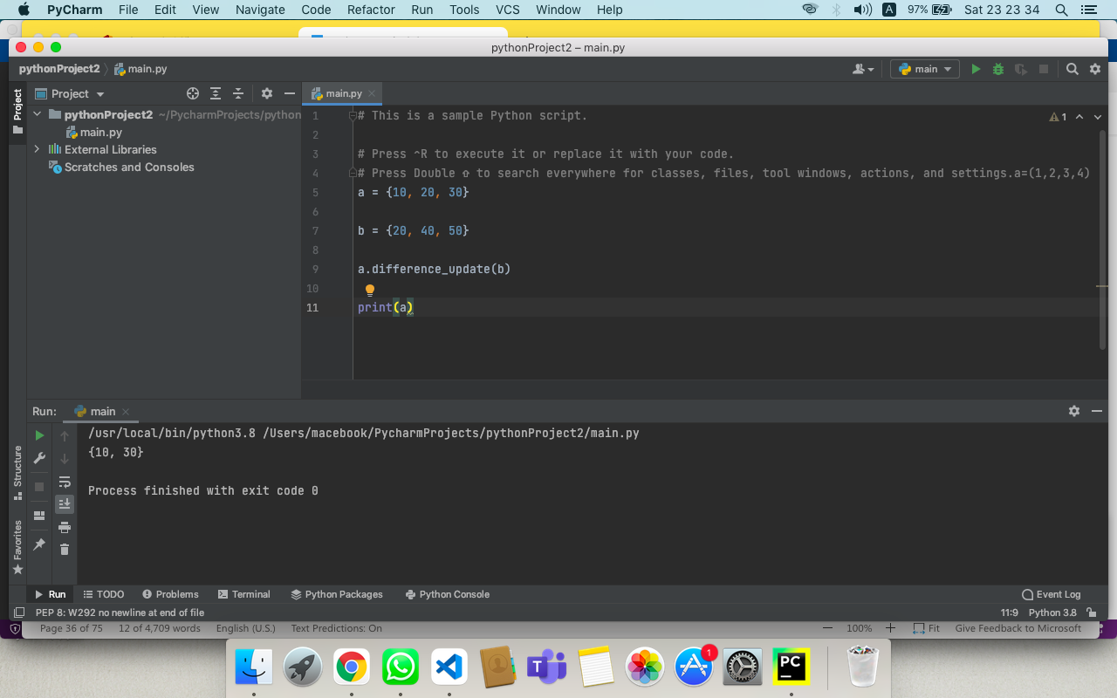

**Q11. Remove items 10, 20, 30 from the following set at once**

**set1 = {10, 20, 30, 40, 50}.**

ANS:-

a = {10, 20, 30, 40, 50}

a.difference_update({10, 20, 30})

print(a)

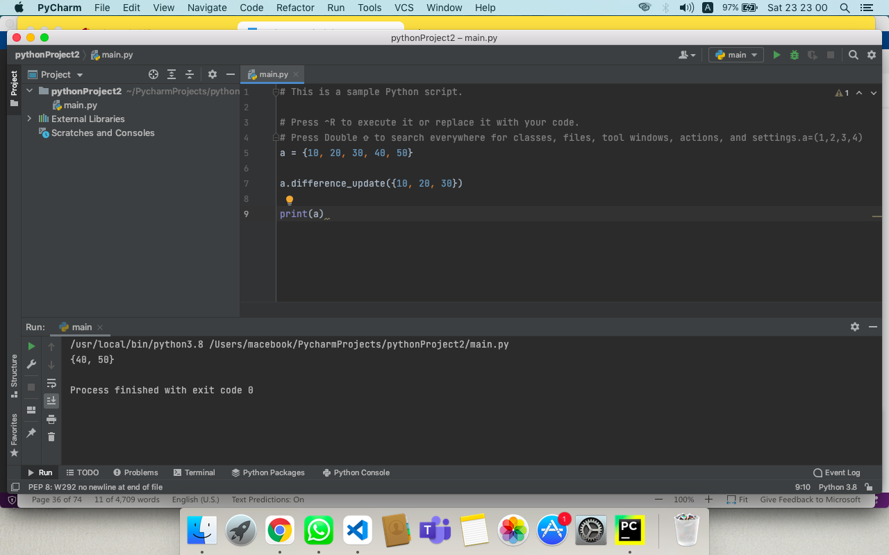

**Q12. Return a set of all elements in either A or B, but not both**

ANS:-

set1 = {2, 4, 5, 6}

set2 = {4, 6, 7, 8}

print(set1.symmetric_difference (set2))

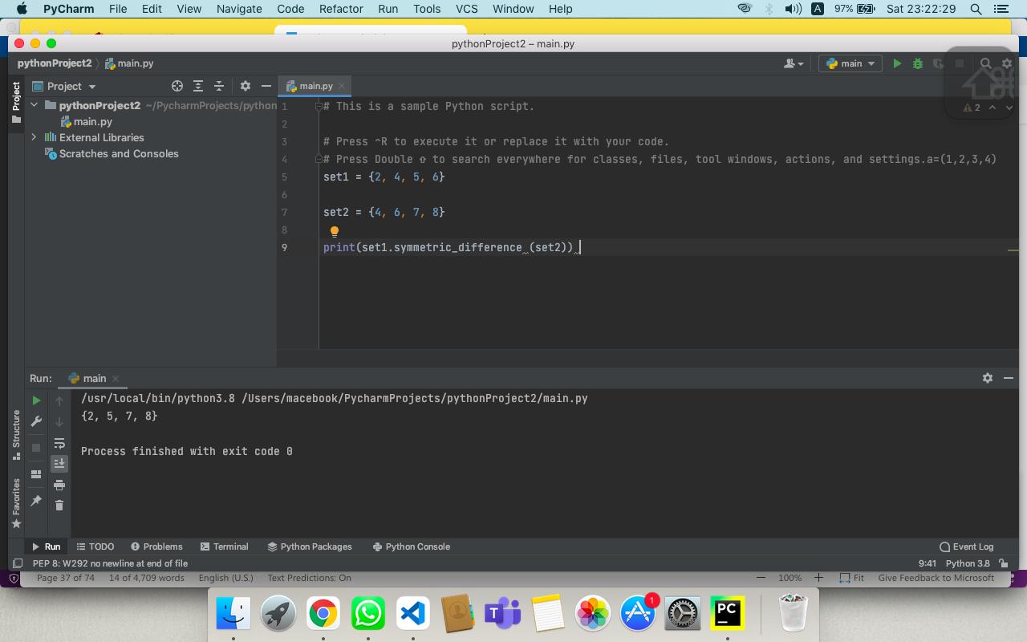

**Q13. Check if two sets have any elements in common. If yes, display the common elements.**

ANS:-

a = { 20, 30, 40, 50}

b = {60, 70, 80, 20}

if a.isdisjoint(b):

print("Two sets have no items in common")

else:

print("Two sets have items in common")

print(a.intersection(b))

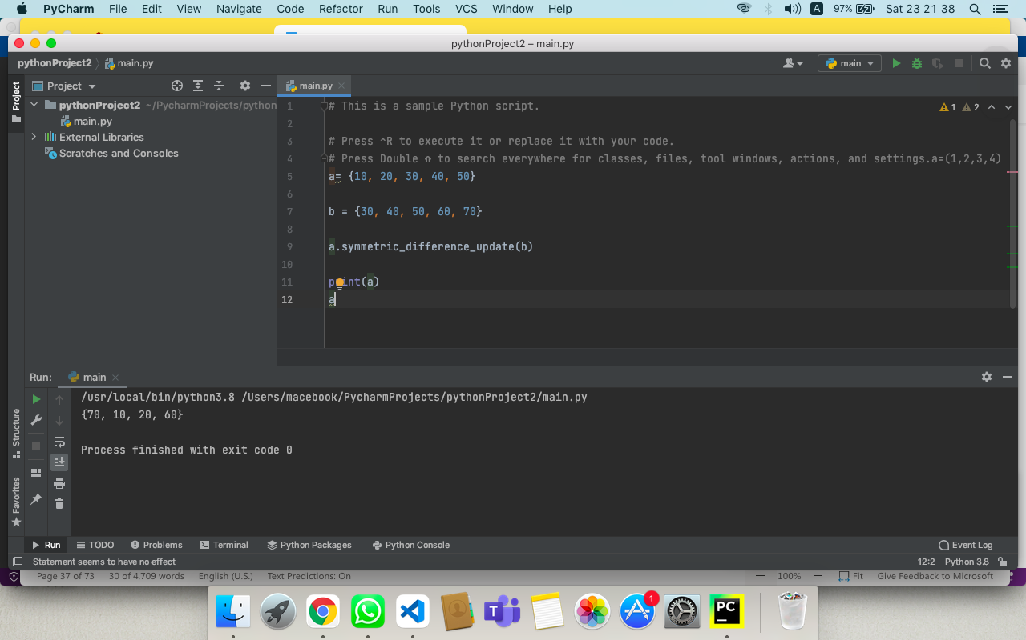

**Q14. Update set1 by adding items from set2, except common items**

ANS:-

a = {10, 20, 30, 40, 50}

b = {30, 40, 50, 60, 70}

a.symmetric_difference_update(b)

print(a)

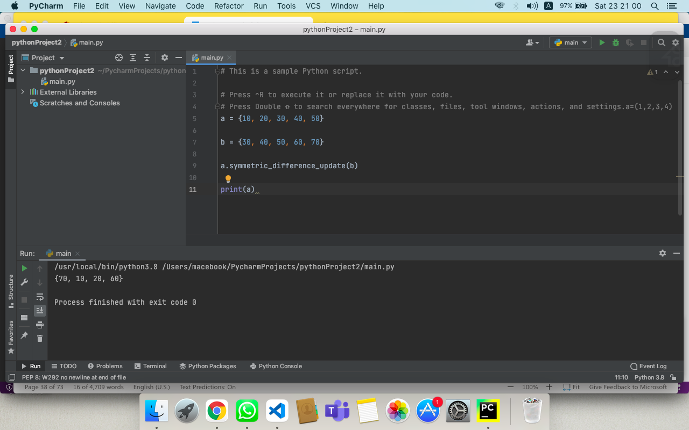

**Q15. Below are the two lists convert it into the dictionary**

**keys = ['Ten', 'Twenty', 'Thirty']**

**values = [10, 20, 30]**

ANS:-

keys = ['Ten', 'Twenty', 'Thirty']

values = [10, 20, 30]

res_dict = dict(zip(keys, values))

print(res_dict).

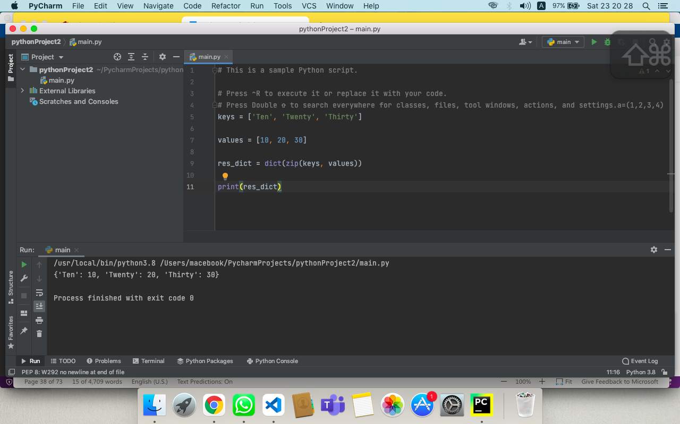

**Q16. Merge following two Python dictionaries into one**

**dict1 = {'Ten': 10, 'Twenty': 20, 'Thirty': 30}**

**dict2 = {'Thirty': 30, 'Fourty': 40, 'Fifty': 50}**

ANS:-

dict1 = {'Ten': 10, 'Twenty': 20, 'Thirty': 30}

dict2 = {'Thirty': 30, 'Fourty': 40, 'Fifty': 50}

dict3 = {**dict1, **dict2}

print(dict3).

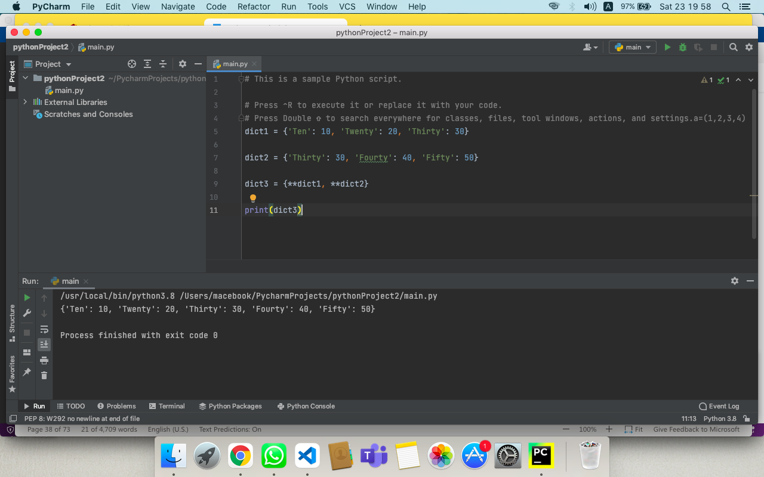

**ASSIGNMENT :- 5**

**Q1. Write a Python program to find those numbers which are divisible by 7 and multiple of 5, between 1500 and 2700 (both included).**

ANS:-

nl=[]

for x in range(1500, 2701):

if (x%7==0) and (x%5==0):

nl.append(str(x))

print (','.join(nl))

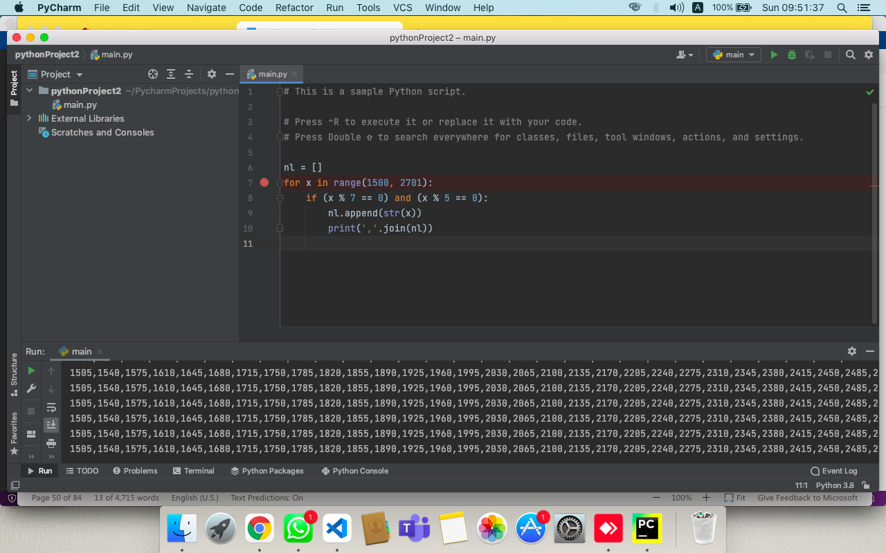

**Q2. Write a Python program to convert temperatures to and from celsius, fahrenheit.**

ANS:-

celsius_1 = float(input("Temperature value in degree Celsius: " ))

Fahrenheit_1 = (celsius_1 * 1.8) + 32

**print**('The %.2f degree Celsius is equal to: %.2f Fahrenheit' %(celsius_1, Fahrenheit_1))

**print**("----OR----")

celsius_2 = float (input("Temperature value in degree Celsius: " ))

Fahrenheit_2 = (celsius_2 * 9/5) + 32

**print** ('The %.2f degree Celsius is equal to: %.2f Fahrenheit'

%(celsius_2, Fahrenheit_2))

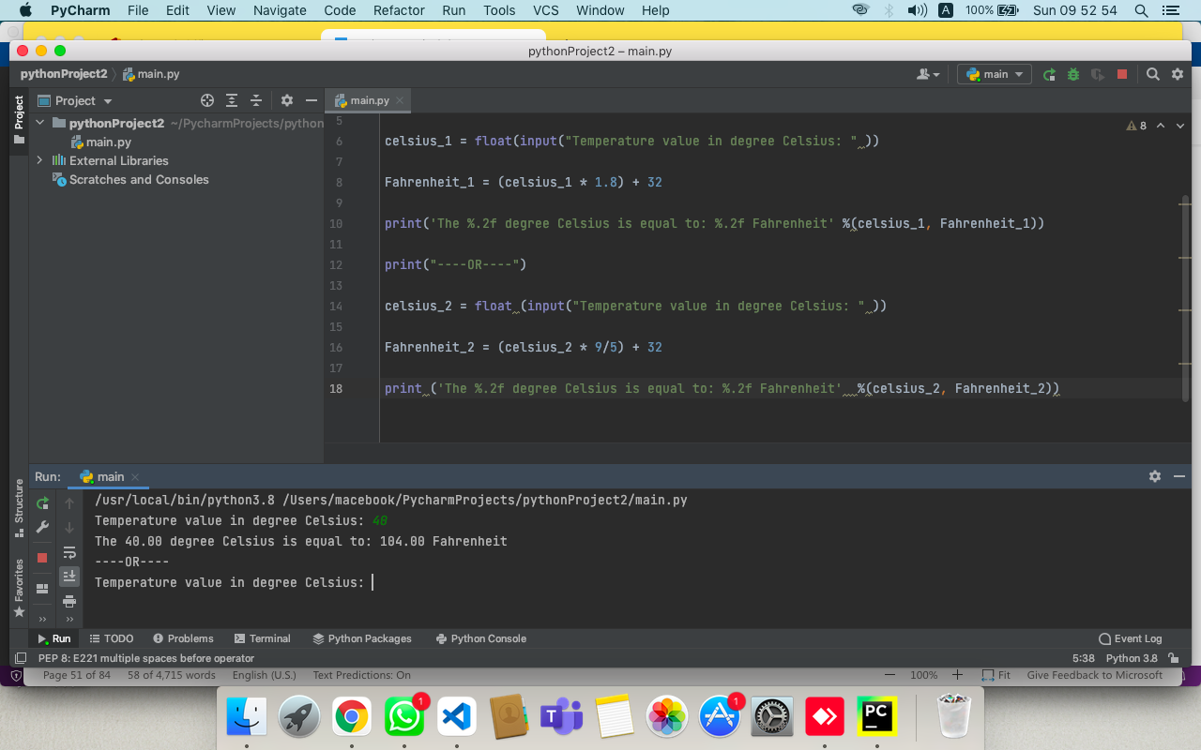

**Q3. Write a Python program to construct the following pattern, using a nested for loop.**

**\***   
**\* \***   
**\* * \***   
**\* * * \***   
**\* * * * \***   
**\* * * \***   
**\* * \***   
**\* \***   
**\***

ANS:-

n=5;

for i in range(n):

for j in range(i):

print ('* ', end="")

print('')

for i in range(n,0,-1):

for j in range(i):

print('* ', end="")

print('')

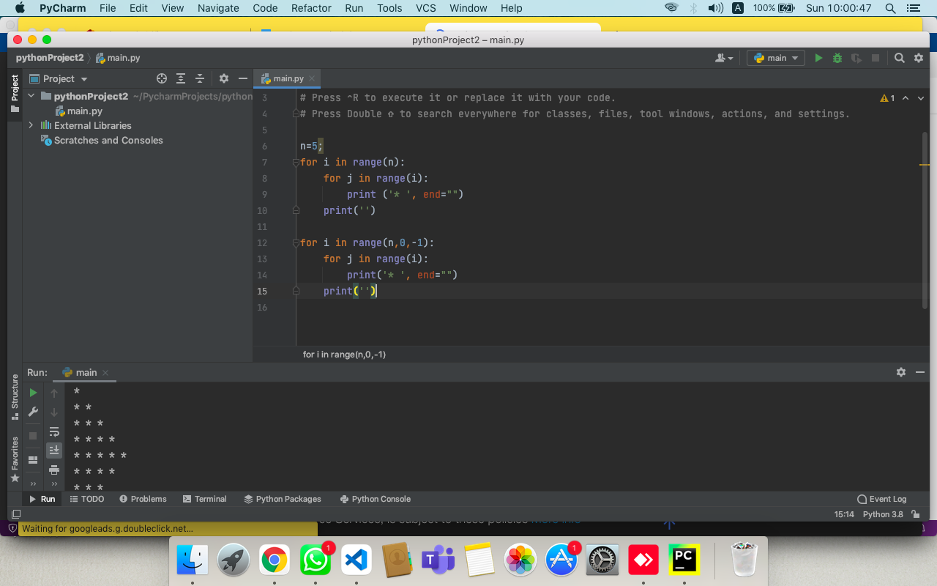

**Q4. Write a Python program that accepts a word from the user and reverse it.**

ANS:-

word = input("Input a word to reverse: ")

for char in range(len(word) - 1, -1, -1):

print(word[char], end="")

print("\n")

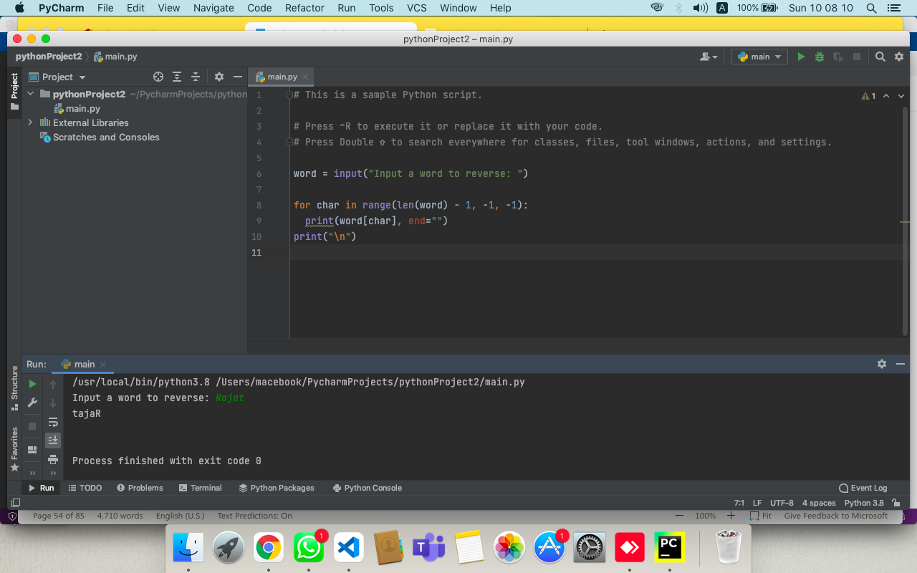

**Q5. Write a Python program to count the number of even and odd numbers from a series of numbers(tuple).**  
ANS:-

tuple1 = (1,2,3,4,5)

c1=0

c2=0

for num in range (len (tuple1)):

if(tuple1 [num]%2==0):

c1+=1

else:

c2+=1

print('Even number = %d'%c2)

print('Odd number = %d'%c1)

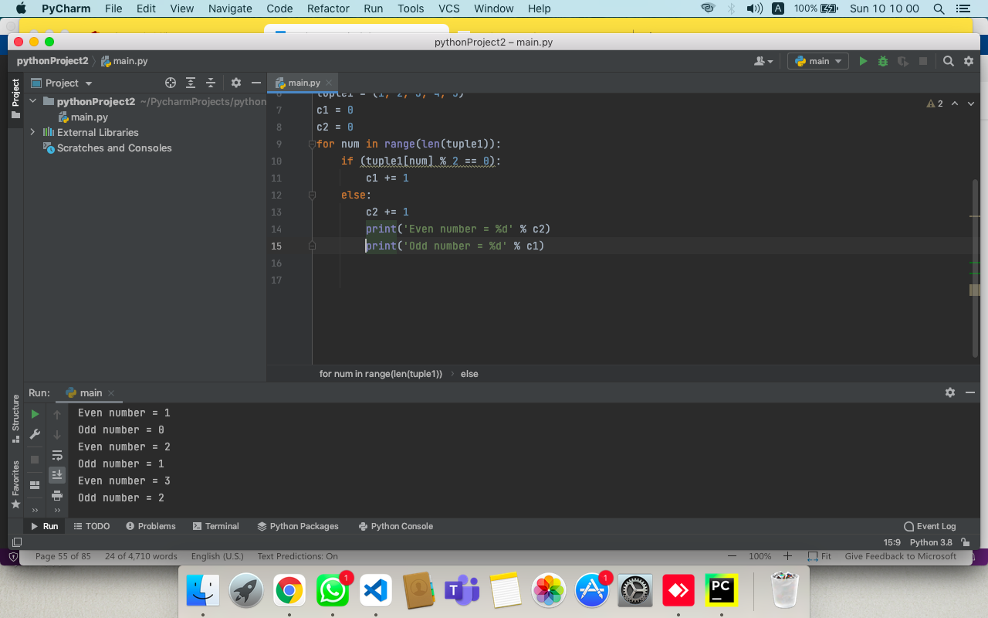

**Q6. Write a Python program that prints each item and its corresponding type from the following list**

***Sample List* : datalist = [1452, 11.23, 1+2j, True, 'resource', (0, -1), [5, 12], {"class":'V', "section":'A'}]**

ANS:-

sample_list = [123, 'Rajat', True, (0, -1),{"key1":"value1"}]

for i in range (len (sample_list)):

print (sample_list[i])

print (type (sample_list[i]))

print('\n')

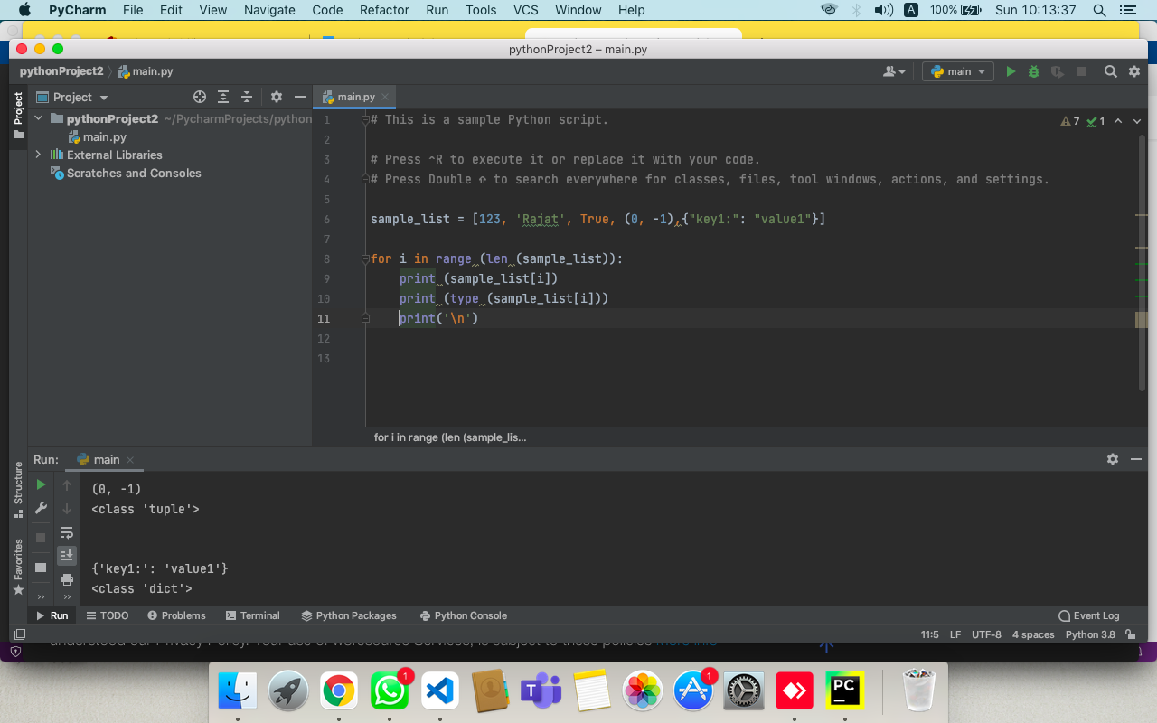

**Q7. Write a Python program that prints all the numbers from 0 to 6 except 3 and 6.**

ANS:-

for a in range (0,7):

if(a%3!=0):

print (a)

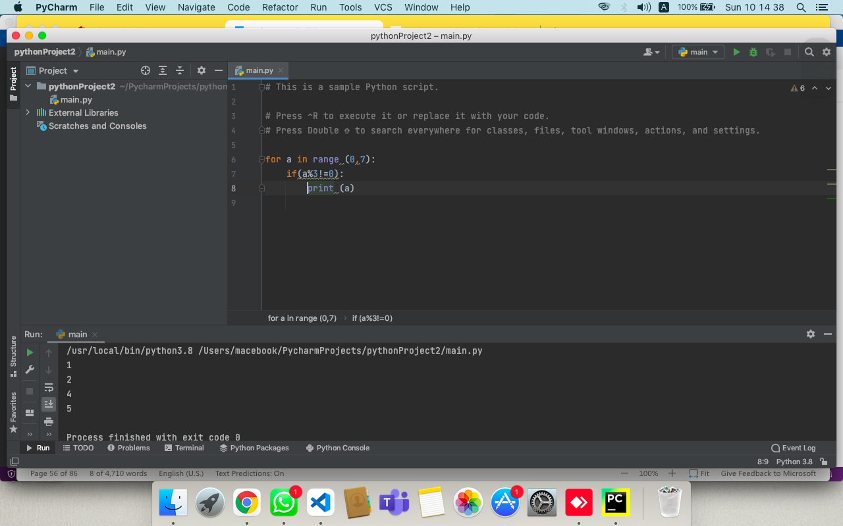

**Q8. Write a Python program to get the Fibonacci series between 0 to 50.**

ANS:-

x,y=0,1

while y<50:

print(y)

x,y = y,x+y

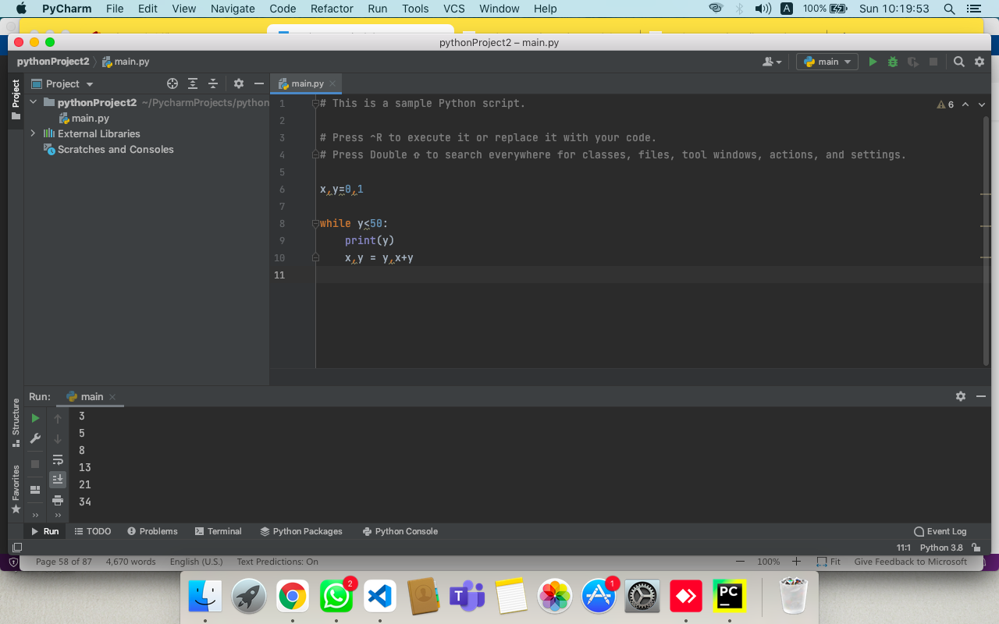

**Q9. Write a Python program which iterates the integers from 1 to 50. For multiples of three print "Fizz" instead of the number and for the multiples of five print "Buzz". For numbers which are multiples of both three and five print "FizzBuzz".**

ANS:-

for i in range (1,50):

if(i%3-0 and 1%5==0):

print("Fizzbuzz");

elif(i%3==0):

print("Fizz");

elif(i%5==0):

print("Buzz");

else:

print(i)

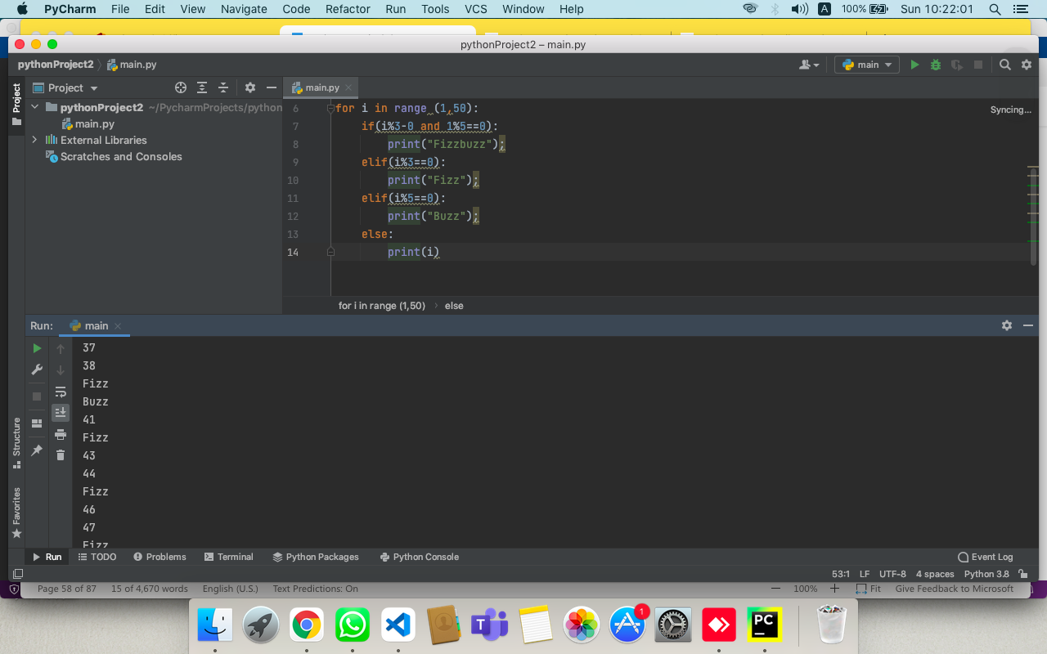

**Q10. Write a Python program which accepts a sequence of comma separated 4 digit binary numbers as its input and print the numbers that are divisible by 5 in a comma separated sequence.**

ANS:-

b_num = input(" enter sets of binary numbers")  
  
numbers = [x for x in b_num.split(',')]  
binary_divisible_by_5 = []  
  
for b in numbers:  
 binary_int = int(b, 2)  
 if not binary_int % 5:  
 binary_divisible_by_5.append(b)  
  
print("The list of numbers that are divisible by 5: ")  
print(','.join(binary_divisible_by_5))

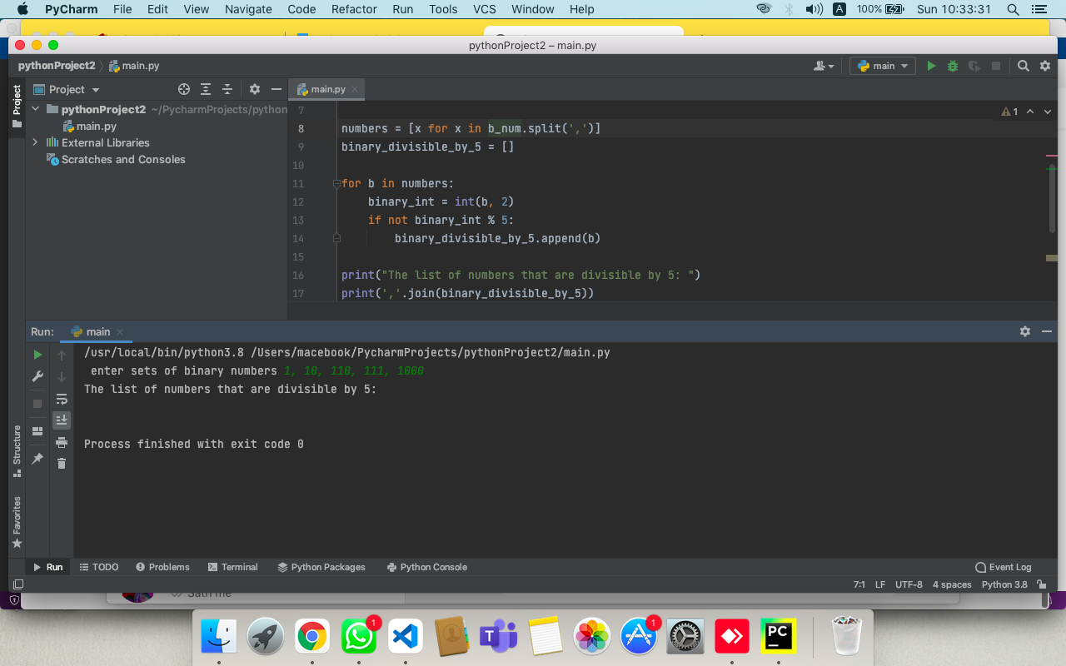

**ASSIGNMENT :- 6**

**Q1. Write a Python function to find the Max of three numbers.**

ANS:-

n1=int(input("Enter first number: "));  
n2=int(input("Enter second number: "));  
n3=int(input("Enter Third number: "));  
  
def f():  
 if(n1>=n2) and (n1>=n3):  
 l=n1  
 elif(n2>=n1) and (n2>=n3):  
 l=n2  
 else:  
 l=n3  
 print("Largest number among the three is",l)  
f()

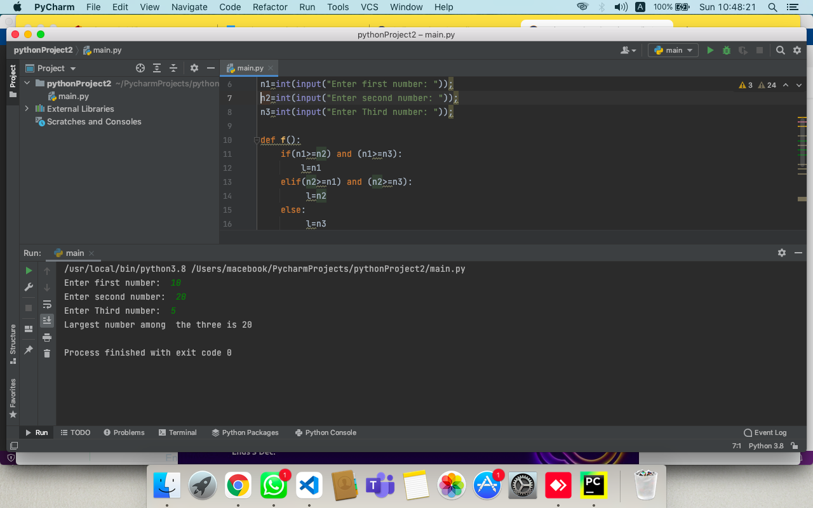

**Q2. Write a Python function to sum all the numbers in a list.**

ANS:-

# creating a list  
list1 =[11, 5, 17, 18, 23]

total = 0  
for ele in range(0, len(list1)):  
 total = total + list1[ele]  
  
# printing total value  
print("Sum of all elements in given list: ", total)

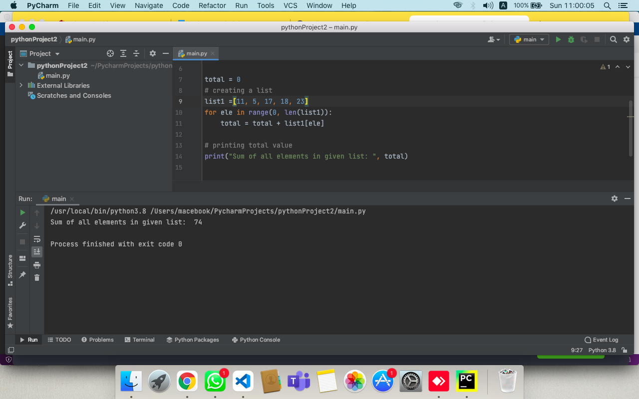

**Q3. Write a Python function to reverse a string.**

ANS:-

def reverse(s):  
 if len(s) == 0:  
 return s  
 else:  
 return reverse(s[1:]) + s[0]  
  
  
s = "RajatGupta"  
  
print("The original string is : ", end="")  
print(s)  
  
print("The reversed string(using recursion) is : ", end="")  
print(reverse(s))

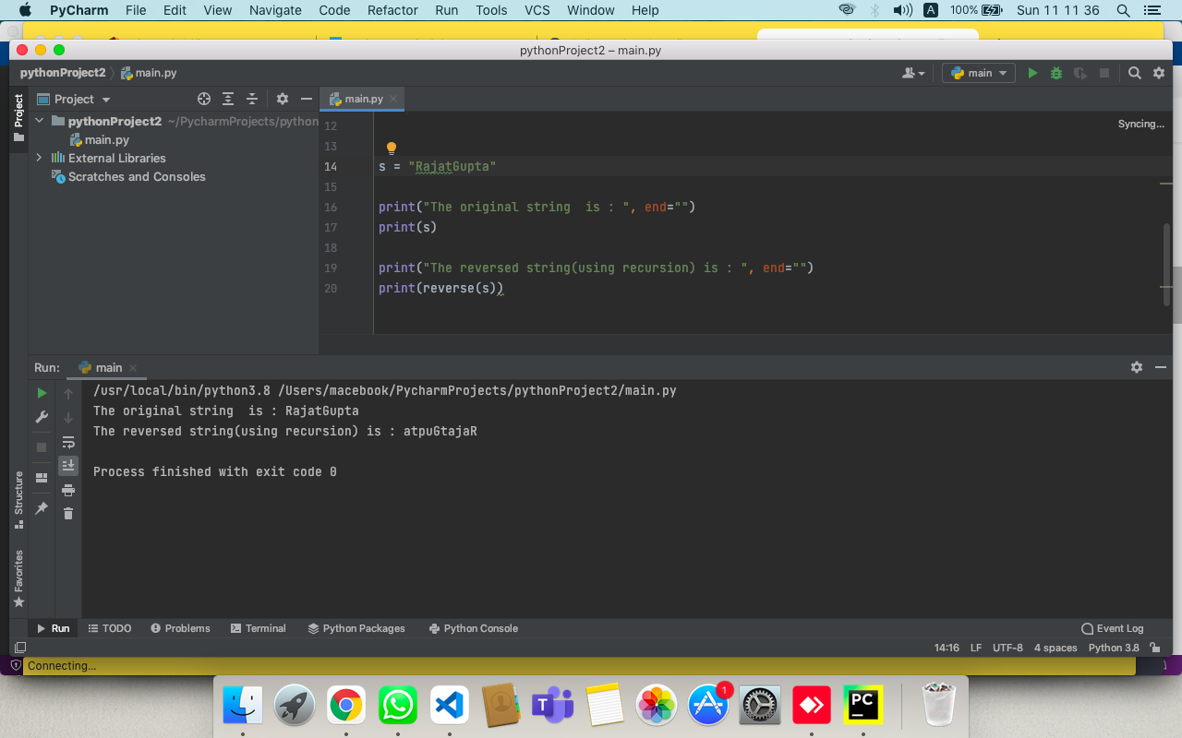

**Q4. Write a Python function to check whether a number falls in a given range.**

ANS:-

def test_range(n):

if n in range(3,9):

print( " %s is in the range"%str(n))

else :

print("The number is outside the given range.")

test_range(5)

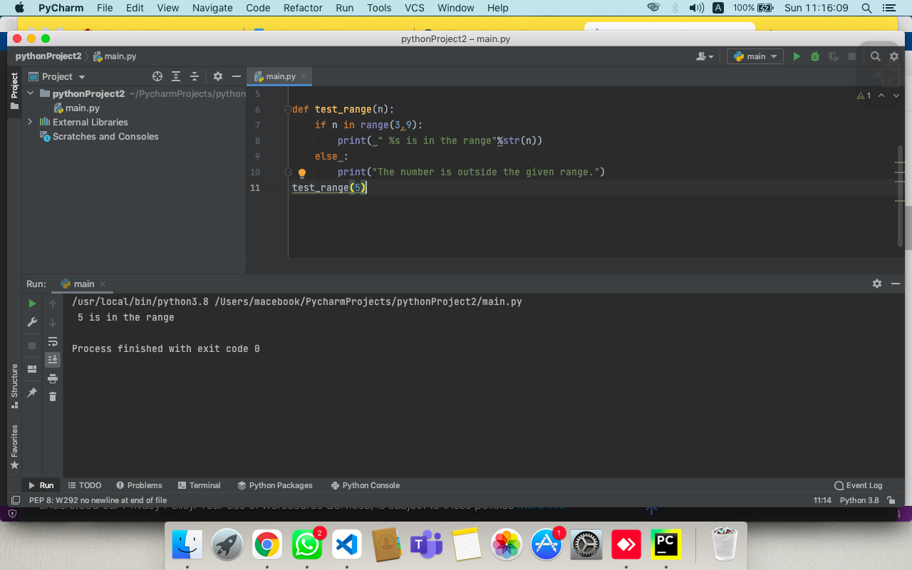

**Q5. Write a Python function that takes a list and returns a new list with unique elements of the first list.**

ANS:-

def f(l):

x = []

for a in l:

if a not in x:

x.append(a)

return x

print(f([1,2,3,3,3,3,4,5]))

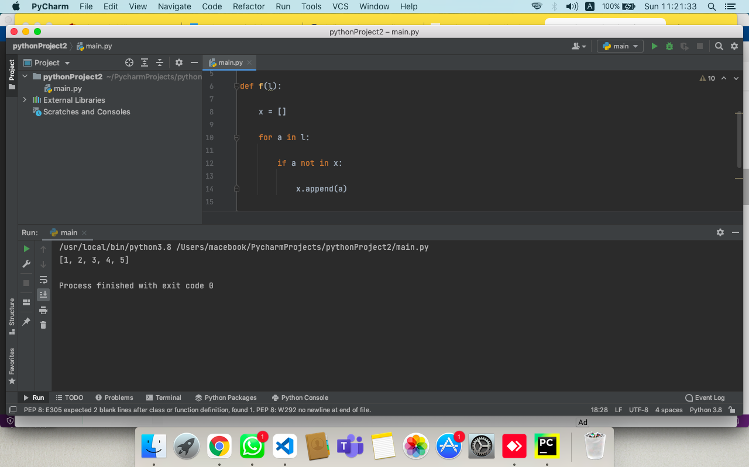

**Q6. Write a Python function that takes a number as a parameter and check the number is prime or not.**   
**Hint : A prime number (or a prime) is a natural number greater than 1 and that has no positive divisors other than 1 and itself.**

ANS:-

number = int(input("Enter any number: "))

if number > 1:

for i in range(2, number):

if (number % i) == 0:

print(number, "is not a prime number")

break

else:

print(number, "is a prime number")

else:

print(number, "is not a prime number")

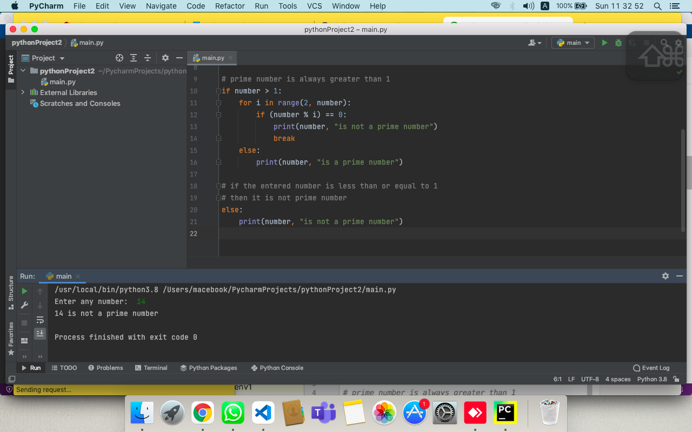

**Q7. Write a Python function to print the list of even numbers from a given list.**

ANS:-

list1 = [11,23,45,23,61,22,11,24]

def new_list(list1):

list2=[]

for num in list1:

if num % 2 == 0:

list2.append(num)

return list2

print("New list of even numbers:",new_list (list1))

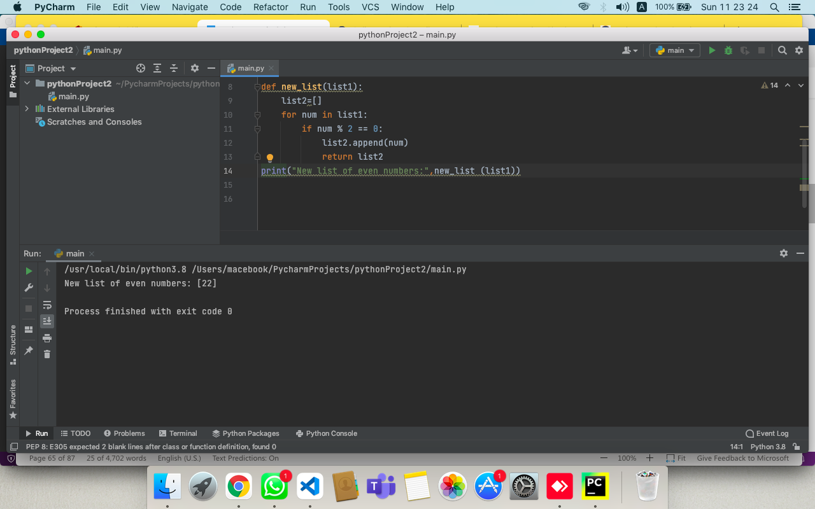

**Q8. Write a Python function that checks whether a passed string is palindrome or not.**

**Hint: A palindrome is a word, phrase, or sequence that reads the same backward as forward, e.g., madam or nurses run.**

ANS:-

def palindrome (str):

if len(str) <1:

return True

else:

if str[0]==str[-1]:

return palindrome (str[1:-1])

else:

return False

x=str(input("Enter any string of your choice: "))

if(palindrome (x)==True):

print("The entered string is a palindrome.")

else:

print("The entered string is not a palindrome")

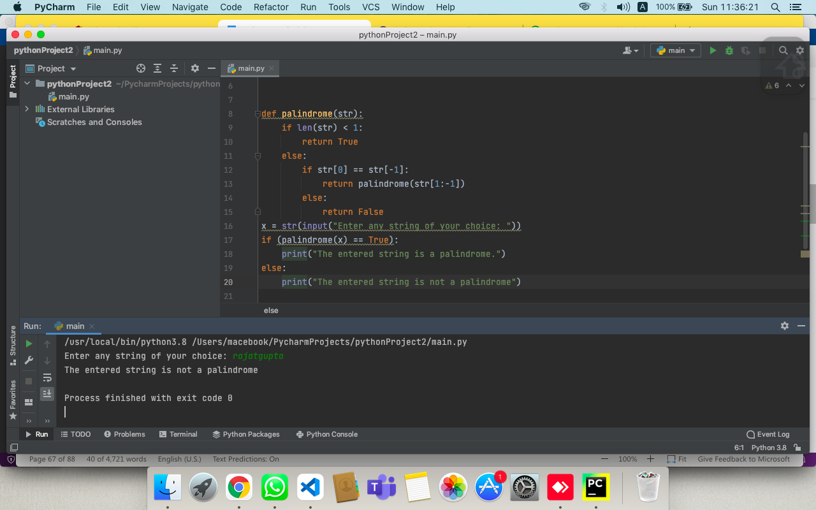

**Q9. Write a Python program that accepts a hyphen-separated sequence of words as input and prints the words in a hyphen-separated sequence after sorting them alphabetically.**

**Hint:**

***Sample Items*: green-red-yellow-black-white**  
**Expected Result : black-green-red-white-yellow**

ANS:-

def word (x) :

for i in range (len(x) + 1) :

for j in range (len(x) - 1) :

if x[ j ][ 0 ] > x[ j + 1][ 0 ] :

x[ j ], x[ j + 1 ] = x[ j + 1 ], x[ j ]

string = ("-").join(x)

print("Sequence After sorting :- ", string)

str = input ("Enter hyphen-separated sequence of words :- ")

a = str.split("-")

word(a)

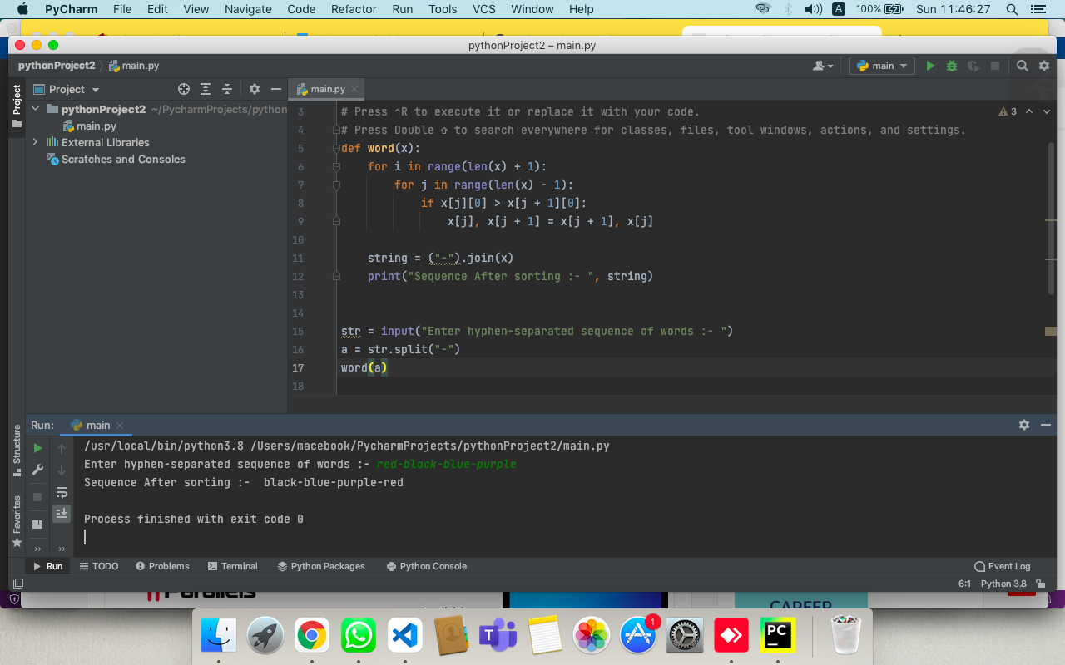

**Q10. Write a Python function to create and print a list where the values are square of numbers between 1 and 30 (both included).**

ANS:-

def printVal():

a=list()

for i in range (1,31): a.append(i**2)

print(a)

printVal()

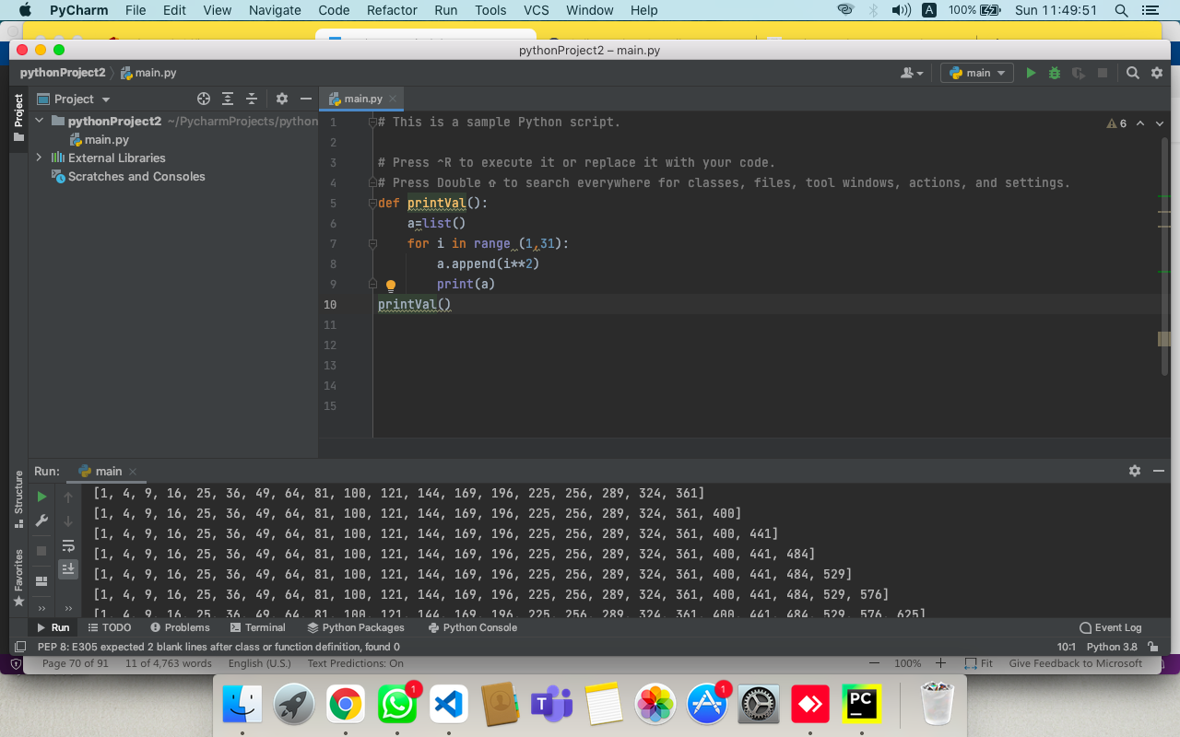

**Q11. Write a function calculation() such that it can accept two variables and calculate the addition and subtraction of them. And also it must return both addition and subtraction in a single return call.**

ANS:-

def function(a, b):

sum=a+b

sub-a-b

return sum, sub

function (4,4)

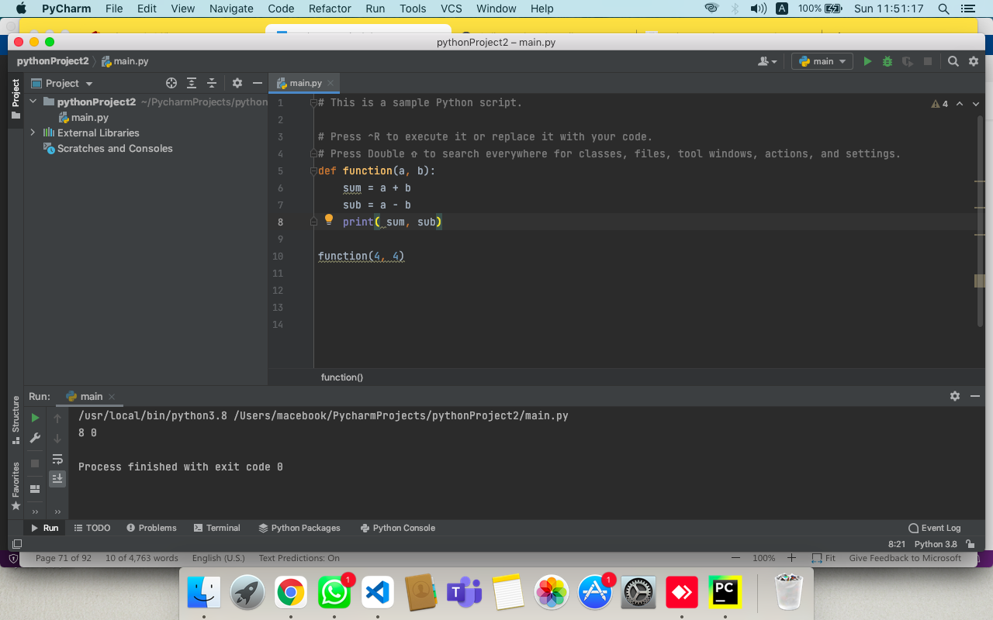

**Q12.Create a function showEmployee() in such a way that it should accept employee name, and its salary and display both. If the salary is missing in the function call assign default value 9000 to salary.**

ANS:-

def showEmployee (employee, salary=9000):

print('Employee Name is=', employee )

print (employee, 'Salary is =', salary)

print("\n")

showEmployee('Raj',7800)

showEmployee('Rajat')

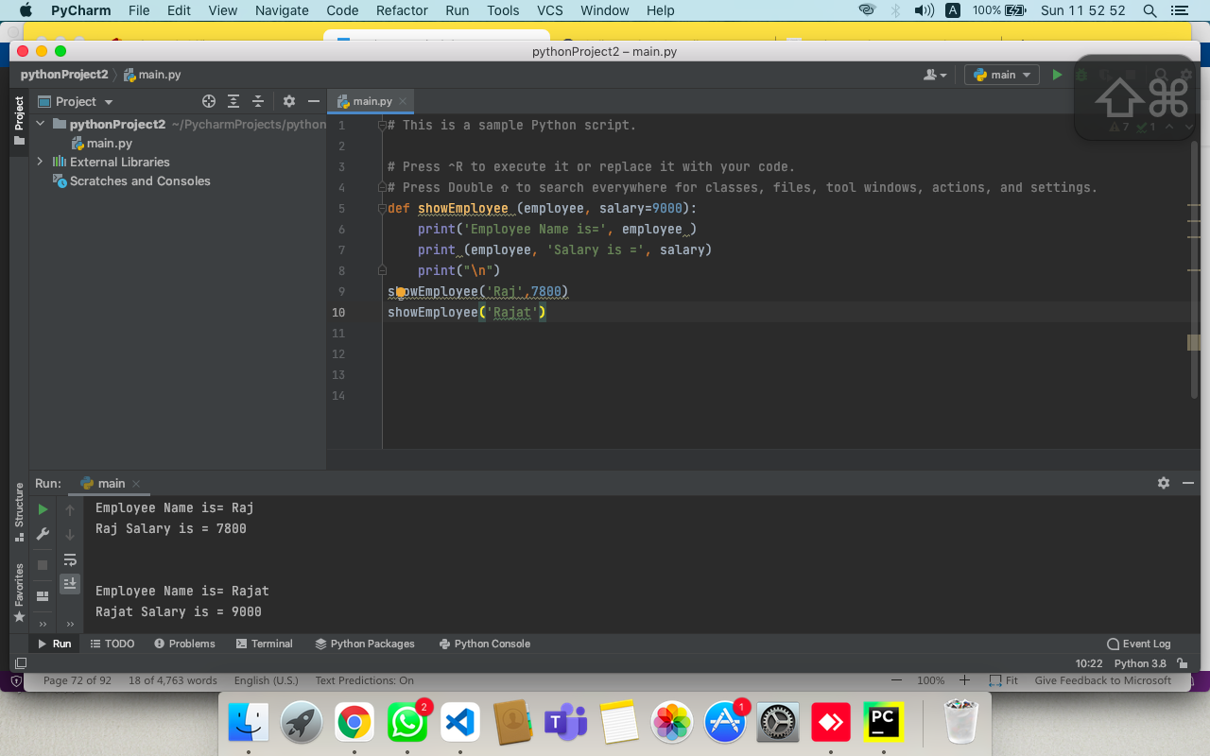

**ASSIGNMENT :- 7**

**Q1. Create a function in such a way that we can pass any number of arguments to this function and the function should process them and display each argument’s value.**

ANS:-

def func1(*args):

for i in args:

print(i)

func1(30, 50, 70)

func1(90, 100)

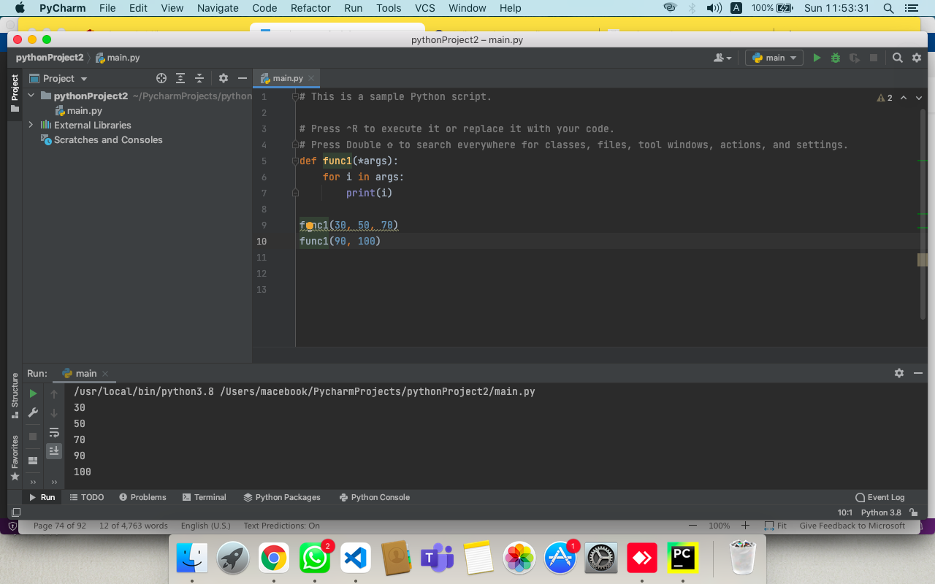

**Q2. Write a program to create function calculation() such that it can accept two variables and calculate addition and subtraction. Also, it must return both addition and subtraction in a single return call.**

ANS:-

def calculation(a, b):  
 addition = a + b  
 subtraction = a - b  
 # return multiple values separated by comma  
 return addition, subtraction  
  
# get result in tuple format  
res = calculation(40, 10)  
print(res)

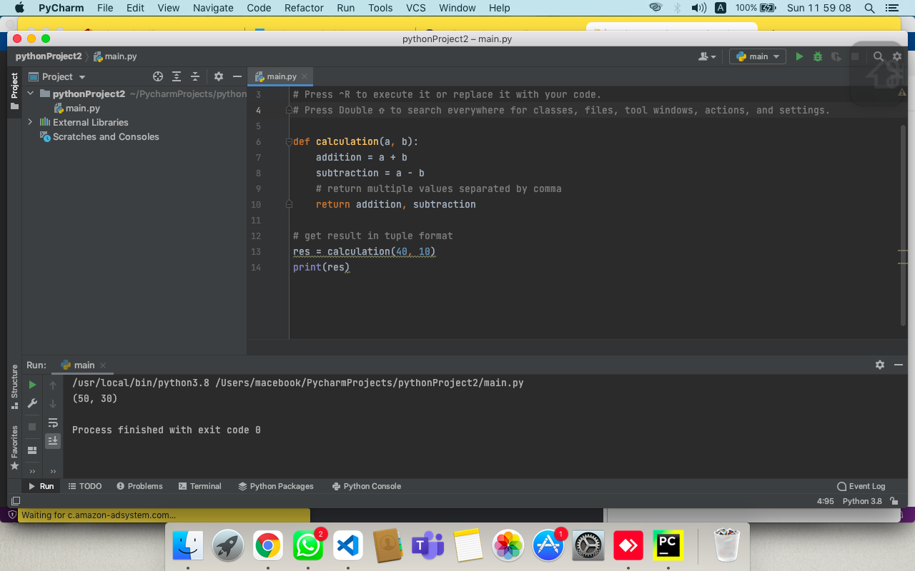

**Q3. Write a program to create a function show_employee() using the following conditions.**

* **It should accept the employee’s name and salary and display both.**
* **If the salary is missing in the function call then assign default value 9000 to salary**

ANS:-

def show_employee(name,salary = 9000):

print("Name:",name,"salary:", salary)

show_employee("Ben", 12000)

show_employee("Jessa")

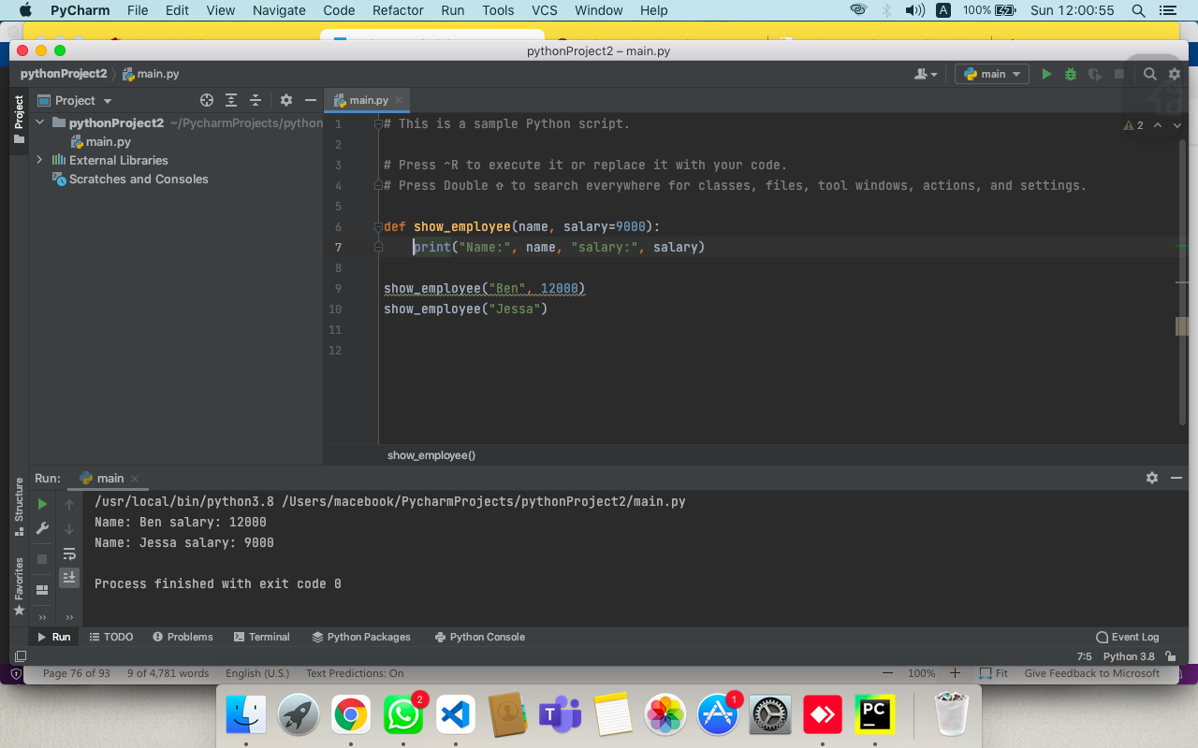

**Q4. Write a program using the following conditions.**

* **Create an outer function that will accept two parameters, a and b**
* **Create an inner function inside an outer function that will calculate the addition of a and b**
* **At last, an outer function will add 5 into addition and return it**

ANS:-

def sum(a, b):  
 def calculate(a, b):  
 return a+b  
 result=calculate(a,b)+5  
 return result  
  
print(sum(5,2))

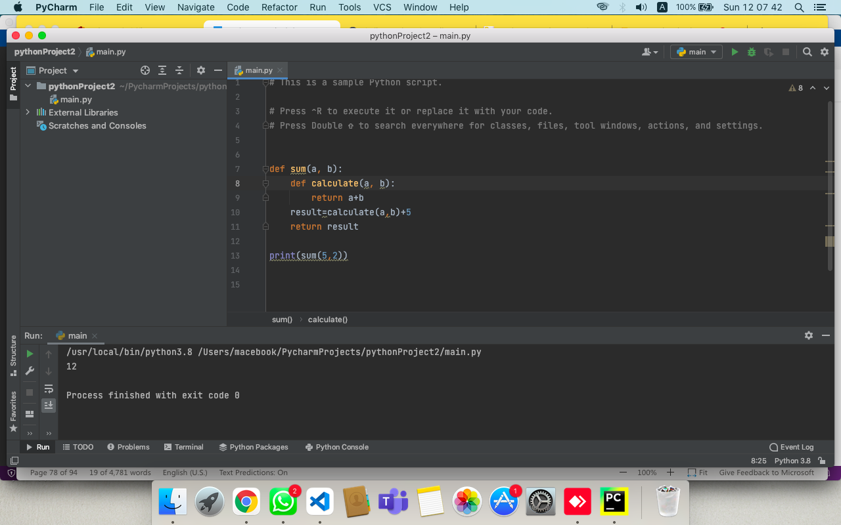

**Q5. Write a program to create a recursive function to calculate the sum of numbers from 0 to 10.**

ANS:-

def recursiveSum(n):

if n <= 1:

return n

return n+ recursiveSum (n - 1)

n=10

print ("sum =", recursiveSum(n))

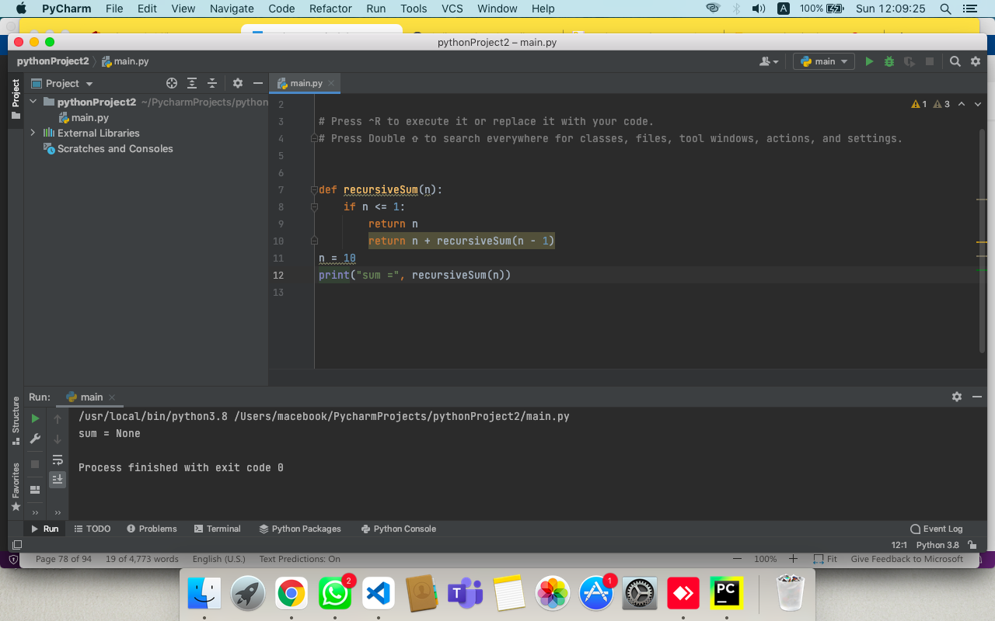

**Q6. Assign a different name to function and call it through the new name**

**Hint: Create function display_student(name, age). Assign a new name show_tudent(name, age) to it and call it using the new name.**

ANS:-

def display_student (name,Age):

print (name,Age)

display_student ("Rajat",18)

showStudent = display_student

showStudent ("Rajat",18)

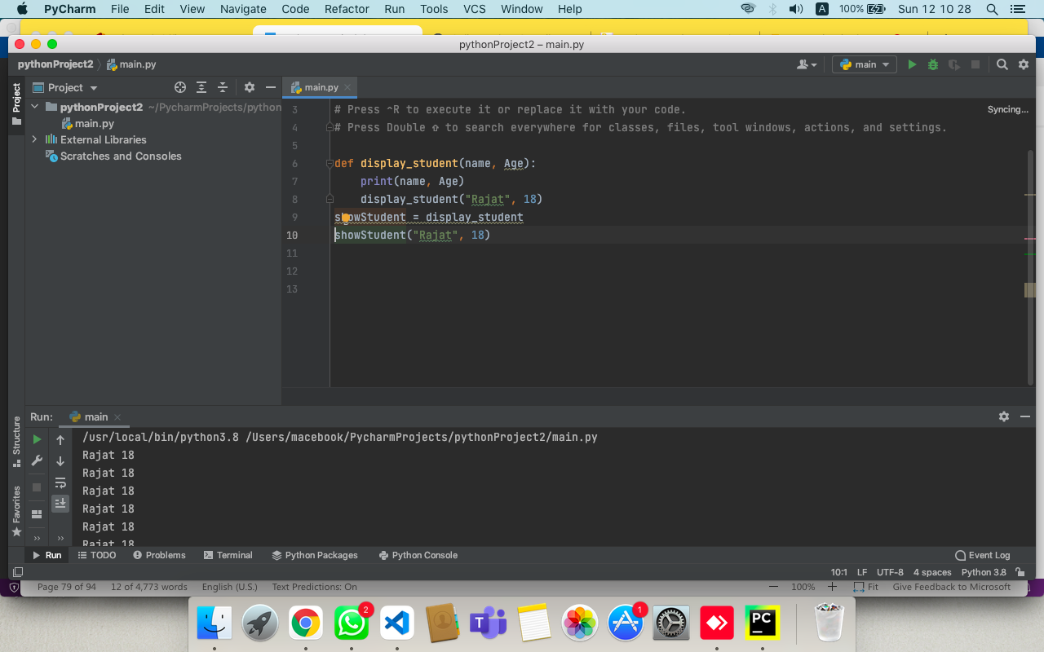

**Q7. Write a recursive function that accepts two numbers as its argument and returns its power.**

ANS:-

def power(a,n):

if(n==1):

return a

else:

return a*power(a,n-1)

base=5

pow =3

print (base,"power",pow,"is=",power(base,pow))

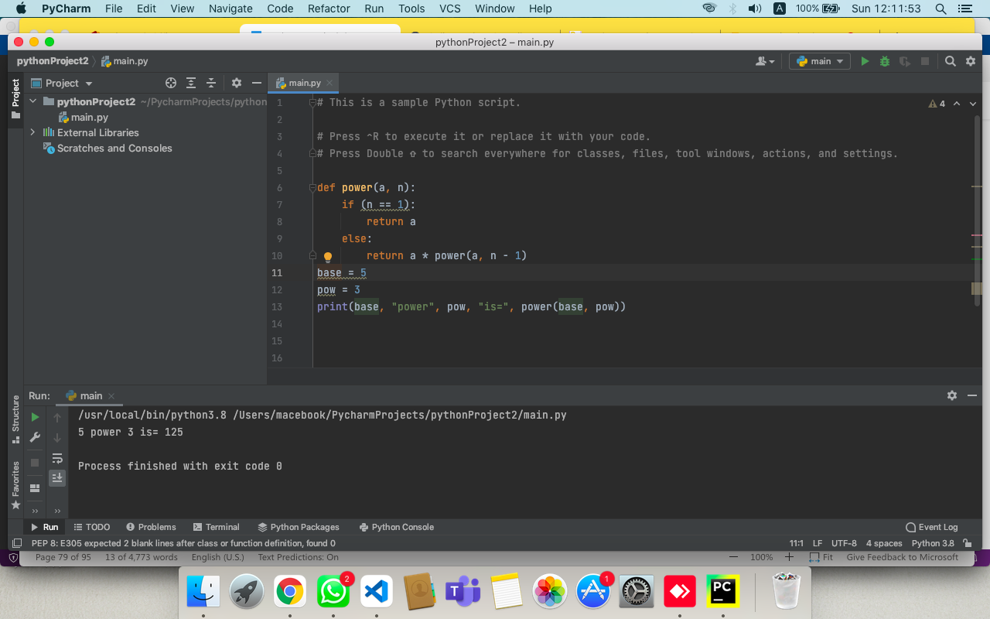

**Q8. Write a recursive function that accepts a number as its argument and returns the sum of digits.**

ANS:-

**def** sum_of_digit( n ):

**if** n **==** 0:

**return** 0

**return** (n **%** 10 **+** sum_of_digit(int(n **/** 10)))

# Driven code to check above

num **=** 12345

result **=** sum_of_digit(num)

**print**("Sum of digits in",num,"is", result)

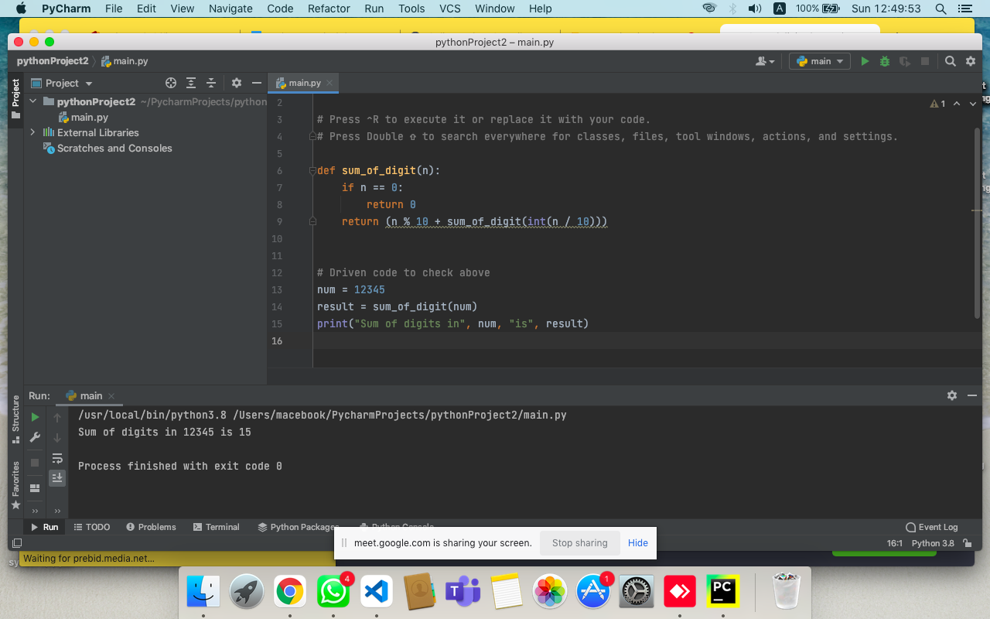

**Q9. Write a recursive function that accepts an integer argument in n. This function returns the nth Fibonacci number. Call the function to print fibonacci sequences.**

ANS:-

def fib(n):

if (n <= 0):

return 0

elif (n == 1):

return 1

else:

return fib(n - 1) + fib(n - 2)

print("The first 10 Fibonacci numbers are")

for x in range(10):

print(fib(x),end=" ")  
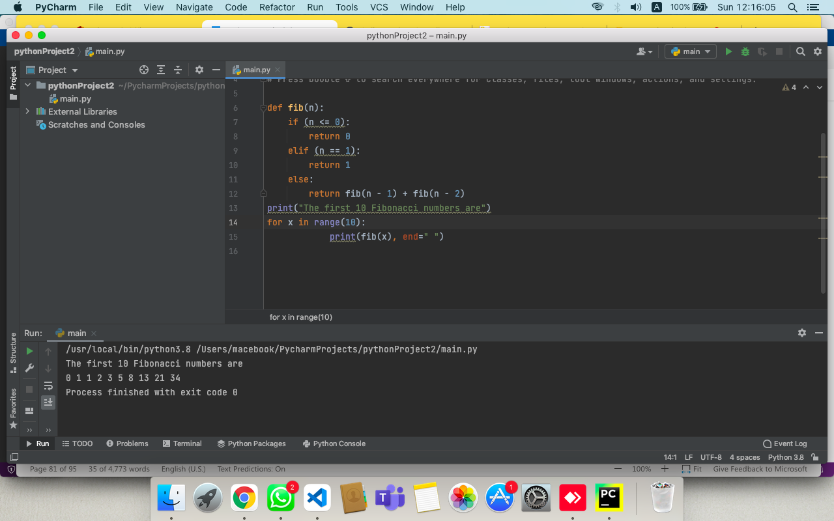

**Q10. Write a recursive function that accepts a decimal integer and display its binary equivalent.**

ANS:-

def convertToBinary(n):

If n> 1:

convertToBinary (n//2)

print (n%2,end =" ")

dec = 3

convertToBinary (dec)

print ()

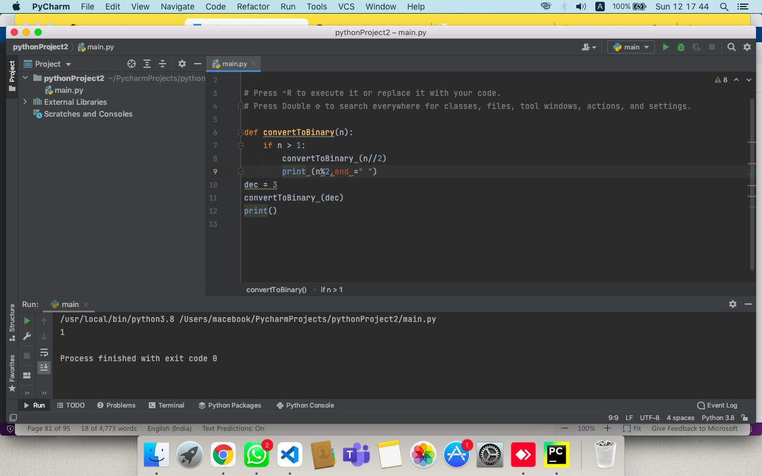

**Q11. Write a Python program to create a lambda function that adds 15 to a given number passed in as an argument, also create a lambda function that multiplies argument x with argument y and print the result.**

ANS:-

r = lambda a : a + 15

print(r(10))

r = lambda x, y : x * y

print(r(12, 4))

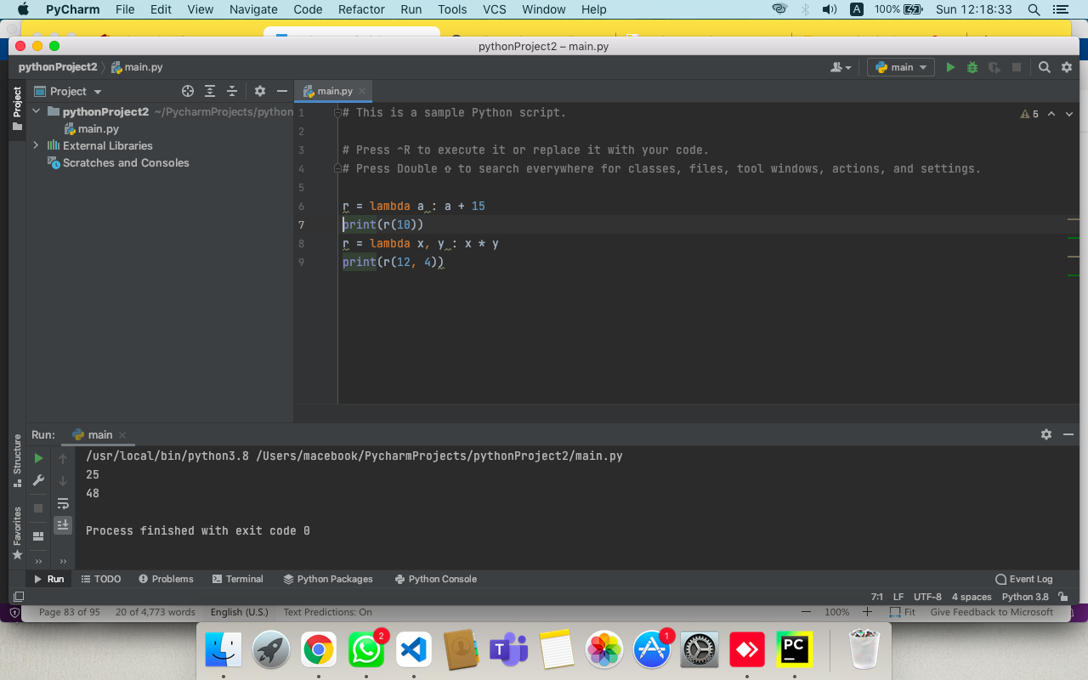

**Q12. Write a Python program to create a function that takes one argument, and that argument will be multiplied with an unknown given number.**

ANS:-

def func_compute(n):

return lambda x : x * n

result = func_compute(2)

print("Double the number of 15 =", result(15))

result = func_compute(3)

print("Triple the number of 15 =", result(15))

result = func_compute(4)

print("Quadruple the number of 15 =", result(15))

result = func_compute(5)

print("Quintuple the number 15 =", result(15))

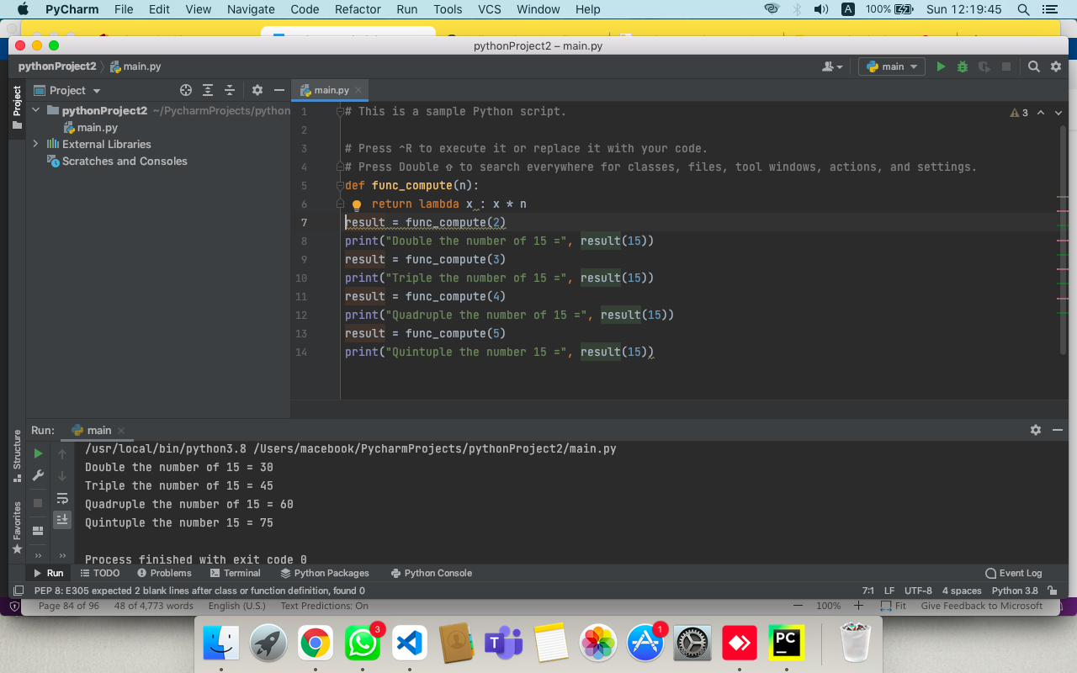

**ASSIGNMENT :- 8**

**Q1. Write a python program to open a file where you do not have write permission, so it should raises an exception and handle it.**

ANS:-

try:  
 fh = open("Report", "r")  
 fh.write("This is my test file for exception handling!!")  
except IOError:  
 print("Error: can\'t find file or read data")  
else:  
 print ("Written content in the file successfully")

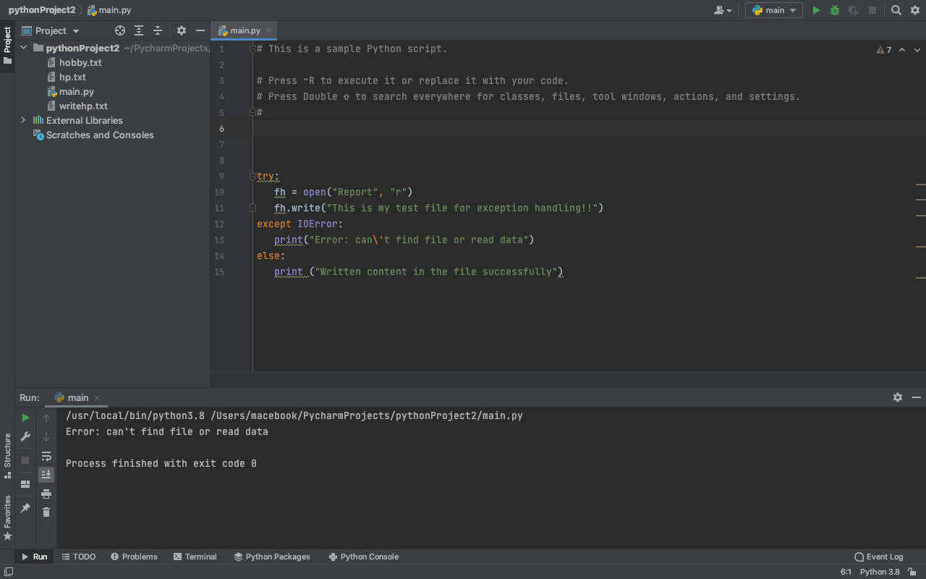

**Q2. Write a statement in python to open a file named “data.txt” stored in folder “content” in XYZ drive.**

ANS:-

f=open("/Users//macebook//Downloads//Rdata.txt","r")  
print(f.read())

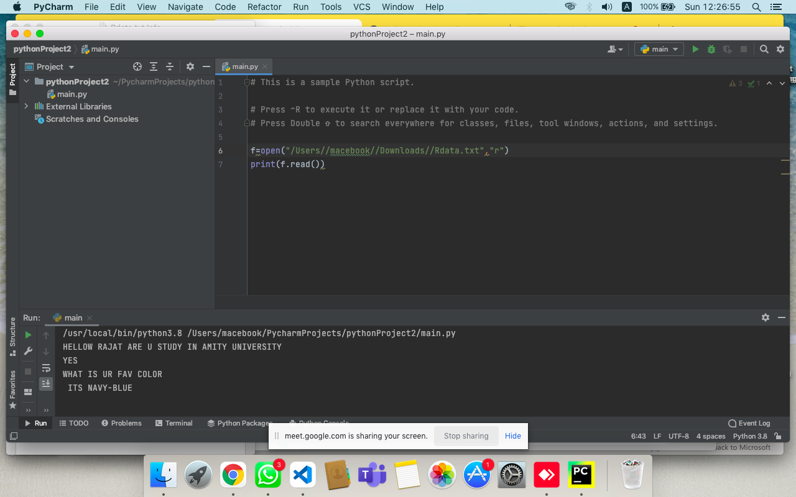

**Q3. Write a program in python to read first 5 characters from the file(“data.txt”)**

ANS:-

f=open("/Users//macebook//Downloads//Rdata.txt","r")  
print(f.read(5))

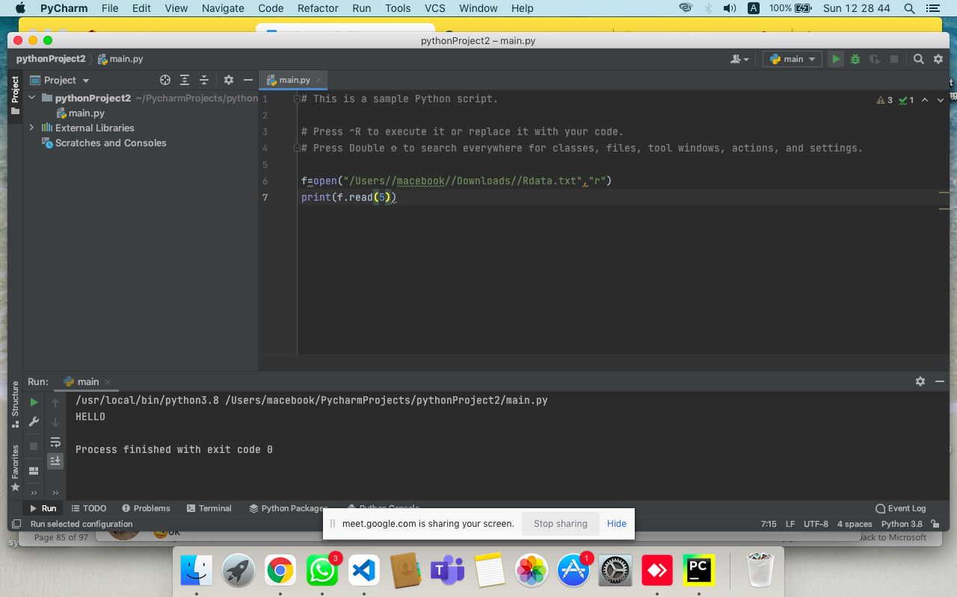

.

**Q4. Write a program in python to read first line from the file(“data.txt”)**

ANS:-

f=open("/Users//macebook//Downloads//Rdata.txt","r")  
print(f.readline())

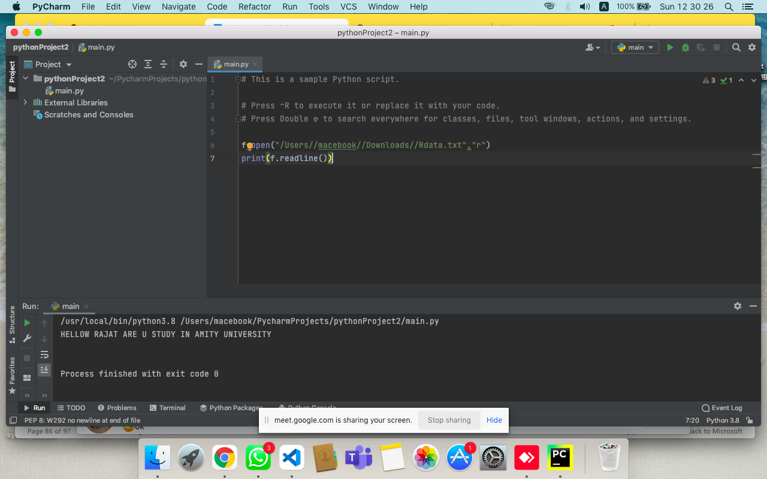

**Q5. Write a program in python to display number of lines in a file(“data.txt”).**

ANS:-

f=open("/Users//macebook//Downloads//Rdata.txt","r")  
print(f.readlines())

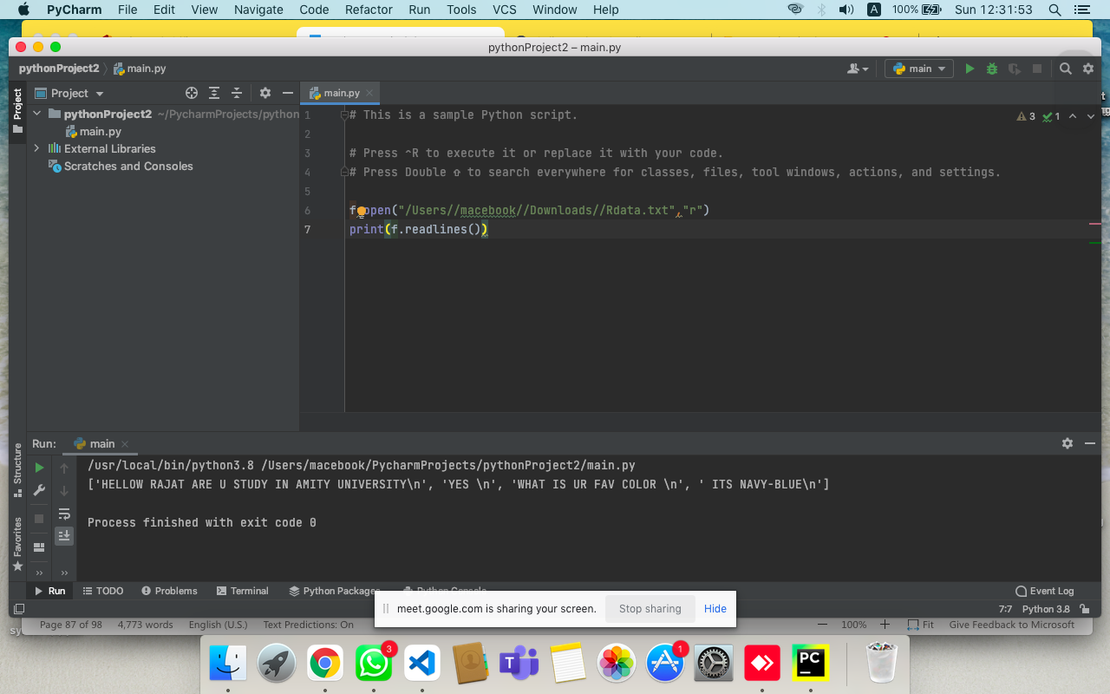

**Q6. Write a program in python to display first line from the file(“data.txt”) using readlines().**

ANS:-

f=open("/Users//macebook//Downloads//Rdata.txt","r")  
print(f.readlines(1))

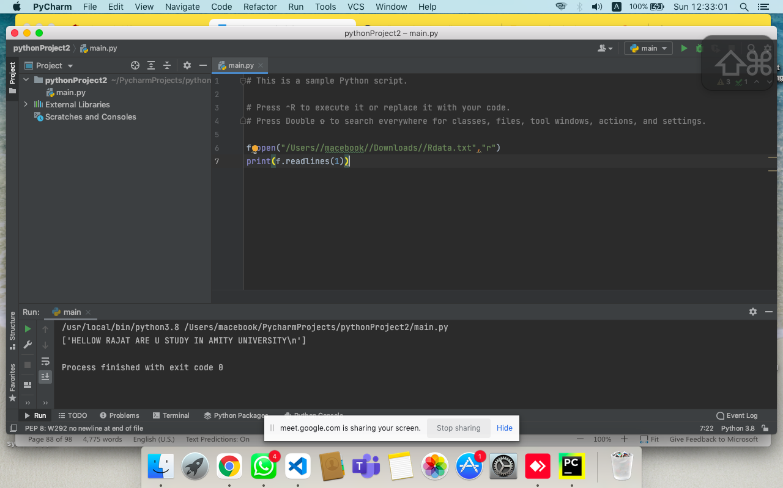

**Q7. Accept five names from the user and write in a file “name.txt”**

ANS:-

f=open("/Users//macebook//Downloads//Rdata.txt","w")  
L=["Rajat\n","Raj\n","Ram\n","dhruv\n","Ayush"]  
f.writelines(L)  
f.close()  
f=open("/Users//macebook//Downloads//Rdata.txt","r")  
print(f.read())

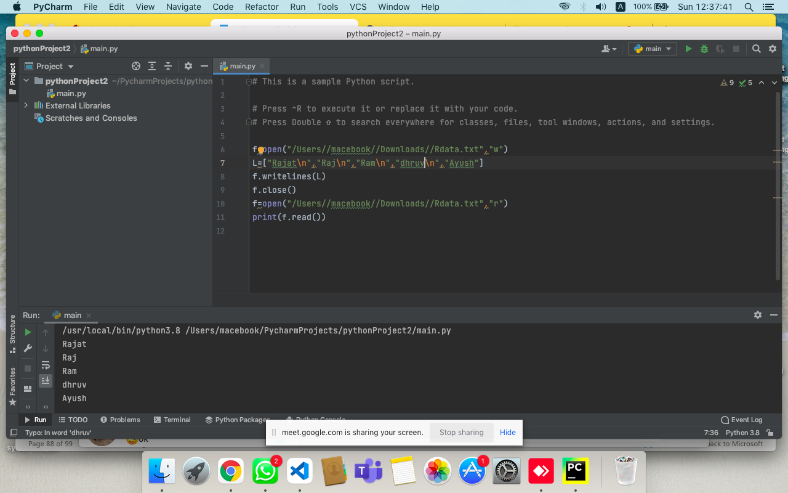

**Q8. Accept five sports names from the user and write in a file “sport.txt” (each name should write in separate line)**

ANS:-

f=open("/Users//macebook//Downloads//sports.txt","w")  
L=["Cricket\n","Bollyball\n","Tabletennis\n","Badminton\n","Carom"]  
f.writelines(L)  
f.close()  
f=open("/Users//macebook//Downloads//sports.txt","r")  
print(f.read())

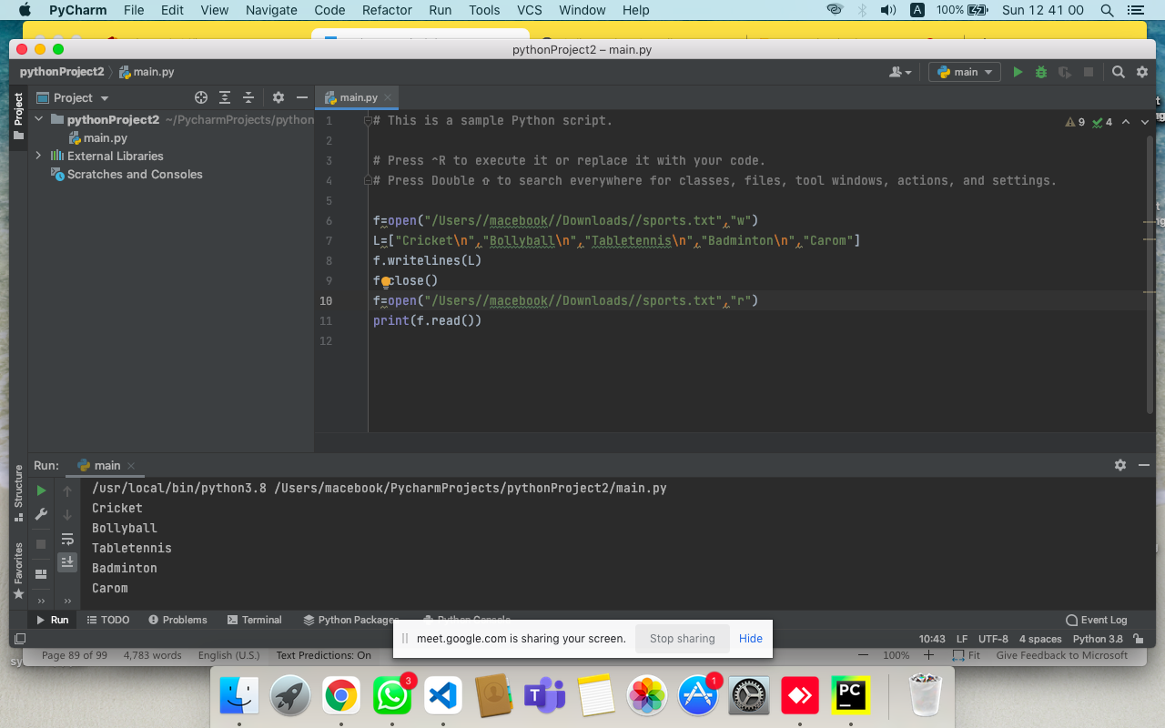

**Q9. Accept five hobbies from the user and write in a file “hobby.txt” (each hobby should write in separate line) without using write() function.**

ANS:-

f = open("hobby.txt","w")

h = []

for i in range(5):

n =input("Enter hobby name")

h.append(n,'\n')

f.writelines(h)

f.close()

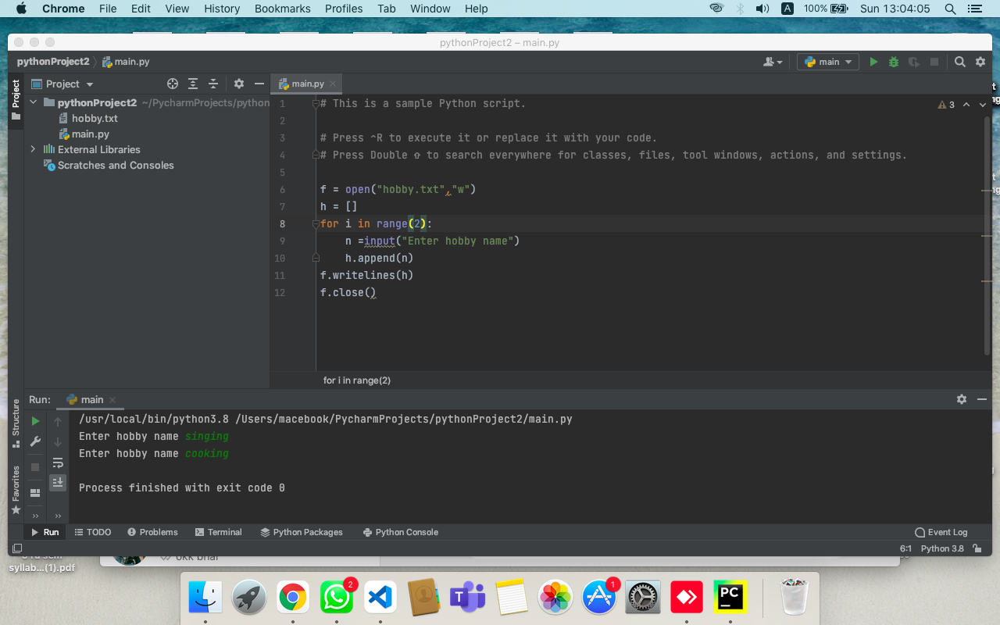

**Q10. Read a file line by line and print it.**

ANS:-

f=open("/Users//macebook//Downloads//Rdata.txt","r")

c= f.read()  
print(c)

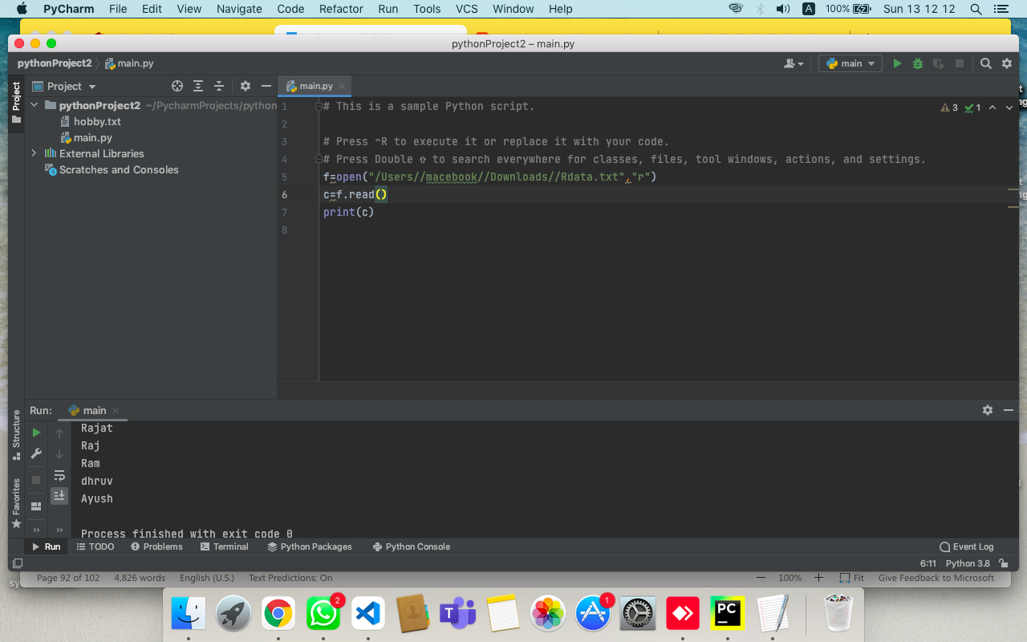

**Q11. Remove all the lines that contain the character “a” in a file and write it into another file.**

ANS:-

fo=open("hp.txt","w")  
fo.write("Harry Potter")  
fo.write("There is a difference in all harry potter books\nWe can see it as harry grows\nthe books were written by J.K rowling ")  
fo.close()  
  
fo=open('hp.txt','r')  
fi=open('writehp.txt','w')  
l=fo.readlines()  
for i in l:  
 if 'a' in i:  
 i=i.replace('a','')  
 fi.write(i)  
fi.close()  
fo.close()

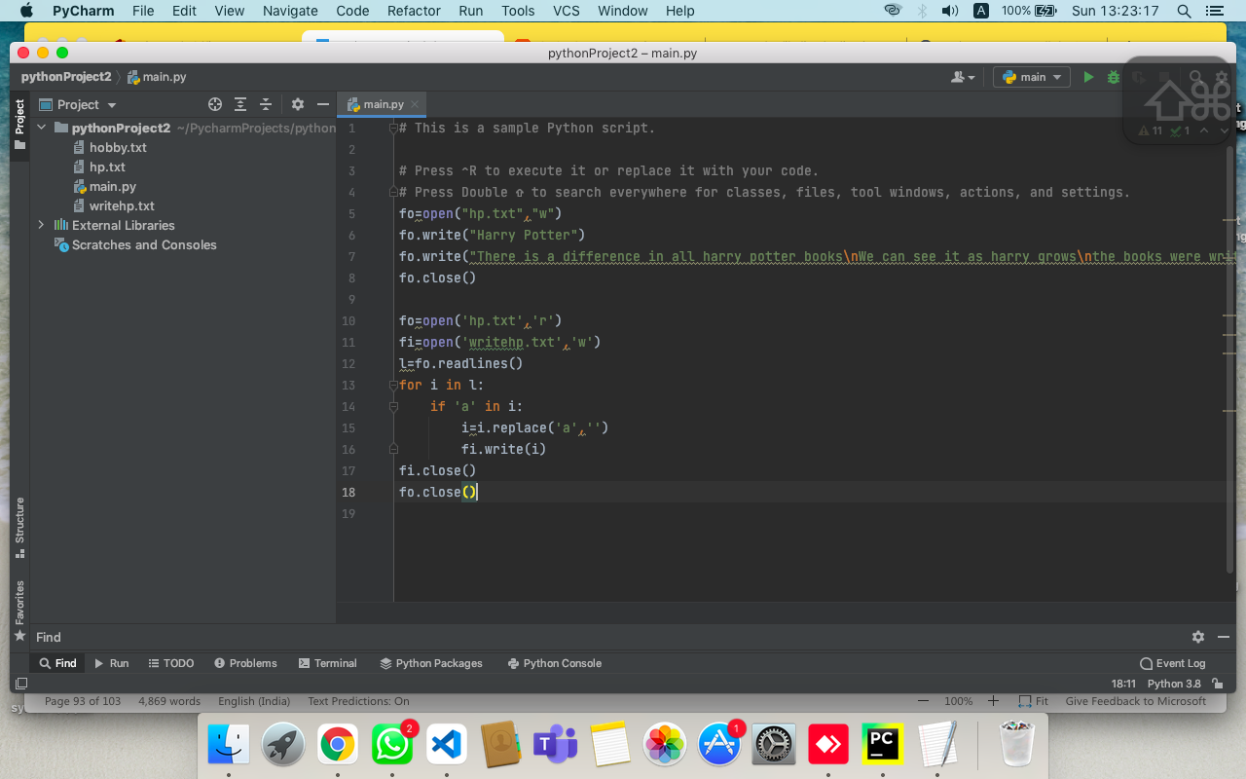

**Q12. Read a text file and display the number of vowels/consonants/uppercase/lowercase characters in the file.**

ANS:-

def CountVCLU():  
 f=open("/Users/macebook/Downloads/Report.txt","r")  
 V=C=L=U=0  
 data=f.read()  
 for i in data:  
 if i.isalpha():  
 if i.isupper():  
 U+=1  
 if i.islower():  
 L+=1  
 if i in 'aeiou':  
 V+=1  
 else:  
 C+=1  
 print("Vowels = ", V)  
 print("consonent = ",C)  
 print("UPPERCASE = ",U)  
 print("lowercase = ",L)  
CountVCLU()

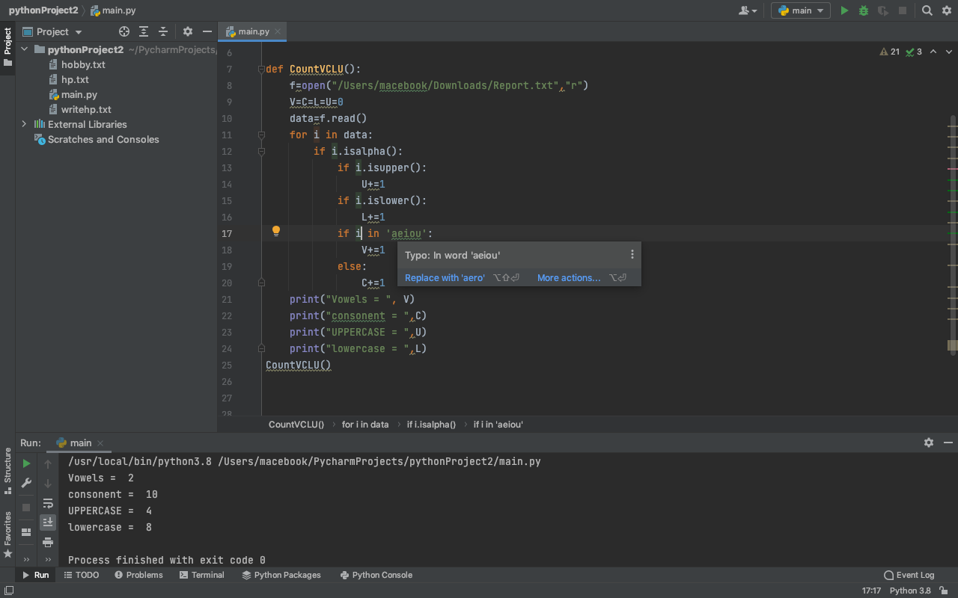

**Q13. What is Index Out Of Range Error? Write a python program to handle this.**

ANS:-

try:  
 colours= ["red","black","yellow","blue","green"]  
 for x in range (6):  
 print(colours[x])  
except IndexError as e:  
 print(e)  
 print(sys.exc_type)

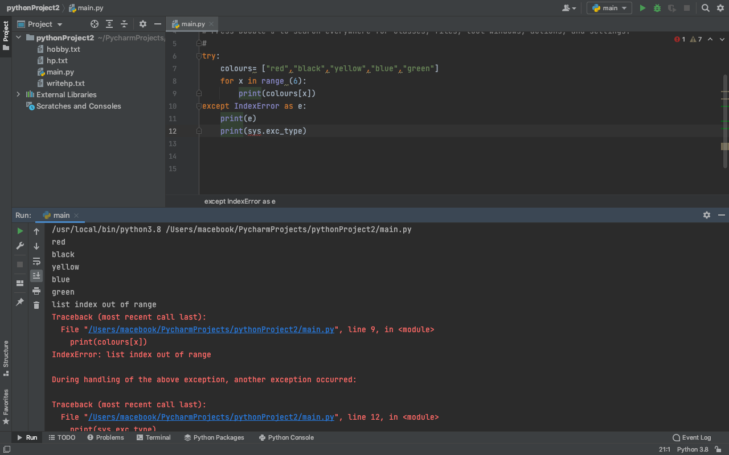

**Q14. Reverse each word of a string**

ANS:-

def rWS(Sentence):  
  
 return ' '.join(word[::-1] for word in Sentence.split(" "))  
Sentence = "AMITY UNIVERSITY"  
print(rWS(Sentence))

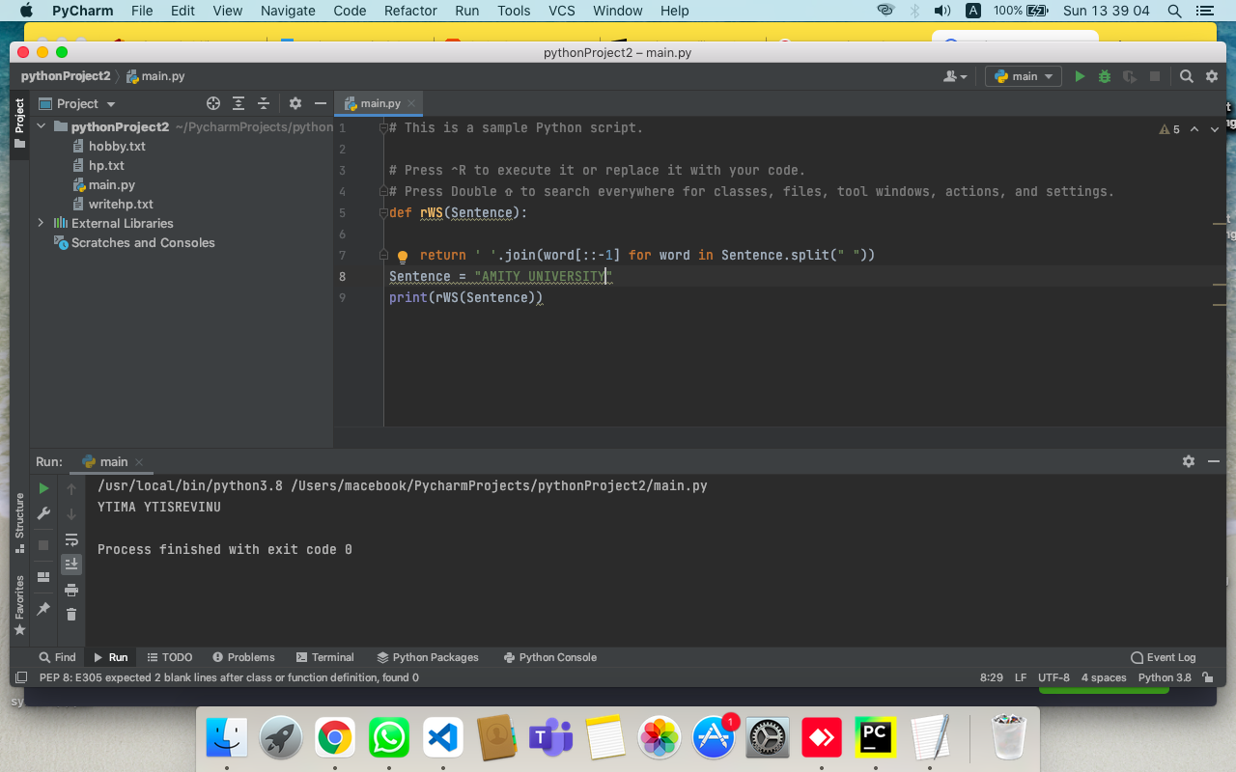

**Q15. Read text file into a variable and replace all newlines with space.**

ANS:-

with open('/Users/macebook/Downloads/Rdata.txt', 'r') as file:  
 data = file.read().replace('\n', 'R')

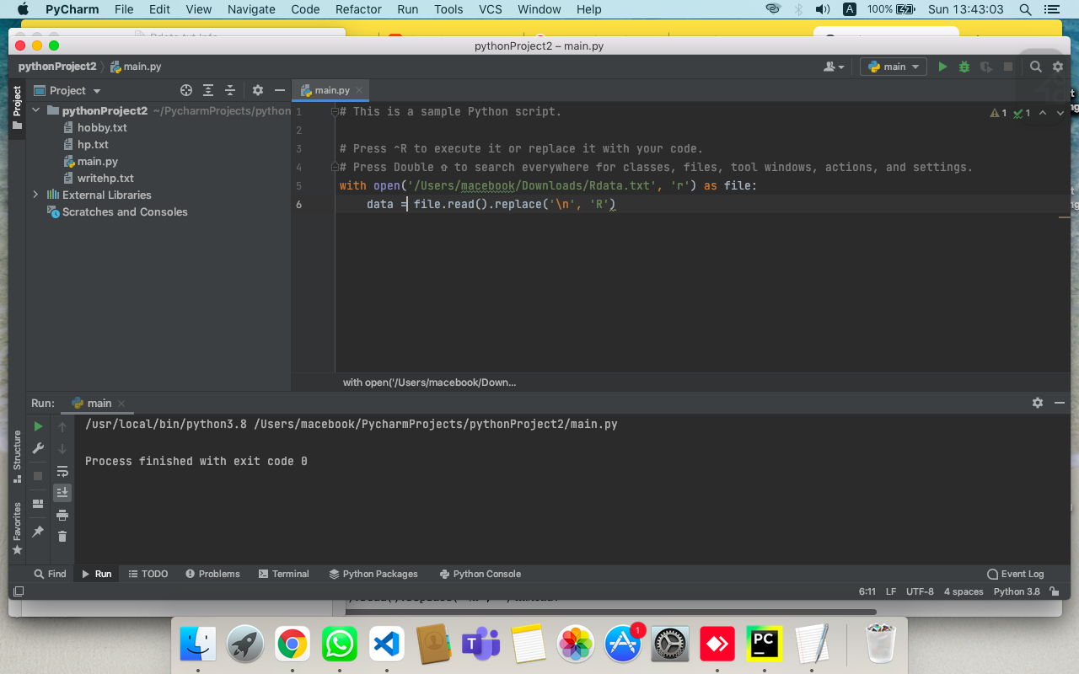

**Q16. Remove items from a list while iterating (You need to remove items from a list while iterating but without creating a different copy of a list. for example remove numbers greater than 50 from the list)**

ANS:-

list_of_num = [11,12,13,15,20,25,51, 52, 53, 54, 55, 56, 57, 58, 59]  
# Remove all occurrences of 54 & 55 from list  
list_of_num = [num for num in list_of_num if num <50 ]  
print(list_of_num)

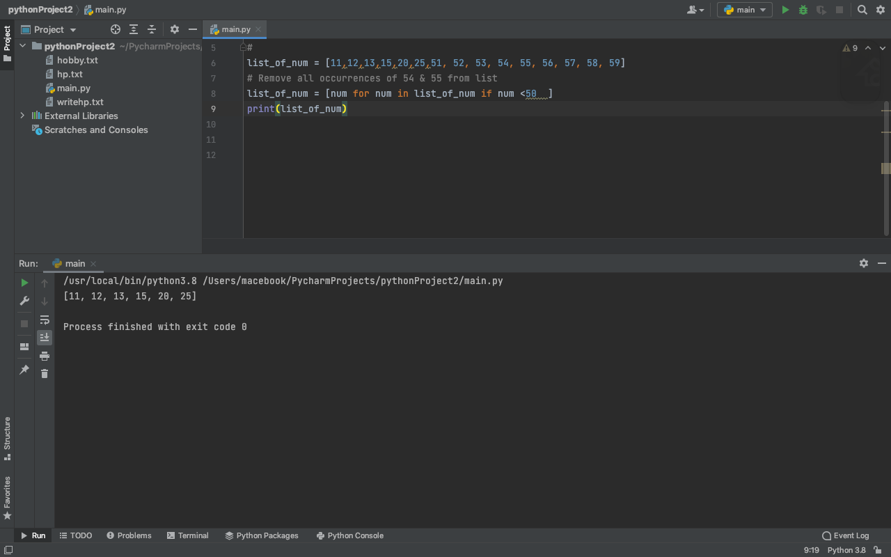

**ASSIGNMENT :- 9**

**Q1. Design a python program as per instructions:**

**a) Create a Vehicle class with name, max_speed and mileage instance attributes create object and show values of instance attribute.**

ANS:-

class Vehicle:  
 def __init__(self, max_speed, mileage):  
 self.max_speed = max_speed  
 self.mileage = mileage  
modelX = Vehicle(240, 18)  
print (modelX.max_speed, modelX.mileage)

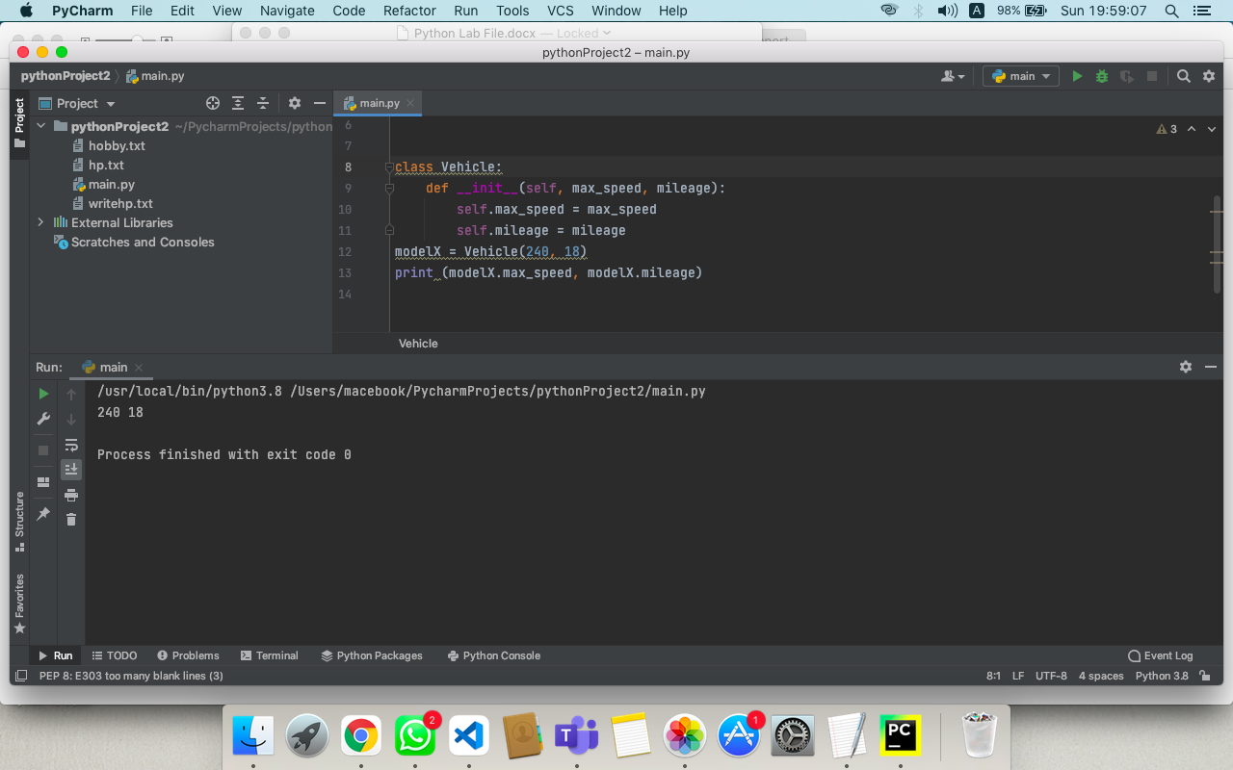

**b) Create a child class Bus that will inherit all of the variables and methods of the Vehicle class, create object and show values of instance attribute.**

ANS:-

class Vehicle:

def __init__(self, name, max_speed, mileage):

self.name = name

self.max_speed = max_speed

self.mileage = mileage

class Bus(Vehicle):

pass

School_bus = Bus("School Volvo", 180, 12)

print("Vehicle Name:", School_bus.name, "Speed:", School_bus.max_speed, "Mileage:", School_bus.mileage)

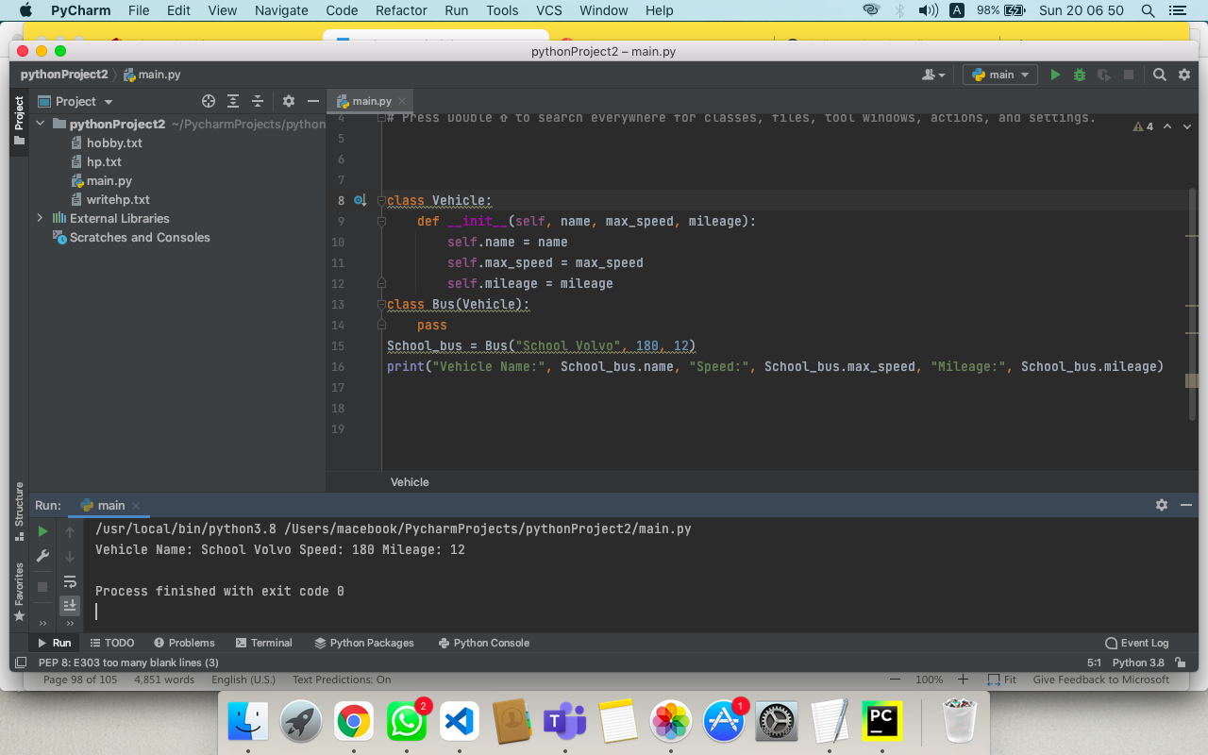

**c) Add method seating_capacity in the Vehicle class, Give the capacity argument of seating_capacity() a default value of 50. Then create a child class Bus that will inherit all of the variables and methods of the Vehicle class. Create a Bus object that will inherit all of the variables and methods of the Vehicle class and display it.**

ANS:-

class Vehicle:

def __init__(self, name, max_speed, mileage):

self.name = name

self.max_speed = max_speed

self.mileage = mileage

def seating_capacity(self, capacity):

return f"The seating capacity of a {self.name} is {capacity} passengers"

class Bus(Vehicle):

# assign default value to capacity

def seating_capacity(self, capacity=50):

return super().seating_capacity(capacity=50)

School_bus = Bus("School Volvo", 180, 12)

print(School_bus.seating_capacity())

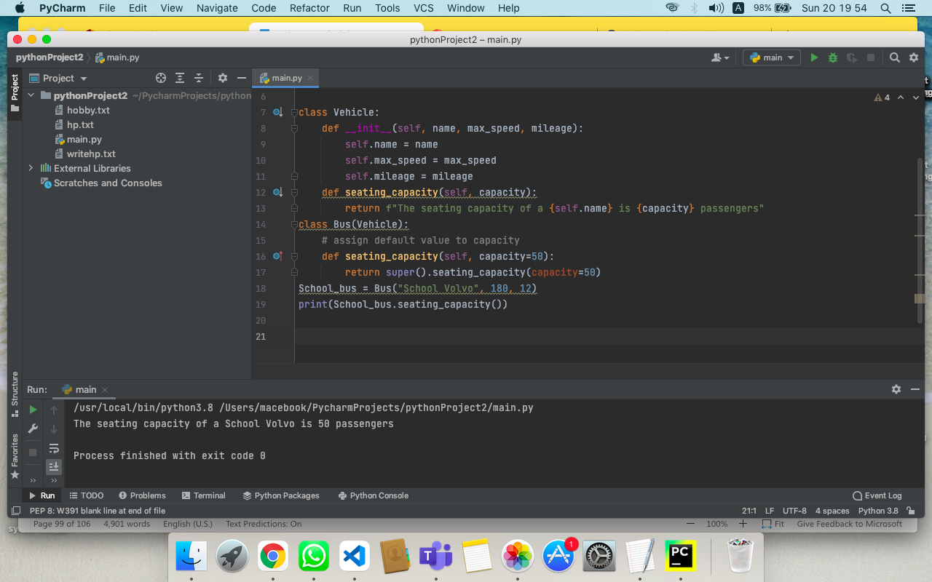

**d)Define property that should have the same value for every class instance for example define a class attribute “color” with a default value white. I.e., Every Vehicle should be white but the name and max_speed and mileage variables’ values will vary depending on the Vehicle instance.**

ANS:-

class Vehicle:

# Class attribute

color = "White"

def __init__(self, name, max_speed, mileage):

self.name = name

self.max_speed = max_speed

self.mileage = mileage

class Bus(Vehicle):

pass

class Car(Vehicle):

pass

School_bus = Bus("School Volvo", 180, 12)

print(School_bus.color, School_bus.name, "Speed:", School_bus.max_speed, "Mileage:", School_bus.mileage)

car = Car("Audi Q5", 240, 18)

print(car.color, car.name, "Speed:", car.max_speed, "Mileage:", car.mileage)

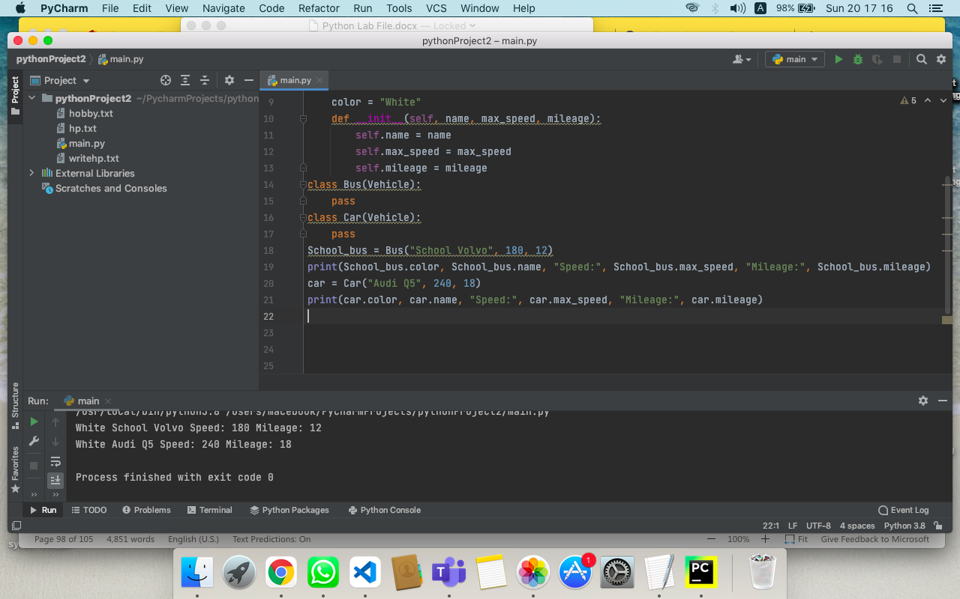

**e) Create a Bus child class that inherits from the Vehicle class. The default fare charge of any vehicle is seating capacity * 100. If Vehicle is Bus instance, we need to add an extra 10% on full fare as a maintenance charge. So total fare for bus instance will become the final amount = total fare + 10% of the total fare. (Hint: The bus seating capacity is 50. so the final fare amount should be 5500. You need to override the fare() method of a Vehicle class in Bus class.)**

ANS:-

class Vehicle:

def __init__(self, name, mileage, capacity):

self.name = name

self.mileage = mileage

self.capacity = capacity

def fare(self):

return self.capacity * 100

class Bus(Vehicle):

passSchool_bus = Bus("School Volvo", 12, 50)

print("Total Bus fare is:", School_bus.fare())

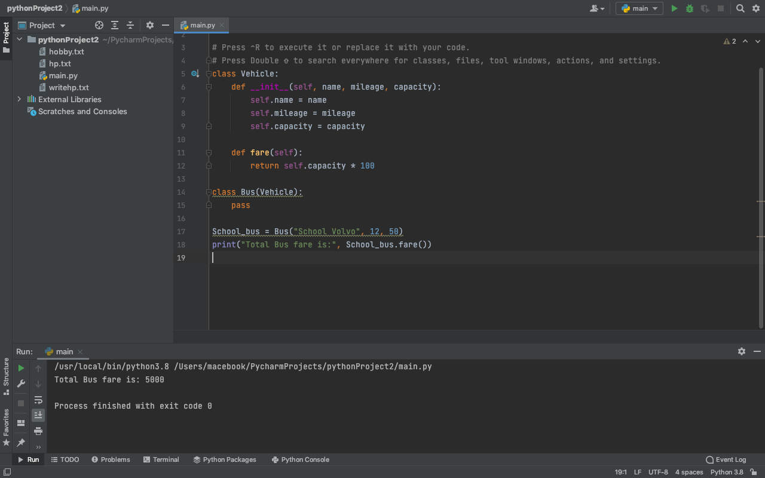

**f) Determine which class a given Bus object belongs to (Check type of an object)**

ANS:-

class Vehicle:

def __init__(self, name, mileage, capacity):

self.name = name

self.mileage = mileage

self.capacity = capacity

class Bus(Vehicle):

pass

School_bus = Bus("School Volvo", 12, 50)

# Python's built-in type()

print(type(School_bus))

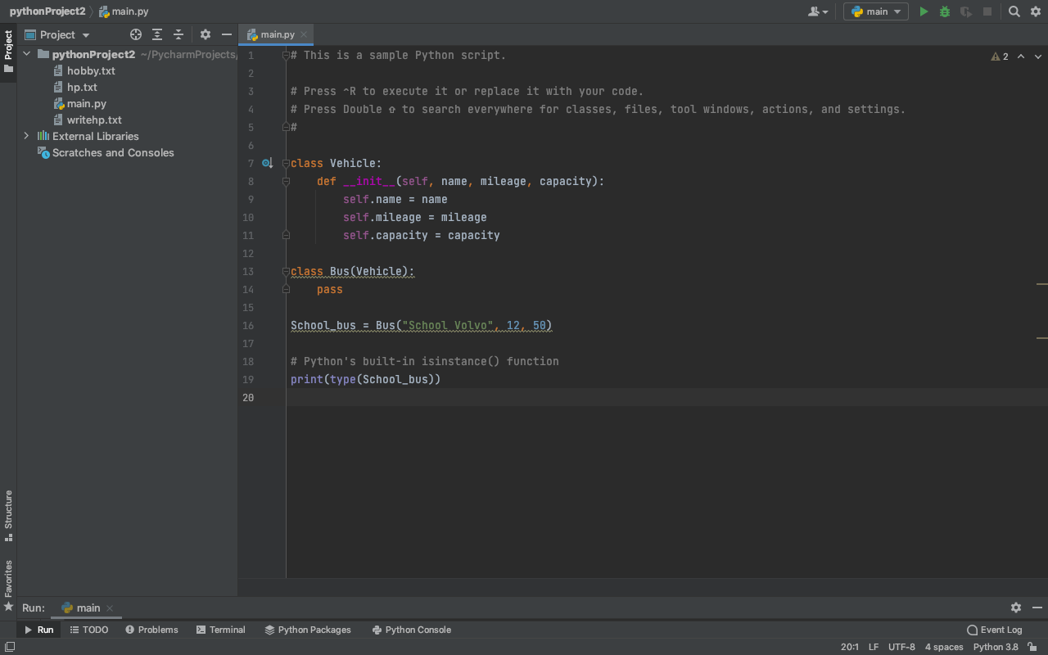

**g) Determine if School_bus is also an instance of the Vehicle class**

ANS:-

class Vehicle:

def __init__(self, name, mileage, capacity):

self.name = name

self.mileage = mileage

self.capacity = capacity

class Bus(Vehicle):

pass

School_bus = Bus("School Volvo", 12, 50)

print(isinstance(School_bus, Vehicle))

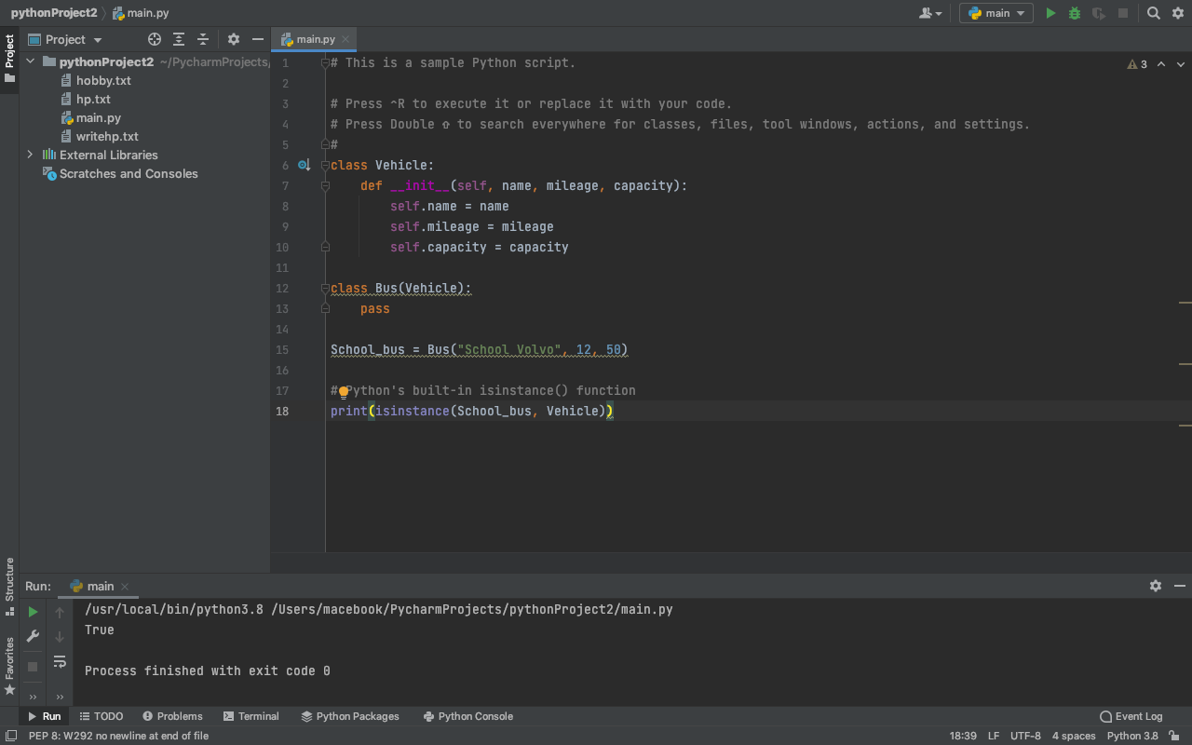

**ASSIGNMENT :- 10**

**Q1. Create a list, from that list keep only the lines that start with a number or a letter after > sign.**

ANS:-

import re  
str="""  
str**=**""">Venues>Marketing>medalists>Controversies>Paralympics>snowboarding>[1]>Netherlands>[2]>Norway>[10]>[11]>References>edit>[12]>Norway>Germany>Canada>Netherlands>Japan>Italy>Belarus>China>Slovakia<$#%#$%<#$#$$<**&&^^>Slovenia>Belgium>Spain>Kazakhstan>[15]>1964>1968>1972>1992>1996>2000"""  
"""  
  
data = re.findall('>\w+', str)  
print(data)

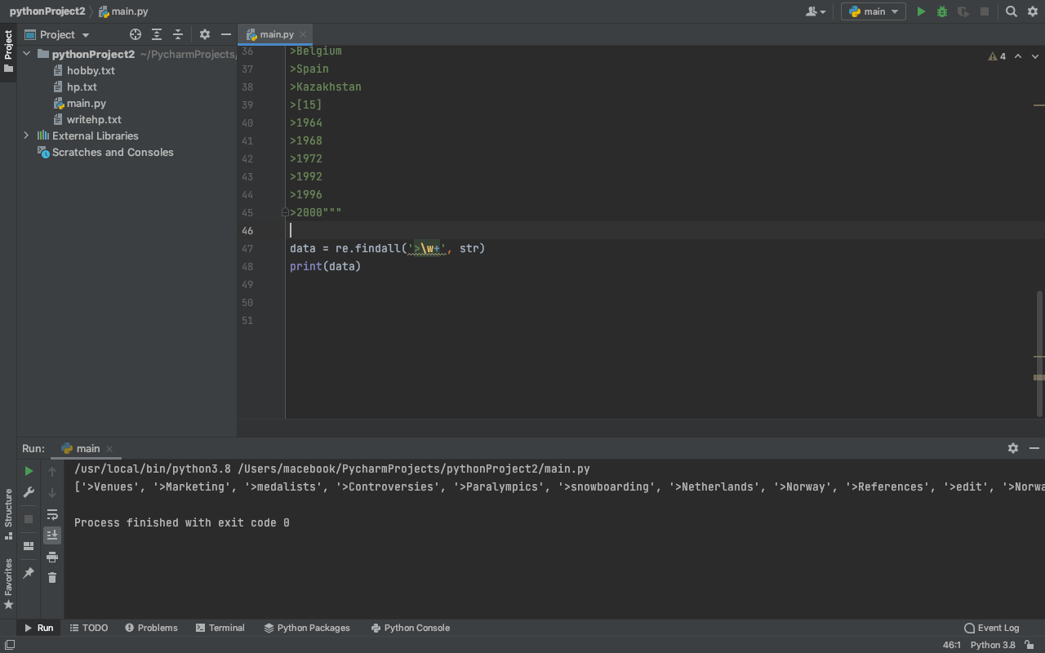

**Q2. Write a regex so that the full email addresses are extracted.**

**For ex. :** [**mama@gmail.com**](mailto:mama@gmail.com)

ANS:-

import re

s = """Hello from rashid199630@gmail.com

to raj@yahoo.com about the meeting @2PM"""

# \S matches any non-whitespace character

# @ for as in the Email

# + for Repeats a character one or more times.

lst = re.findall('\S+@\S+', s)

print(lst)

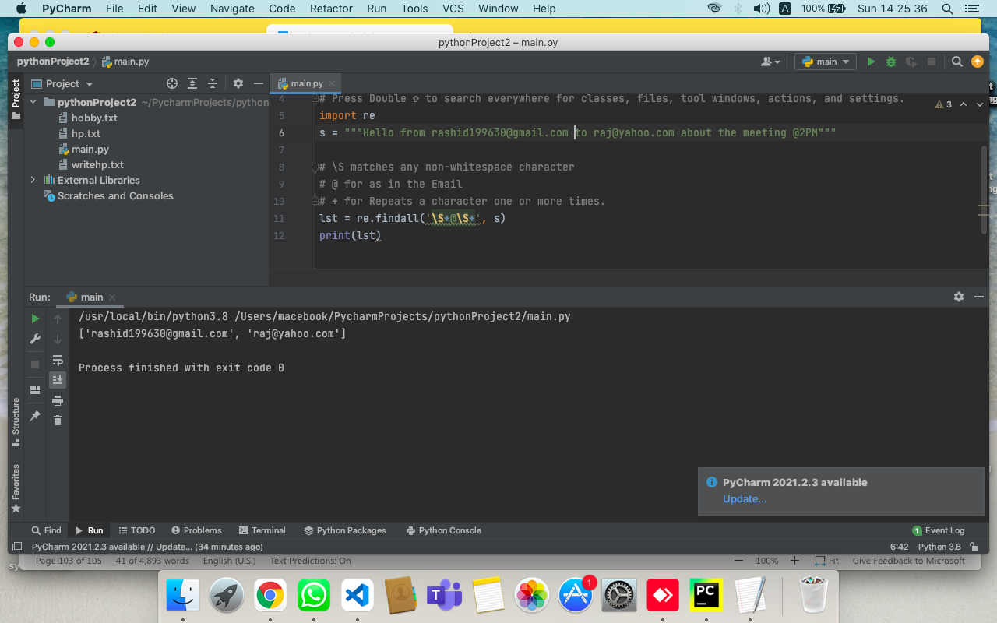

**Q3. Write a regex to get only the part of the email before the "@" sign and include the "@" sign.**  
**i.e: only mama@ part from** [**mama@gmail.com**](mailto:mama@gmail.com)

ANS:-

import re  
  
str='mail to pt@gmail.com and rajatg@gmail.com'  
#Type your answer here.  
regex = r'\S+@'  
emails=re.findall(regex, str)  
  
  
print(emails)

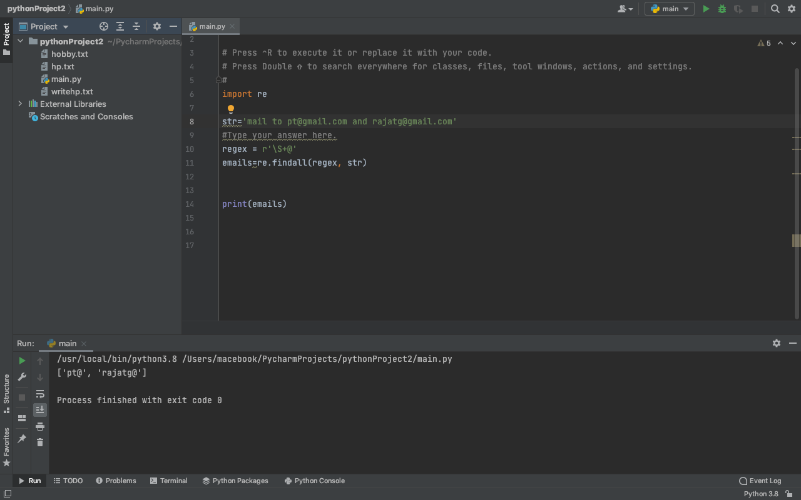

**Q4.  write a regex to get only the part of the email before the "@" sign excluding the "@" sign.**

ANS:-

import re  
  
str='mail to harshit@gmail.com and rajat@gmail.com'  
#Type your answer here.  
  
regex = r'(\S+)@'  
emails=re.findall(regex, str)  
  
  
print(emails)

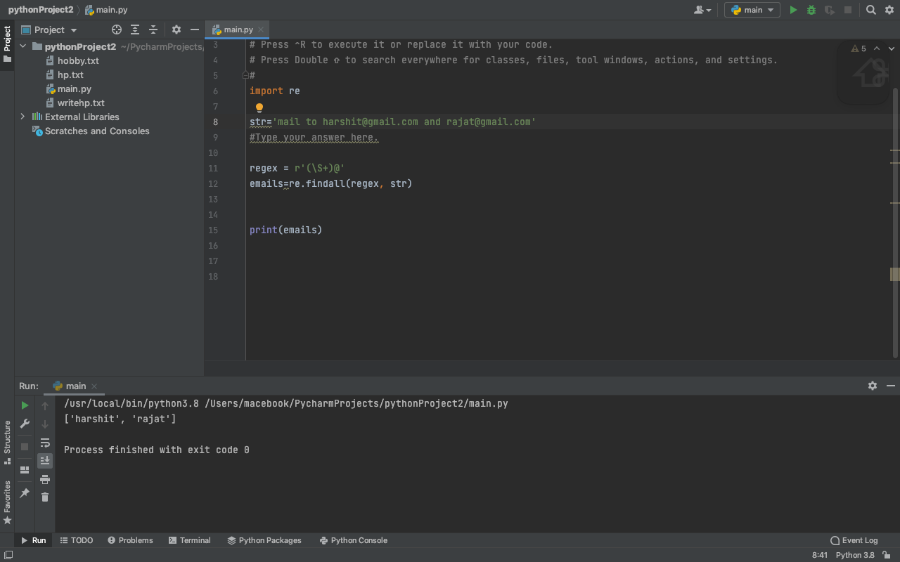

**Q5. Find the words with exactly 8 letters using regex.**

ANS:-

import re  
  
str='''sun say to moon do u RajatGPt'''  
  
#Type your answer here.  
  
regex = r'\w{8}'  
emails=re.findall(regex, str)  
  
  
print(emails)

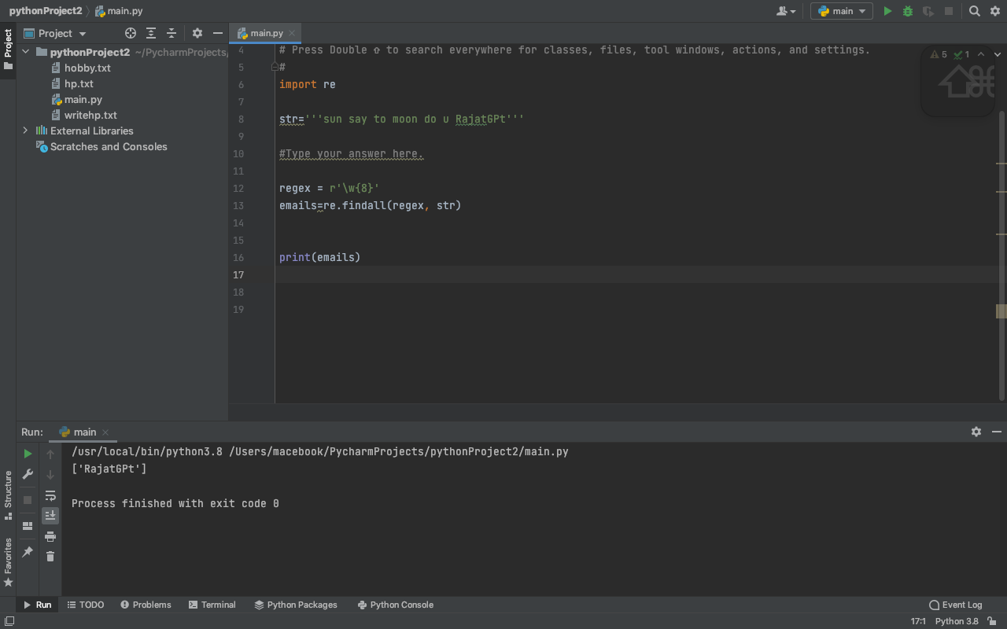

**Q6. Find the numbers starting with 212.**

ANS:-

import re  
  
str='''my num is 270-8282 and your is 212-13 '''  
  
#Type your answer here.  
  
regex = r'212\S+'  
data=re.findall(regex, str)  
  
  
print(data)

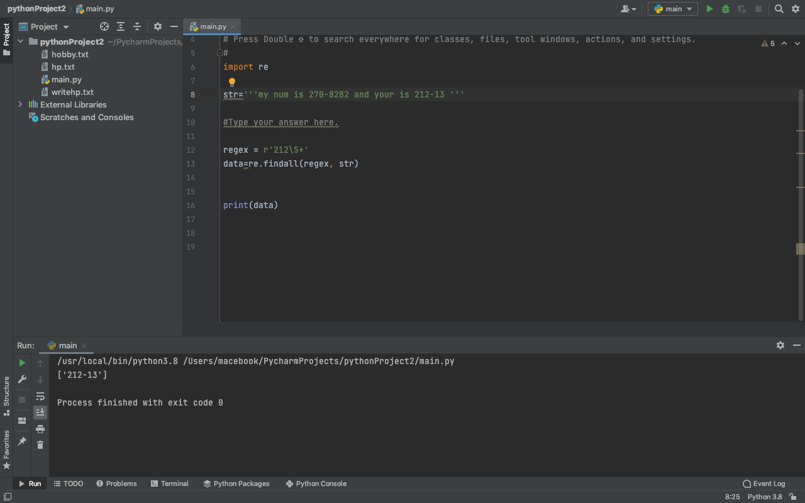

**Q7. You are given stock prices for related financial tickers. (Symbols representing companies in the stock market)**  
**Find a way to extract the tickers mentioned in the report.**  
**i.e.: TSLA, NFLX ...**

ANS:-

**import** re

str**=**"""Some of the prices were as following TSLA:749.50, ORCL: 50.50, GE: 10.90, MSFT: 170.50, BIDU: 121.40. As the macroeconomic developments continue we will update the prices. """

*#Type your answer here.*

regex **=** r'[A-Z]{2,}'

data**=**re**.**findall(regex, str)

print(data)

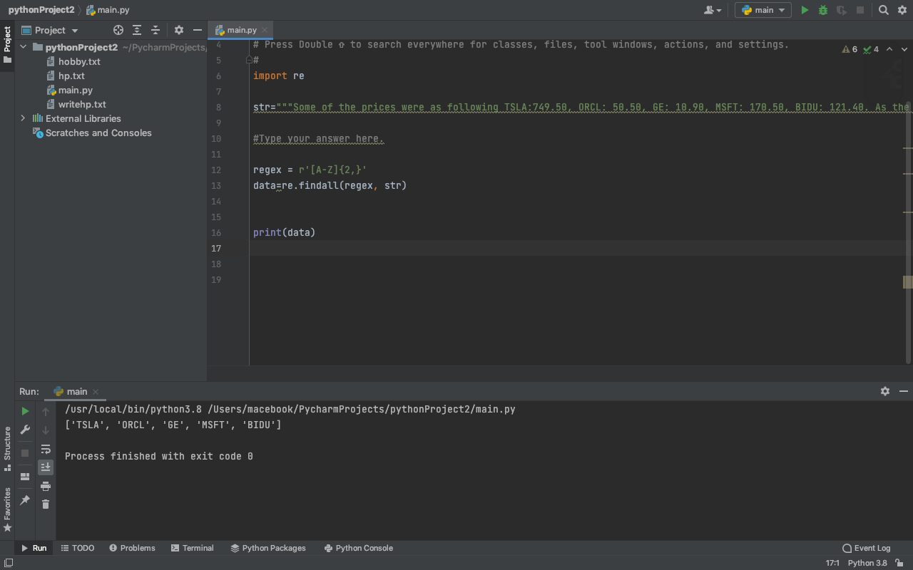

**Q8. Find the html tags that are more than 4 letters.**  
**Html tags can be found inside <> characters and closing html tags can be found in the same format after / character. </>**  
**i.e.: <param> </param>**

ANS:-

**import** re

str**=**"""<div class="tut-list tut-list-new tut-row "> <div class="tut-list-primary"> <div class="tut-vote"> <video>intro</video> <span class="count">50</span> <span class="tut-upvotes-text hidden">Upvotes</span> </a> </div> <center>k="11" rel="nofollow"></center><span class="tutorial-title-txt">Automate the Boring Stuff with Python</span> <span class="tut-title-link"> <span class="js-tutorial" data-id="3529" title="Automate the Boring Stuff with Python" target="_blank">(udemy.com)</span> </span> </a></div> <div class="action-footer"><form class="save-tutorial-form" method="post" <button></button> </form>"""

*#Type your answer here.*

regex **=** r'</([a-z]{5,})>'

data**=**re**.**findall(regex, str)

print(data)

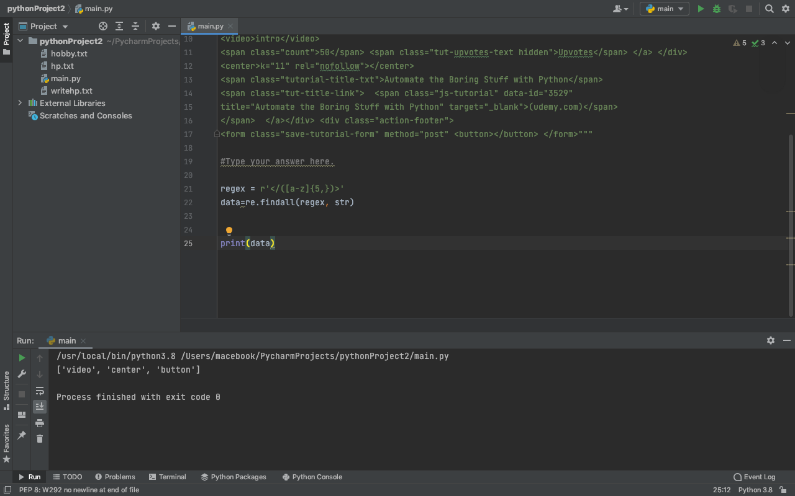

**Q9. Loop through the list and apply regex to each element so that only items ending with semicolon (;) are matched.**

**str=["js/prettify-full.en.js 4e6ee9163220","js/moderator.en.js:", "transaction no: 75553942;", "", "transaction no: 75551263;", "transaction no: 46553942;", "c01c47765ca21b82b08b90403b4c7af3886098683e3869ad1:", "transaction no: 75554942;"]**

ANS:-

**import** re

str**=**["js/prettify-full.en.js 4e6ee9163220","js/moderator.en.js:", "transaction no: 75553942;", "", "transaction no: 75551263;", "transaction no: 46553942;", "c01c47765ca21b82b08b90403b4c7af3886098683e3869ad1:", "transaction no: 75554942;"]

*#Type your answer here.*

lst**=**[]

**for** i **in** str:

data **=** re**.**findall(r"(.+);$" ,i)

**try**: lst**.**append(data[0])

**except** Exception:

**pass**print(lst)

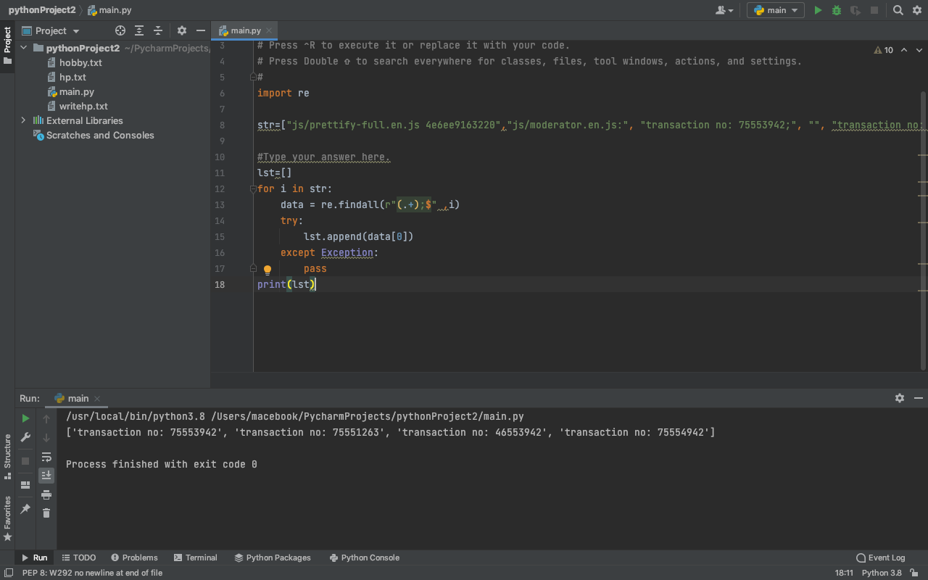

**ASSIGNMENT :- 11**

**TOPIC CGI**

**1st program**

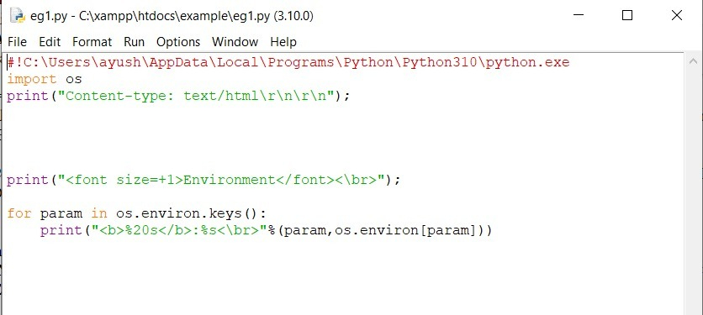

#!C:\Users\ayush\AppData\Local\Programs\Python\Python310\python.exe

import os

print("Content-type: text/html\r\n\r\n");

print("<font size=+1>Environment</font><\br>");

for param in os.environ.keys():

print("<b>%20s</b>:%s<\br>"%(param,os.environ[param]))

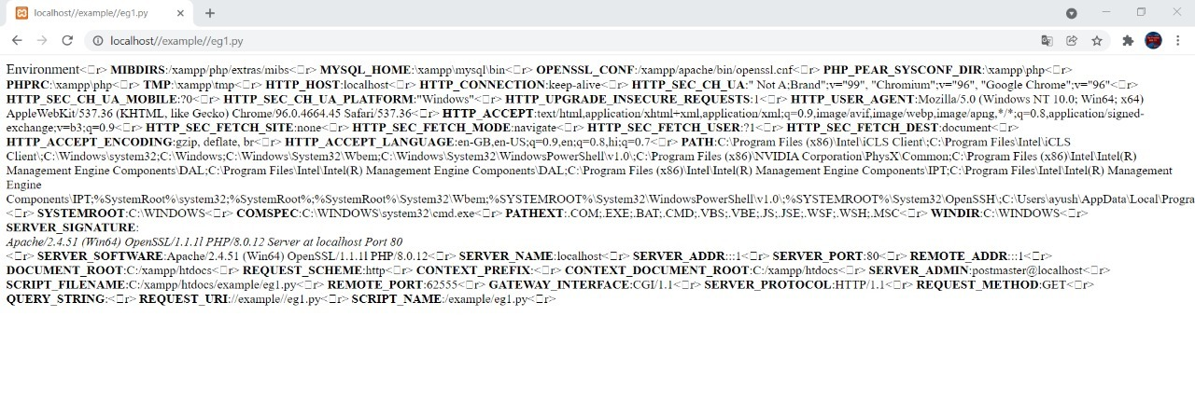

**2nd program**

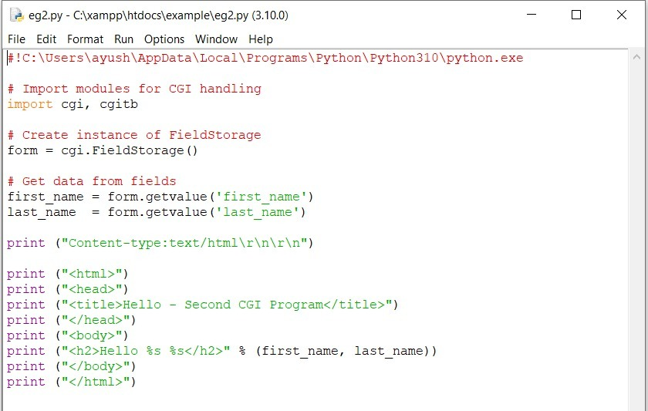

#!C:\Users\ayush\AppData\Local\Programs\Python\Python310\python.exe

# Import modules for CGI handling

import cgi, cgitb

# Create instance of FieldStorage

form = cgi.FieldStorage()

# Get data from fields

first_name = form.getvalue('first_name')

last_name = form.getvalue('last_name')

print ("Content-type:text/html\r\n\r\n")

print ("<html>")

print ("<head>")

print ("<title>Hello - Second CGI Program</title>")

print ("</head>")

print ("<body>")

print ("<h2>Hello %s %s</h2>" % (first_name, last_name))

print ("</body>")

print ("</html>")

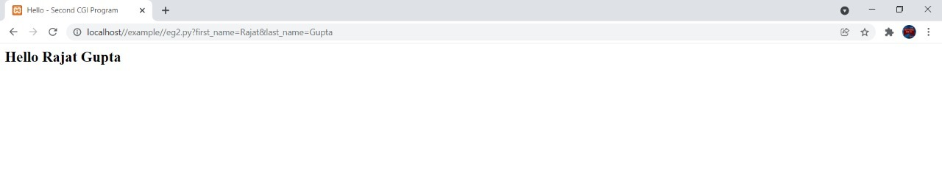

**ASSIGNMENT :- 12**

**TOPIC :- TKINTER**

Ques 1. **Python program to create a simple GUI calculator using Tkinter.**

|  |
| --- |
| Python program to create a simple GUI  calculator using Tkinter    # import everything from tkinter module  **from** tkinter **import** **\***    # globally declare the expression variable  expression **=** ""      # Function to update expression  # in the text entry box  **def** press(num):  # point out the global expression variable  **global** expression    # concatenation of string  expression **=** expression **+** str(num)    # update the expression by using set method  equation.set(expression)      # Function to evaluate the final expression  **def** equalpress():  # Try and except statement is used  # for handling the errors like zero  # division error etc.    # Put that code inside the try block  # which may generate the error  **try**:    **global** expression    # eval function evaluate the expression  # and str function convert the result  # into string  total **=** str(eval(expression))    equation.set(total)    # initialize the expression variable  # by empty string  expression **=** ""    # if error is generate then handle  # by the except block  **except**:    equation.set(" error ")  expression **=** ""      # Function to clear the contents  # of text entry box  **def** clear():  **global** expression  expression **=** ""  equation.set("")      # Driver code  **if** __name__ **==** "__main__":  # create a GUI window  gui **=** Tk()    # set the background colour of GUI window  gui.configure(background**=**"light green")    # set the title of GUI window  gui.title("Simple Calculator")    # set the configuration of GUI window  gui.geometry("270x150")    # StringVar() is the variable class  # we create an instance of this class  equation **=** StringVar()    # create the text entry box for  # showing the expression .  expression_field **=** Entry(gui, textvariable**=**equation)    # grid method is used for placing  # the widgets at respective positions  # in table like structure .  expression_field.grid(columnspan**=**4, ipadx**=**70)    # create a Buttons and place at a particular  # location inside the root window .  # when user press the button, the command or  # function affiliated to that button is executed .  button1 **=** Button(gui, text**=**' 1 ', fg**=**'black', bg**=**'red',  command**=lambda**: press(1), height**=**1, width**=**7)  button1.grid(row**=**2, column**=**0)    button2 **=** Button(gui, text**=**' 2 ', fg**=**'black', bg**=**'red',  command**=lambda**: press(2), height**=**1, width**=**7)  button2.grid(row**=**2, column**=**1)    button3 **=** Button(gui, text**=**' 3 ', fg**=**'black', bg**=**'red',  command**=lambda**: press(3), height**=**1, width**=**7)  button3.grid(row**=**2, column**=**2)    button4 **=** Button(gui, text**=**' 4 ', fg**=**'black', bg**=**'red',  command**=lambda**: press(4), height**=**1, width**=**7)  button4.grid(row**=**3, column**=**0)    button5 **=** Button(gui, text**=**' 5 ', fg**=**'black', bg**=**'red',  command**=lambda**: press(5), height**=**1, width**=**7)  button5.grid(row**=**3, column**=**1)    button6 **=** Button(gui, text**=**' 6 ', fg**=**'black', bg**=**'red',  command**=lambda**: press(6), height**=**1, width**=**7)  button6.grid(row**=**3, column**=**2)    button7 **=** Button(gui, text**=**' 7 ', fg**=**'black', bg**=**'red',  command**=lambda**: press(7), height**=**1, width**=**7)  button7.grid(row**=**4, column**=**0)    button8 **=** Button(gui, text**=**' 8 ', fg**=**'black', bg**=**'red',  command**=lambda**: press(8), height**=**1, width**=**7)  button8.grid(row**=**4, column**=**1)    button9 **=** Button(gui, text**=**' 9 ', fg**=**'black', bg**=**'red',  command**=lambda**: press(9), height**=**1, width**=**7)  button9.grid(row**=**4, column**=**2)    button0 **=** Button(gui, text**=**' 0 ', fg**=**'black', bg**=**'red',  command**=lambda**: press(0), height**=**1, width**=**7)  button0.grid(row**=**5, column**=**0)    plus **=** Button(gui, text**=**' + ', fg**=**'black', bg**=**'red',  command**=lambda**: press("+"), height**=**1, width**=**7)  plus.grid(row**=**2, column**=**3)    minus **=** Button(gui, text**=**' - ', fg**=**'black', bg**=**'red',  command**=lambda**: press("-"), height**=**1, width**=**7)  minus.grid(row**=**3, column**=**3)    multiply **=** Button(gui, text**=**' * ', fg**=**'black', bg**=**'red',  command**=lambda**: press("*"), height**=**1, width**=**7)  multiply.grid(row**=**4, column**=**3)    divide **=** Button(gui, text**=**' / ', fg**=**'black', bg**=**'red',  command**=lambda**: press("/"), height**=**1, width**=**7)  divide.grid(row**=**5, column**=**3)    equal **=** Button(gui, text**=**' = ', fg**=**'black', bg**=**'red',  command**=**equalpress, height**=**1, width**=**7)  equal.grid(row**=**5, column**=**2)    clear **=** Button(gui, text**=**'Clear', fg**=**'black', bg**=**'red',  command**=**clear, height**=**1, width**=**7)  clear.grid(row**=**5, column**=**'1')    Decimal**=** Button(gui, text**=**'.', fg**=**'black', bg**=**'red',  command**=lambda**: press('.'), height**=**1, width**=**7)  Decimal.grid(row**=**6, column**=**0)  # start the GUI  gui.mainloop() |

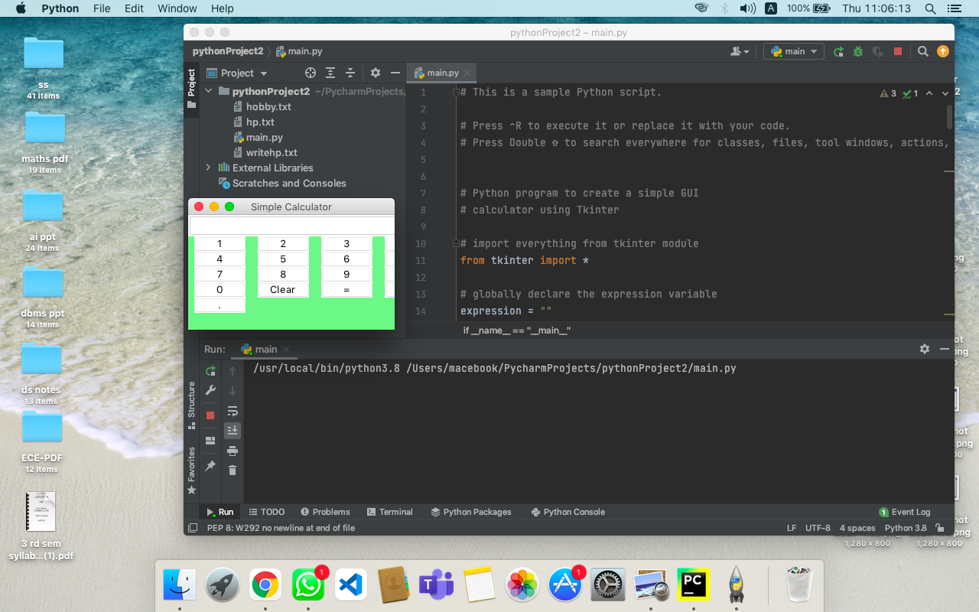

Ques 2.

import tkinter as tk  
import mysql.connector  
from tkinter import *  
  
  
def submitact():  
 user = Username.get()  
 passw = password.get()  
  
 print(f"The name entered by you is {user} {passw}")  
  
 logintodb(user, passw)  
  
  
def logintodb(user, passw):  
 # If password is enetered by the user  
 if passw:  
 db = mysql.connector.connect(host="localhost", user=user, password=passw, db="amity")  
 cursor = db.cursor();  
 # If no password is enetered by the user  
 else:  
 db = mysql.connector.connect(host="localhost", user="root", password="", db="amity")  
 cursor = db.cursor();  
  
 # A Table in the database  
 savequery = "select * from student"  
  
 try:  
 cursor.execute(savequery)  
 myresult = cursor.fetchall();  
 # Printing the result of the query  
 for x in myresult:  
 print(x)  
 print("Query Excecuted successfully")  
  
 except:  
 db.rollback()  
 print("Error occured")  
  
  
root = tk.Tk()  
root.geometry("300x300")  
root.title("DBMS Login Page")  
  
# Defining the first row  
lblfrstrow = tk.Label(root, text="Username -", )  
lblfrstrow.place(x=50, y=20)  
  
Username = tk.Entry(root, width=35)  
Username.place(x=150, y=20, width=100)  
  
lblsecrow = tk.Label(root, text="Password -")  
lblsecrow.place(x=50, y=50)  
  
password = tk.Entry(root, width=35)  
password.place(x=150, y=50, width=100)  
  
submitbtn = tk.Button(root, text="Login", bg='blue', command=submitact)  
submitbtn.place(x=150, y=135, width=55)  
  
root.mainloop()

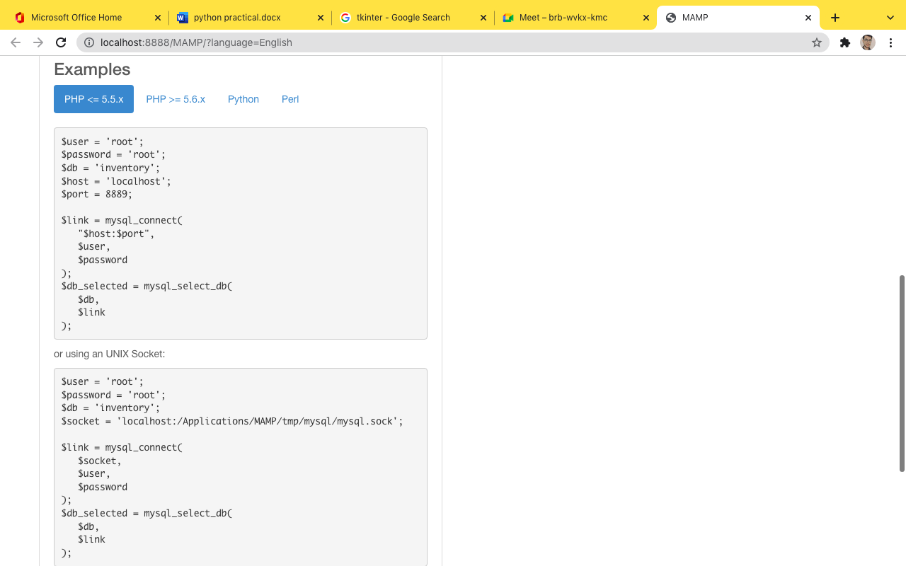

**ASSIGNMENT:- 12**

**TOPIC:- PACKAGES**

**First blank module**

**__init__.py**

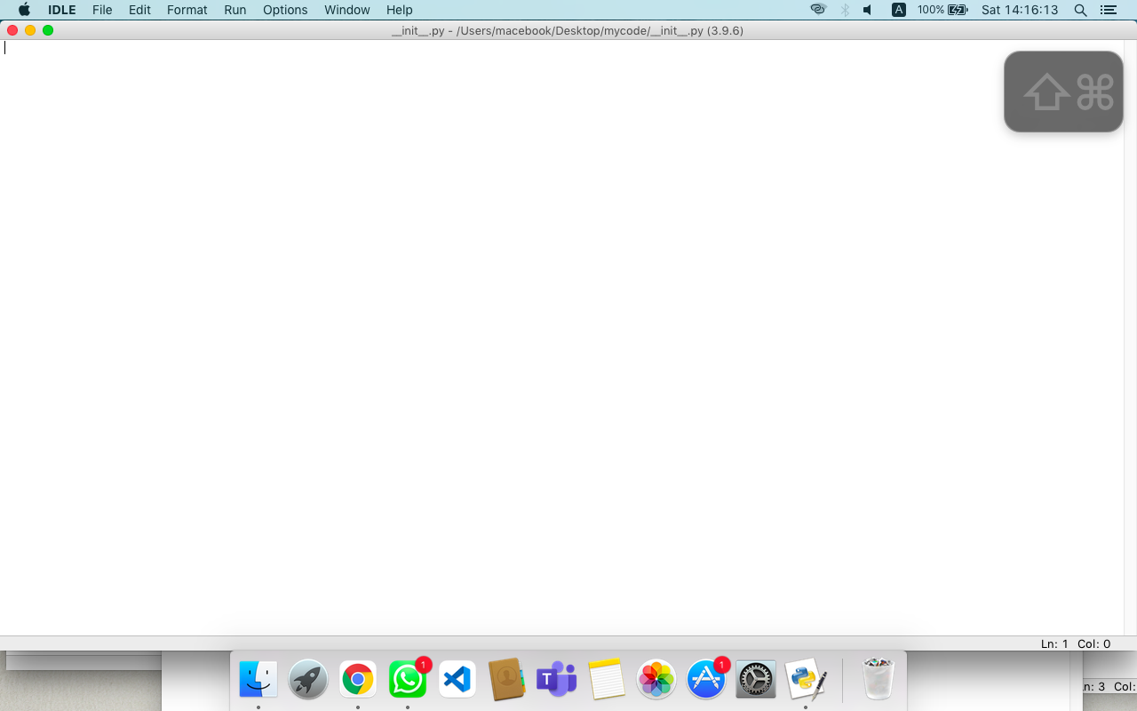

**sum.py module**

**def summation(num1,num2):**

**return num1 + num2**

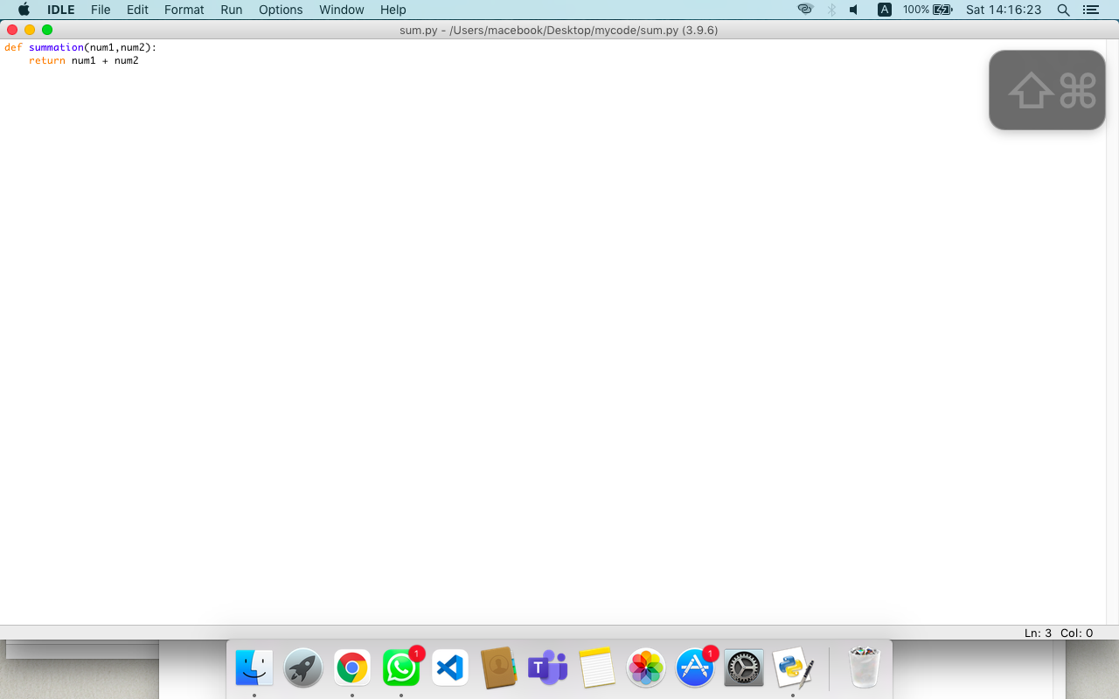

**mul.py module**

**def multiplication(num1,num2):**

**return num1*num2**

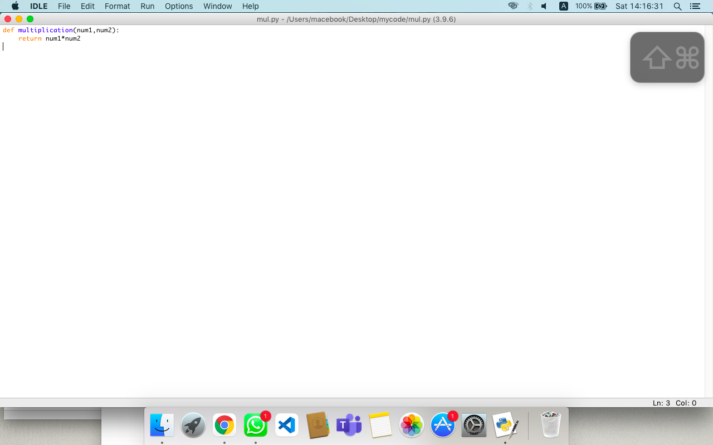

**calc.py module**

**import mycode.sum**

**import mycode.mul**

**def calculator():**

**print("enter : \n 1.summation \n 2.multiplicaton")**

**c=int(input("enter your choice"))**

**if c==1:**

**a=int(input("enter num 1:"))**

**b=int(input("enter num 2:"))**

**print(mycode.sum.summation(a,b))**

**elif c==2:**

**a=int(input("enter num 1:"))**

**b=int(input("enter num 2:"))**

**print(mycode.mul.multiplication(a,b))**

**else:**

**print("wrong choice")**

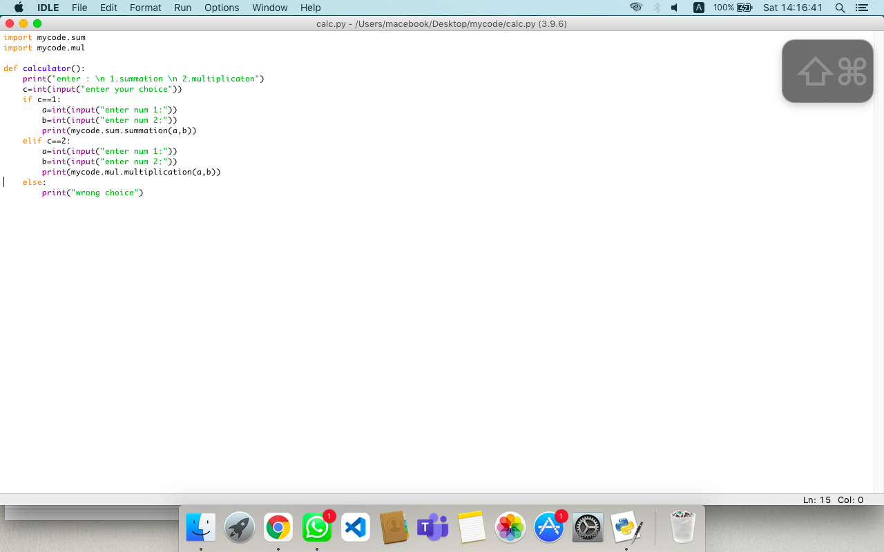

import mycode.calc

Mycode.calc.calculator()

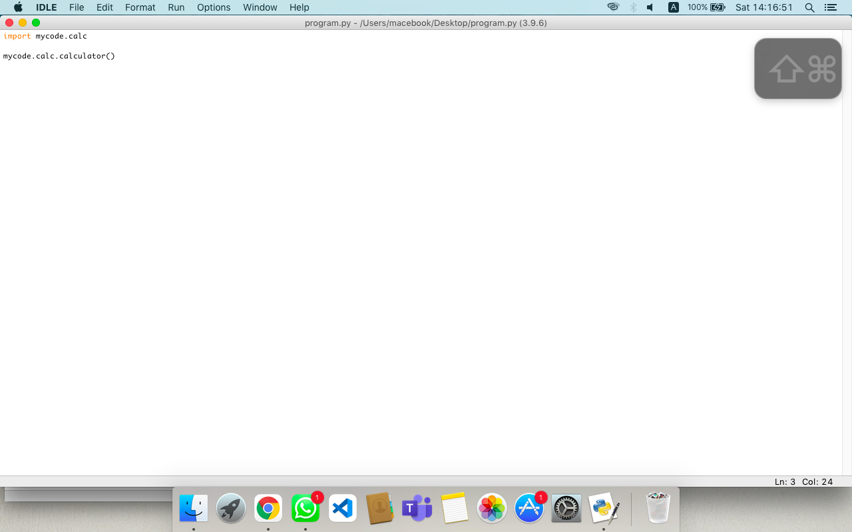

enter :

1.summation

2.multiplicaton

enter your choice 2

enter num 1: 5

enter num 2: 3

15

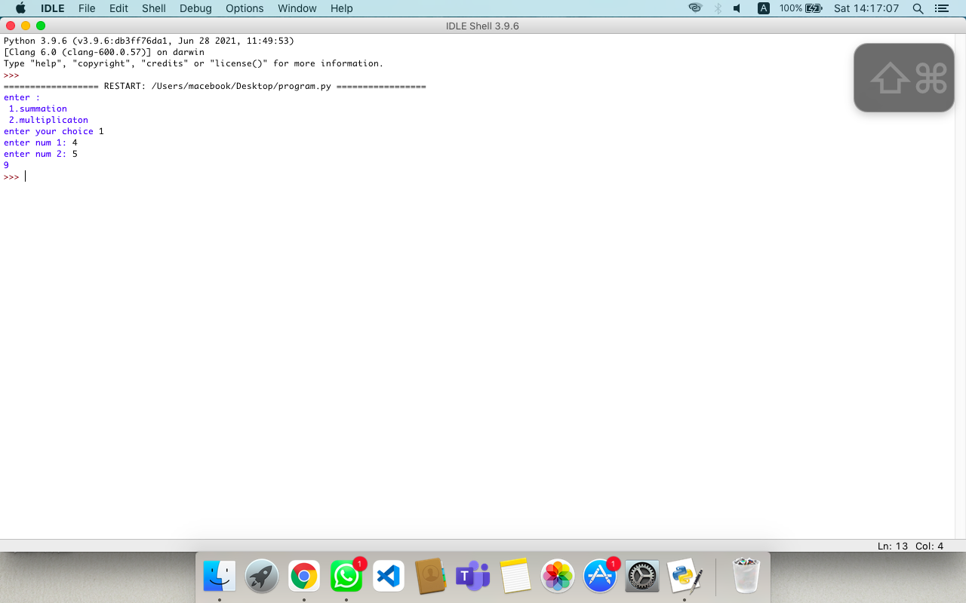

**Whole python package implementation**

